RÜFÜS DU SOL Release Highly-Anticipated Debut Film & Live Album
RÜFÜS DU SOL: Live from Joshua Tree

Featuring Beloved Favorites Across Albums SOLACE, Bloom and Atlas

Sold-Out World Premiere in Los Angeles and Benefit Screenings in Sydney & Melbourne Alongside The Chemical Brothers for the Australian Red Cross Bush Fire Appeal

Watch RÜFÜS DU SOL: Live from Joshua Tree HERE

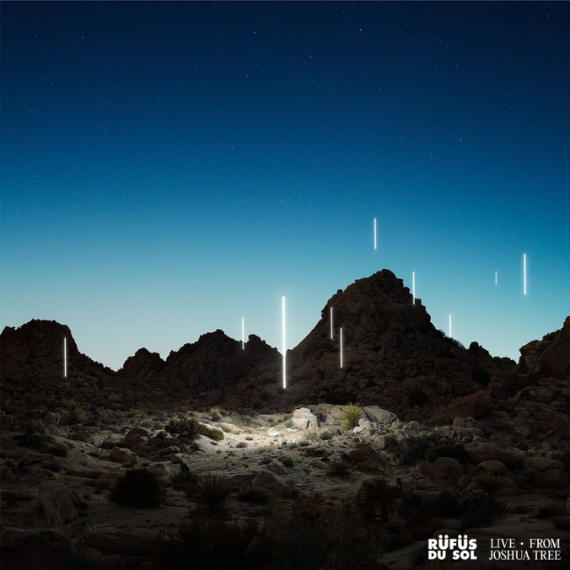

March 6, 2020 (Los Angeles, CA) - Today, RÜFÜS DU SOL have released their debut film and live album, RÜFÜS DU SOL: Live from Joshua Tree, worldwide. The 45-minute immersive experience captures the band’s powerful live energy set against a backdrop of captivating desert terrain.

The film opens as the sun sets over stunning rock formations, cascading into darkness with the trio surrounded by a sea of radiant light poles and endless vastness. Performing their acclaimed hits “Solace,” “Underwater,” and “Innerbloom,” the live project also features new track “Valley of the Yuccas.” With the film directed by Jon George’s brother Alex George, “Live from Joshua Tree” unearths a meaningful and personal body of work created for their dedicated fans around the globe.

Listen to RÜFÜS DU SOL: Live from Joshua Tree HERE and watch the film HERE.

Last month the trio held their sold-out world premiere in Los Angeles at the iconic Vista Theatre. Attracting rave reviews and heightened excitement for the global release, they announced two additional premieres in Sydney at Randwick Ritz and Melbourne at IMAX alongside GRAMMY-winning duo The Chemical Brothers, who screened their acclaimed concert documentary, “Don’t Think.” With both bands hailing from Australia, they joined efforts to donate all ticket and merch proceeds towards the Australian Red Cross Bush Fire Appeal.

Amidst the release of their debut film and live album, RÜFÜS DU SOL set out on another world tour across the Americas and Europe, with a brand new production. Following over a year of sold-out shows to half a million fans, the band will take to renowned venues and leading festival stages including Masonic Temple in Detroit, Germania Insurance Amphitheater in Austin, two nights at Red Rocks in August, and slots on Okeechobee, M3F, CRSSD, Corona Capital, Governors Ball, Melt Festival, Lollapalooza Paris, and more.

RÜFÜS DU SOL: Live from Joshua Tree Tracklist
1. Valley of the Yuccas (Live from Joshua Tree)
2. Eyes (Live from Joshua Tree)
3. New Sky (Live from Joshua Tree)
4. Desert Night (Live from Joshua Tree)
5. Solace (Live from Joshua Tree)
6. Underwater (Live from Joshua Tree)
7. Innerbloom (Live from Joshua Tree)
8. No Place (Live from Joshua Tree)

Listen to RÜFÜS DU SOL: Live from Joshua Tree HERE
Watch RÜFÜS DU SOL: Live from Joshua Tree HERE
Purchase tickets to RÜFÜS DU SOL on Tour HERE

RÜFÜS DU SOL World Tour 2020
March 5 - Okeechobee Music & Arts Festival - Okeechobee, FL
March 7 - M3F Festival - Phoenix, AZ
March 8 - CRSSD Festival - San Diego, CA
March 11 - Orpheum Theater - New Orleans, LA
March 13 - Revention Music Center - Houston, TX
March 14 - Germania Insurance Amphitheater - Austin, TX
March 15 - Art of the Wild - Las Vegas, NV (DJ Set)
May 15 - Pepsi Center - Mexico City, Mexico
May 16 - Corona Capital - Guadalajara, Mexico
May 19 - The Ritz - Raleigh, NC
May 21 - Stage AE - Pittsburgh, PA
May 22 - Masonic Temple - Detroit, MI
May 23 - The Agora - Cleveland, OH
May 27 - The Pageant - Saint Louis, MO
May 29 - Marathon Music Works - Nashville, TN
May 30 - Huntington Bank Pavilion - Chicago, IL
June 2 - Express Live! - Columbus, OH
June 5 - RBC Echo Beach - Toronto, ON
June 6 - Parc Jean-Drapeau - Montréal, QC
June 7 - The Governors Ball Music Festival - New York, NY
July 1 - Open’er Festival - Gdynia, Poland
July 3 - Rosklide Festival - Rosklide, Denmark
July 5 - Main Square Festival - Arras, France
July 10 - Mad Cool Festival - Madrid, Spain
July 14 - Gru Village Festival - Turin, Italy
July 17 - Melt Festival - Gräfenhainichen, Germany
July 19 - Lollapalooza - Paris, France
August 6 - PNE Amphitheatre - Vancouver, BC
August 7 - Cuthbert Amphitheater - Eugene, OR
August 12 - Red Rocks Amphitheatre - Morrison, CO
August 13 - Red Rocks Amphitheatre - Morrison, CO

Connect with RÜFÜS DU SOL
Facebook | Instagram | Twitter | Spotify | YouTube

