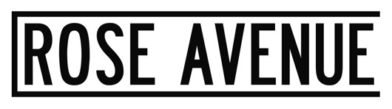

RÜFÜS DU SOL Announce an 18-Track Collection of Reworks From The Band’s Third Studio Album, SOLACE

‘SOLACE REMIXED’ Is Available September 6th
Collection Features Electronic Tastemakers Including
Adam Port, Audiofly, Cassian, Edu Imbernon, Gerd Janson, Hot Since 82, Justin Martin, Made In Paris, Will Clarke, Willaris. K, and More

Stream “Solace (Lastlings Remix)” HERE

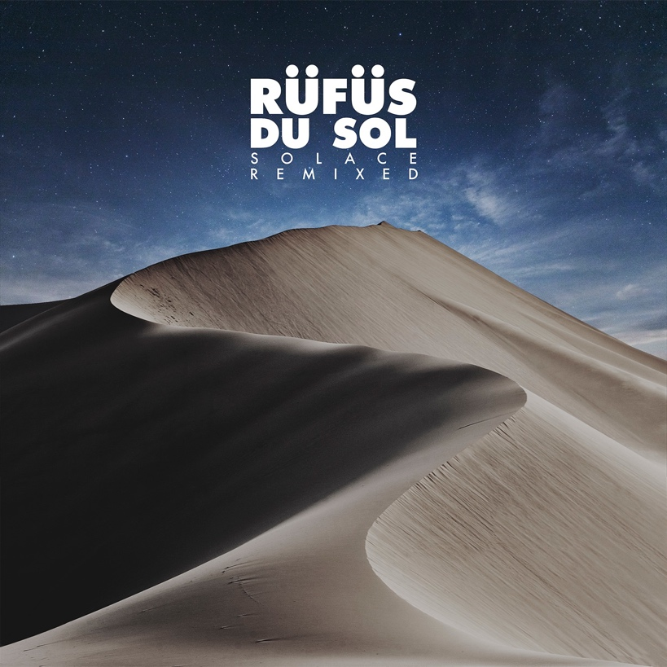

July 26, 2019 (Los Angeles, CA) - In celebration of RÜFÜS DU SOL’s universally acclaimed third studio album, SOLACE, comes the announcement today of a reimagined 18-track remix album, SOLACE REMIXED – out September 6th on Rose Avenue / Reprise Records. The collection features a sonically diverse amalgamation of reworks from some of electronic music’s most influential figures including Audiofly, Adam Port, Edu Imbernon, and Hot Since 82. The package reimagines the story of SOLACE into club-ready portraits spanning from brooding techno to cerebral house.

REMIXED serves as a testament to the trio’s clubland roots and their newfound role as global curators within the scene. It is the forward-thinking nature of the underground that gave way to the experimental crafting of SOLACE, with the remix album offering a look into the record box that helped shape the original. Those who have attended the group’s coveted DJ sets at iconic clubbing locales like Space Miami, Ibiza’s Amnesia Terrace, or Do LaB at Coachella will recognize these massive cuts. Fans can pre-order the collection HERE. A special vinyl edition will also be made available on October 18th.

Australian indie-electronic duo Lastlings, signed to RÜFÜS DU SOL’s own Rose Avenue Records, share their rendition of “Solace” ahead of the full remix album launch. In a nearly unrecognizable rendition of the original, Lastlings add a dark and pulsating beat to the shadowy synths that echo over lead singer, Amy Dowdle’s, velvety harmonies. In just over a year, the pair have experienced an explosive rise, amassing over a few million streams to date, securing a coveted performance on the Do LaB stage at Coachella, and supporting RÜFÜS on major dates across their Australian and North American tours.

This week marks the second leg of the band’s massive SOLACE World Tour, which sees them sell out two nights at Berkeley’s Greek Theatre, three nights at NY’s Brooklyn Mirage, two nights at the iconic Red Rocks, a top-billing performance at Lollapalooza, and their largest headline show to date at Los Angeles State Historic Park.

Whilst on the road, RÜFÜS have launched a new episodic series titled “Between Du Sols” featuring backstage conversations between the band and supporting artists along the way. Check out Episode 1 with Cassian HERE.

Pre-order SOLACE REMIXED HERE.
Purchase tickets to see RÜFÜS DU SOL on tour HERE.

SOLACE REMIXED Tracklist
Treat You Better (Cassian Remix)
Eyes (RÜFÜS DU SOL VIP Edit)
New Sky (Audiofly Remix)
Lost In My Mind (Icarus Remix)
No Place (Eelke Kleijn Remix)
All I've Got (Mathame Remix)
Underwater (Adam Port Remix)
Solace (Lastlings Remix)
Another Life (Hot Since 82 Remix)
Treat You Better (Gerd Janson Remix)
Eyes (Durante & Cassian Remix)
New Sky (Edu Imbernon Remix)
Lost In My Mind (Justin Martin Remix)
No Place (Will Clarke Remix)
All I've Got (Gorje Hewek & Izhevski Remix)
Underwater (Willaris. K Remix)
Solace (TERR Remix)
Another Life (Made In Paris Remix)

RÜFÜS DU SOL 2019 US Tour Dates
July 26 - Austin, TX - ACL Live at The Moody Theater SOLD OUT
July 27 - New Orleans, LA - Joy Theater SOLD OUT
July 31 - Chicago, IL - Vic Theatre SOLD OUT
August 1 - Chicago, IL - Lollapalooza
August 3 - Montreal, QC - Osheaga
August 6 - Philadelphia, PA - Franklin Music Hall
August 8 - Washington, DC - The Anthem
August 9 - Brooklyn, NY - Brooklyn Mirage SOLD OUT
August 10 - Brooklyn, NY - Brooklyn Mirage SOLD OUT
August 11 - Brooklyn, NY - Brooklyn Mirage
September 20 - Pomona, CA - Fox Theater
September 21 - Las Vegas, NV - Life Is Beautiful
September 22 - Las Vegas, NV - Wynn Las Vegas Hotel & Casino (DJ SET)
September 25 - Missoula, MT - Wilma Theater
September 26 - Boise, ID - Outlaw Field at the Idaho Botanical Garden
September 27 - Ogden, UT - The Ogden Amphitheater
September 28 - Aspen, CO - Belly Up Aspen SOLD OUT
October 2 - Morrison, CO - Red Rocks Amphitheatre SOLD OUT
October 3 - Morrison, CO - Red Rocks Amphitheatre SOLD OUT
October 5 - Los Angeles, CA - Los Angeles State Historic Park SOLD OUT

Connect with RÜFÜS DU SOL
Facebook | Instagram | Twitter | Spotify

###
Press Contacts:
Bobbie Gale / Warner Records
(818) 953-3692 / Bobbie.Gale@warnerrecords.com

Maxfield Frieser / Infamous PR
mfrieser@infamouspr.com

Press materials:
http://press.warnerrecords.com/rufusdusol/

