RÜFÜS DU SOL Announce Live Album From Debut Film
“RÜFÜS DU SOL: Live from Joshua Tree”

Following Sold-Out World Premiere in Los Angeles at Historic Vista Theatre,
Live Album and Film Set for Worldwide Release on March 6, 2020

Pre-Order “RÜFÜS DU SOL: Live from Joshua Tree” HERE
Watch / Listen to “Solace” Live HERE
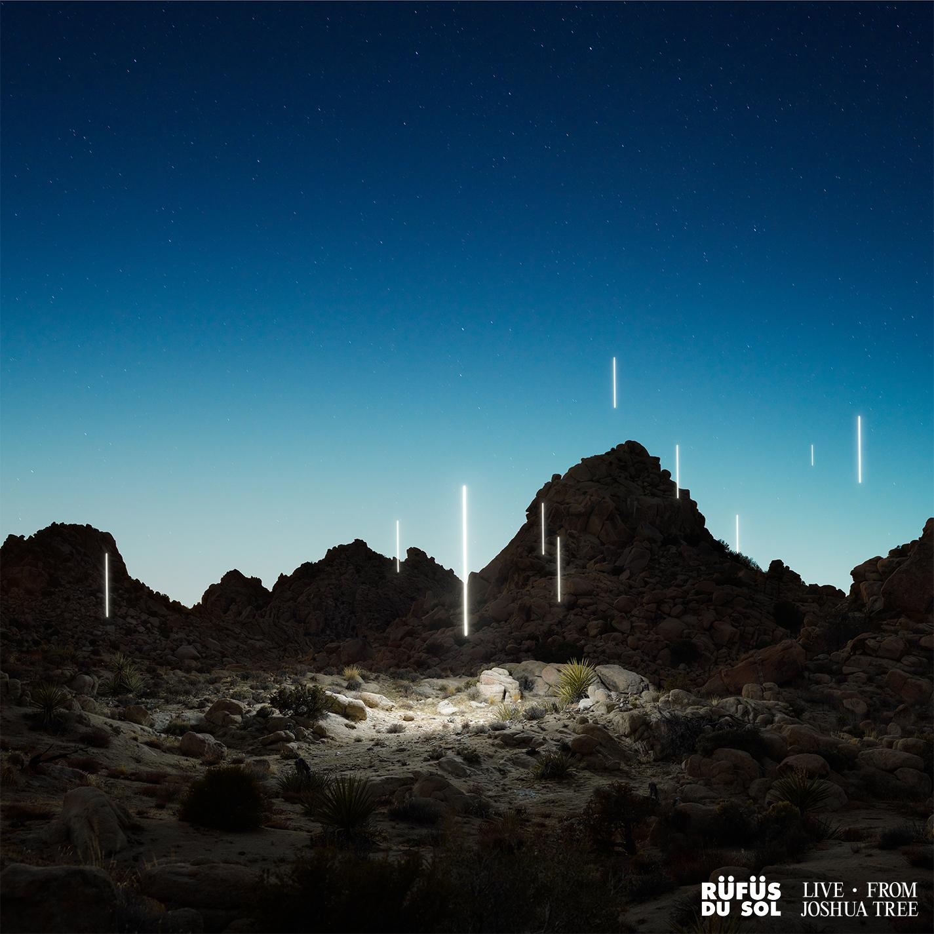

February 21, 2020 (Los Angeles, CA) - RÜFÜS DU SOL officially announced today the live album accompaniment to their debut film, “RÜFÜS DU SOL: Live from Joshua Tree.” The title-track from their GRAMMY-Nominated album SOLACE is the first to be released in audio and video straight from the 45-minute feature; a fitting debut as it captures the band’s emotive gravitas amongst the powerful energy of the desert landscape.

Pre-order “RÜFÜS DU SOL: Live from Joshua Tree” here, listen to “Solace” Live, here, and watch “Solace” Live via Mixmag here.

Drummer James Hunt shares how Live From Joshua Tree came together: "The idea for a film was born out of a writing trip in Joshua Tree when we were trying to finish SOLACE. We stayed up all night writing as the sun rose, this creeping light over the valley made its way into the room. We climbed these wild rock formations to a little vista at the top, about 100 feet above where we were writing, and sat to take in the sunrise. We were listening to tunes on a speaker and someone put on ‘Time’ by the Pachanga Boys. Watching dawn break with this epic 15 minute journey playing out, we started joking about putting together a sunrise set in the desert where we would play to no one. People talk a lot of shit in the desert at 5am, but walking around this alien world at dawn, we definitely felt there was something calling us back out there. So over an 18 month period, we workshopped ideas and locations and finally were able to put time aside to shoot in September last year. It was decided sunset would be more practical for our crew. We originally planned for it to be a live stream, but as the idea grew and the production got bigger and bigger, it organically morphed into a film. It’s something that’s taken two years to pull together and something we are so excited to share with the world and make available everywhere.”

The trio held their sold-out world premiere screening in Los Angeles on February 18 for over 400 fans, friends and family to witness the immersive live experience at the iconic Vista Theatre. Additional intimate screenings will be announced soon, with the live album and film set for worldwide release on March 6.

The monumental release of RÜFÜS DU SOL’s first-ever motion picture and live album arrives at the head of their 2020 World Tour, seeing the band travel around the globe with a brand new production. Following more than a year of sold-out shows to half a million fans, RÜFÜS DU SOL will take to renowned venues and leading festival stages including Masonic Temple in Detroit, Germania Insurance Amphitheater in Austin, two nights at Red Rocks in August, and slots on Okeechobee, M3F, CRSSD, Corona Capital, Governors Ball, and more. Amidst their live run, they’ve been committed to supporting the bushfire relief efforts in every way they can. This month they’re hosting a fundraiser in partnership with CRSSD benefitting the RSPCA Bushfire Appeal. Fans can donate via the festival raffle, here.

“RÜFÜS DU SOL: Live from Joshua Tree” Tracklist
1. Valley of the Yuccas (Live from Joshua Tree)
2. Eyes (Live from Joshua Tree)
3. New Sky (Live from Joshua Tree)
4. Desert Night (Live from Joshua Tree)
5. Solace (Live from Joshua Tree)
6. Underwater (Live from Joshua Tree)
7. Innerbloom (Live from Joshua Tree)
8. No Place (Live from Joshua Tree)

Pre-Order “RÜFÜS DU SOL: Live from Joshua Tree” HERE
Listen to “Solace” Live HERE
Watch “Solace” Live via Mixmag HERE
Purchase tickets to RÜFÜS DU SOL on Tour HERE

RÜFÜS DU SOL World Tour 2020
February 22 - Envision Festival - Uvita, Costa Rica
February 26 - The Pavilion - Indianapolis, IN
February 27 - The Sylvee - Madison, WI
February 28 - The Fillmore - Minneapolis, MI
February 29 - The Fillmore - Minneapolis, MI
March 3 - The Fillmore - Charlotte, NC
March 5 - Okeechobee Music & Arts Festival - Okeechobee, FL
March 7 - M3F Festival - Phoenix, AZ
March 8 - CRSSD Festival - San Diego, CA
March 11 - Orpheum Theater - New Orleans, LA
March 13 - Revention Music Center - Houston, TX
March 14 - Germania Insurance Amphitheater - Austin, TX
March 15 - Art of the Wild - Las Vegas, NV (DJ Set)
May 15 - Pepsi Center - Mexico City, Mexico
May 16 - Corona Capital - Guadalajara, Mexico
May 19 - The Ritz - Raleigh, NC
May 21 - Stage AE - Pittsburgh, PA
May 22 - Masonic Temple - Detroit, MI
May 23 - The Agora - Cleveland, OH
May 27 - The Pageant - Saint Louis, MO
May 29 - Marathon Music Works - Nashville, TN
May 30 - Huntington Bank Pavilion - Chicago, IL
June 2 - Express Live! - Columbus, OH
June 5 - RBC Echo Beach - Toronto, ON
June 6 - Parc Jean-Drapeau - Montréal, QC
June 7 - The Governors Ball Music Festival - New York, NY
July 1 - Open’er Festival - Gdynia, Poland
July 5 - Main Square Festival - Arras, France
July 10 - Mad Cool Festival - Madrid, Spain
July 14 - Gru Village Festival - Turin, Italy
July 17 - Melt Festival - Gräfenhainichen, Germany
July 19 - Lollapalooza - Paris, France
August 6 - PNE Amphitheatre - Vancouver, BC
August 7 - Cuthbert Amphitheater - Eugene, OR
August 12 - Red Rocks Amphitheatre - Morrison, CO
August 13 - Red Rocks Amphitheatre - Morrison, CO

Connect with RÜFÜS DU SOL
Facebook | Instagram | Twitter | Spotify | YouTube

