Ricky Montgomery Continues Viral Success with New Version of Breakthrough Hit “Mr Loverman” with chloe moriondo

LISTEN HERE

March 5, 2021 (Los Angeles, CA) – Fresh off the release of the new mxmtoon-assisted version of “Line Without A Hook”, rising indie-pop singer/songwriter Ricky Montgomery has teamed up with chloe moriondo on a new version of breakthrough hit “Mr Loverman,” out today on Warner Records. Together, the original versions of the two songs have catapulted Ricky’s career to new heights since taking off on TikTok in 2020, landing simultaneously on the Spotify 200 and Spotify Viral 50 charts with now more than 285M streams to date and 15M streams weekly. Listen to “Mr Loverman” with chloe moriondo HERE and watch the accompanying lyric video HERE.

The new collaboration is truly a full circle moment for Ricky, who explains, "Chloe posted a cover of a Honeysticks song ‘Out Like a Light’ a few years ago and it genuinely kept me going at a low point in my career. It was such an effortless reimagining of the song and inspired me so much.” Equally inspired, Chloe adds, “I’ve loved Ricky’s music for a weirdly long time. A lot of ‘Montgomery Ricky’ was, like, the soundtrack to most of my coming of age experiences. I remember ‘Out Like A Light’ was the first Honeysticks song I’d heard, and it made me cry so I covered it and Ricky noticed it. I wanted to cry again cus this mf was literally like my vine ukulele icon and now he let me on this gorgeous fuckin song that I’m very grateful to be on.”

Ricky Montgomery’s music was ahead of its time—literally. The two once-obscure, yet universal singles – “Line Without A Hook” and “Mr. Loverman” – were suddenly reinvigorated four years after their original release on his 2016 debut album Montgomery Ricky. Ironically, it came just when he was ready to call it quits on a music career entirely after years of nominal wins. The seemingly impossible—yet somehow inevitable— happened: suddenly people were finding solace in his songs. Now, among all the hip-hop hits, the Los Angeles native’s indie-pop has been a balm in the midst of a heavy time, comforting listeners with warm melodies and relatable lyrics. He balances melancholy with a touch of sweet humor and loads of humanity. With a newly-inked deal on Warner Records, Ricky’s using that momentum to prepare for the release of much more music to come in 2021 and beyond. “I just want to create something that can feel as special for other people as it is to me,” he says.

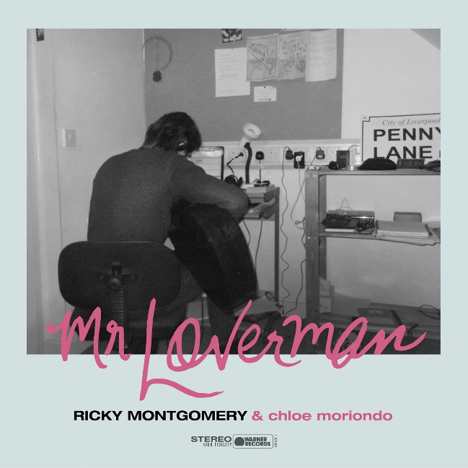
High-res photos + artwork available HERE

###

For more information, contact:
Jaime Rosenberg, Jaime.Rosenberg@warnerrecords.com
Ceri Roberts, Ceri.Roberts@warnerrecords.com

Press Materials:
press.warnerrecords.com/rickymontgomery

Follow Ricky Montgomery:
INSTAGRAM | TWITTER | YOUTUBE | TIKTOK

Follow chloe moriondo:
WEBSITE | INSTAGRAM | TWITTER | YOUTUBE | FACEBOOK

