RICKY MONTGOMERY DROPS NOSTALGIC EP
IT’S 2016 SOMEWHERE + "SETTLE DOWN" VIDEO

LISTEN TO IT’S 2016 SOMEWHERE EP HERE
WATCH “SETTLE DOWN” HERE

NEARLY SOLD-OUT HEADLINE TOUR KICKS OFF ON APRIL 26TH

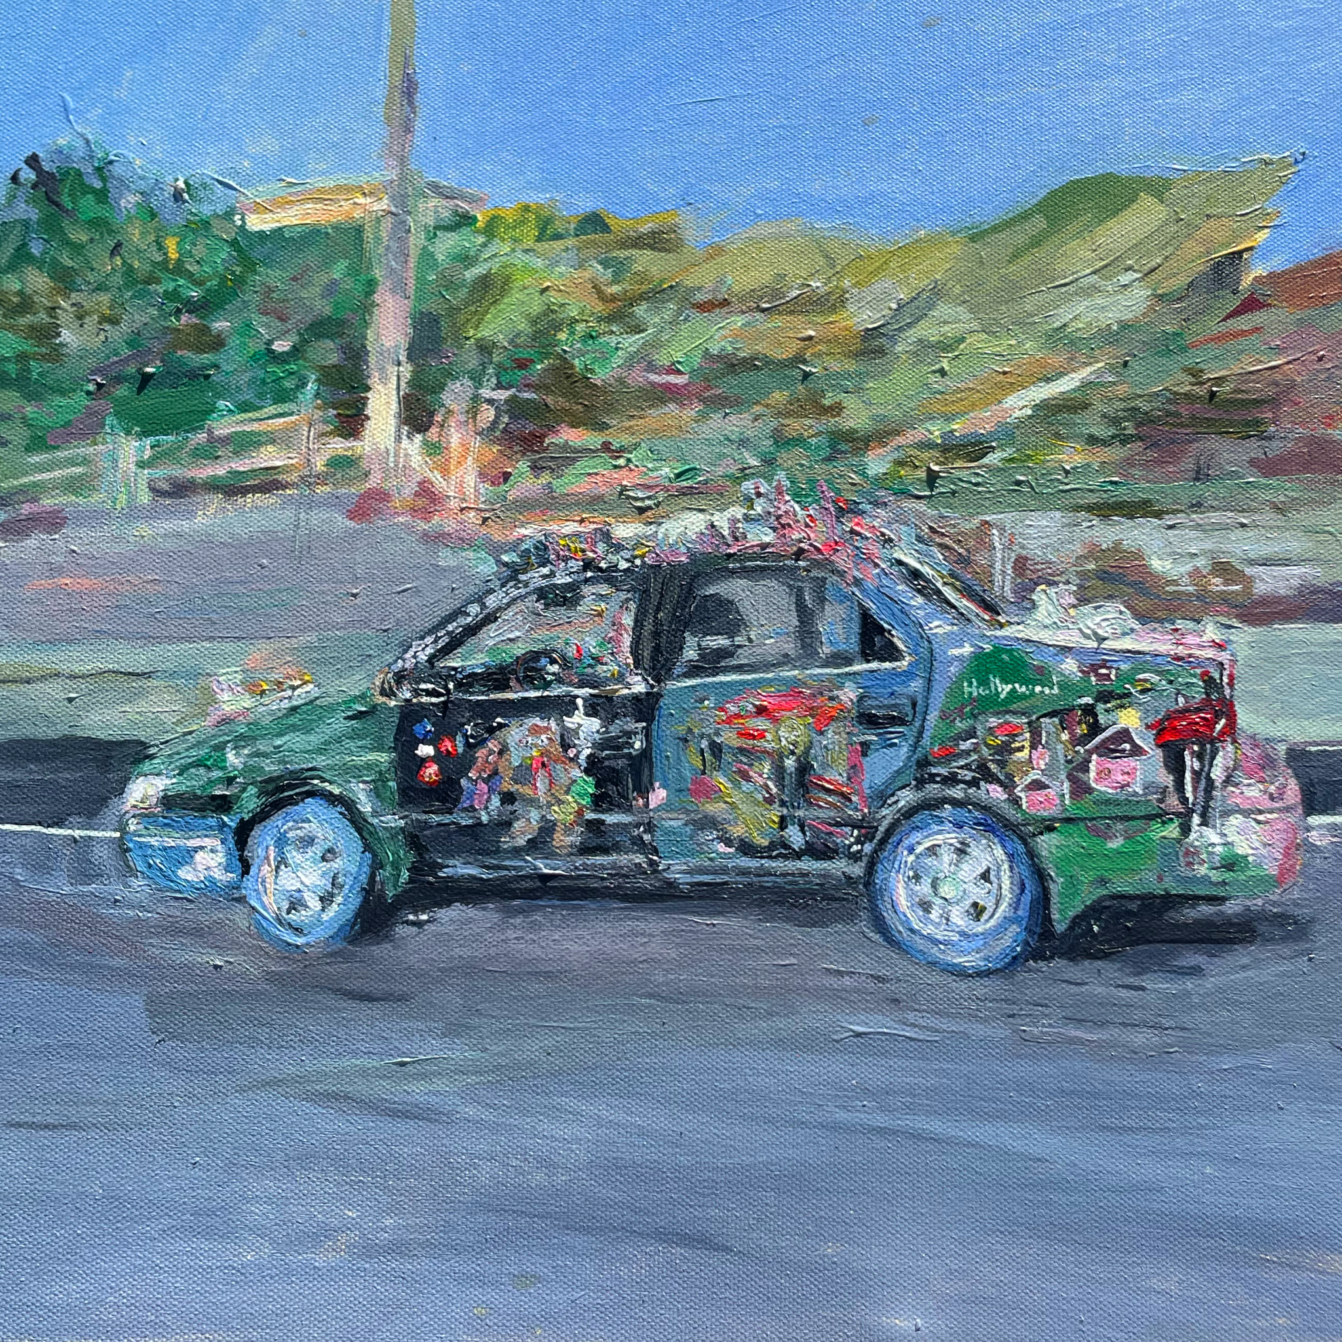

April 15, 2022 (Los Angeles, CA) – On his way to reaching a billion global streams, indie-pop artist Ricky Montgomery shares his playful, deeply personal It’s 2016 Somewhere EP today on Warner Records, closing a major chapter of his life since becoming a viral sensation with hit singles “Mr. Loverman” and “Line Without a Hook.” The nostalgic 7-track set includes an acoustic version of “Mr. Loverman,” plus previously released singles “Talk To You” and “Sorry For Me,” as well as new track “Settle Down,” which comes alongside a hijinks-filled video. Listen to the EP HERE and watch the “Settle Down” video HERE.

In 2016, at age 22, Ricky released Montgomery Ricky, featuring “Mr. Loverman” and “Line Without a Hook.” But it wasn’t until four years later that the songs began to hit. They have now been certified RIAA Gold and taken Ricky to close to 1 billion global streams, thanks in part to his rapidly growing 1.4 million followers on TikTok. He’s also now selling out massive tours across the U.S., with another nearly sold-out tour kicking off April 26th – see a full list of dates below.

“It’s 2016 Somewhere is a reflection on my career since having my viral TikTok moment, getting signed to a major label, and my life since then,” the singer/songwriter explains. “I haven’t felt like my real self since 2020, so with this final revisit to the past, I’m able to look ahead to what’s to come for me as an artist, and, more importantly, as a person.”

While his songs reflect on painful memories, Montgomery injects them with a sunny, often sardonic urgency. The breezy “Talk to You” may come off like a sugary love song, but its real inspiration was fueled by the grief of his dad’s death. On strings-soaked ballad “Sorry for Me,” he channels another traumatic moment, the day his (now) ex-stepfather was arrested.

Meanwhile, power-pop bop “Settle Down” has him questioning a different type of relationship: “I can’t see why you won’t move to L.A. / You only call me when you’re angry / I don’t think this is gonna take,” he croons. The song’s accompanying video takes that first line to heart as he reveals his first true love—his native Los Angeles—where he sings from the rooftops and picks up strangers in a beat-up car decked-out in dolls.

The EP closes on a more subdued note, with two of his oldest tracks—“Mr. Loverman” and “I Don’t Love You Anymore”—both slowed and stripped down, rendering them even more devastating than their originals. They serve as fitting elegies to Montgomery’s past. Now, his future looks brighter and busier than ever as he gears up for a nearly sold-out U.S. headlining tour, starting April 26. Check out the full confirmed itinerary below.

IT’S 2016 SOMEWHERE EP TRACKLIST:
1. Intro
2. Talk to You
3. Sorry for Me
4. Mom
5. Settle Down
6. Mr. Loverman (Acoustic)
7. I Don’t Love You Anymore (Acoustic)

TOUR DATES:
4/26: HiFi (Dallas, TX)
4/27: Antone’s (Austin, TX) SOLD OUT
4/28: White Oak Music Hall downstairs (Houston, TX)
4/30: The Abbey (Orlando, FL) SOLD OUT
5/1: The Loft (Atlanta, CA) SOLD OUT
5/3: Foundry (Philadelphia, PA) SOLD OUT
5/4: Union Stage (Washington, DC) SOLD OUT
5/6: Irving Plaza (New York, NY) SOLD OUT
5/7: Sinclair (Cambridge, MA) SOLD OUT
5/9: Le Ministere (Montreal, QC) SOLD OUT
5/10: Velvet Underground (Toronto, ON) SOLD OUT
5/12: Delmar Hall (St. Louis, MO) SOLD OUT
5/13: House of Blues (Chicago, IL) SOLD OUT
5/15: Fine Line (Minneapolis, MN) SOLD OUT
5/17: Bluebird (Denver, CO) SOLD OUT
5/18: Complex (Salt Lake City, UT) SOLD OUT
5/20: Valley Bar (Phoenix, AZ) SOLD OUT
5/21: HOB Voodoo Room/Main Room (San Diego, CA) SOLD OUT
5/24: Observatory (Santa Ana, CA)
5/26: Hawthorne Theatre (Portland, OR) SOLD OUT
5/27: Neumos (Seattle, WA) SOLD OUT
5/28: Venue (Vancouver, BC) SOLD OUT
5/31: GAMH (San Francisco, CA) SOLD OUT
6/3: El Rey (Los Angeles, CA) SOLD OUT
6/4: El Rey (Los Angeles, CA)

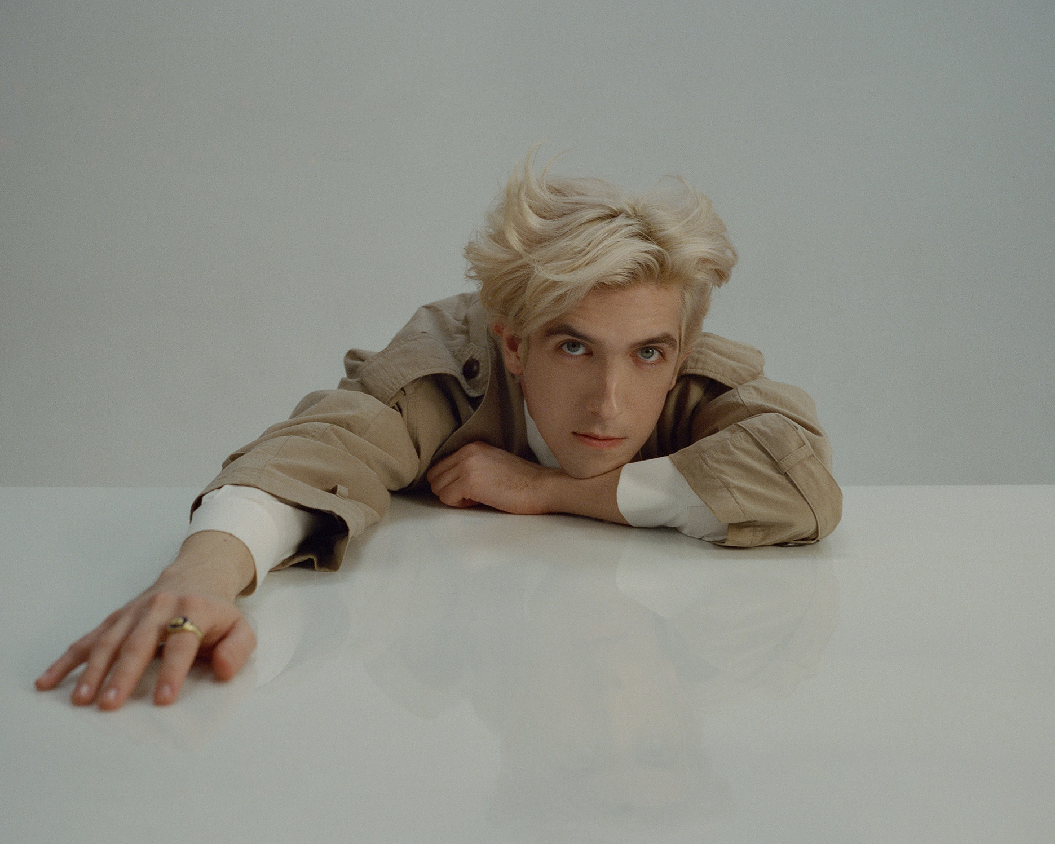

ABOUT RICKY MONTGOMERY:
Ricky Montgomery’s music was ahead of its time—literally. The two once-obscure, yet universal singles—“Line Without A Hook” and “Mr. Loverman”—were suddenly reinvigorated four years after their original release on his 2016 debut album Montgomery Ricky. Ironically, it came just when he was ready to call it quits on a music career entirely after years of nominal wins. The seemingly impossible—yet somehow inevitable— happened: suddenly people were finding solace in his songs. Now, among all the hip-hop hits, the Los Angeles native’s indie-pop has been a balm in the midst of a heavy time, comforting listeners with warm melodies and relatable lyrics. He balances melancholy with a touch of sweet humor and loads of humanity. With a newly-inked deal on Warner Records, Ricky’s using that momentum to prepare for the release of much more music to come. “I just want to create something that can feel as special for other people as it is to me,” he says.
###
For more information, contact:
Ceri Roberts / Ceri.Roberts@warnerrecords.com
Connor Hunt / Connor.Hunt@warnerrecords.com
Patrice Compere / Patrice.Compere@warnerrecords.com

Press Materials:
press.warnerrecords.com/rickymontgomery

Follow Ricky Montgomery:
INSTAGRAM | TWITTER | YOUTUBE | TIKTOK

