Rising Indie-Pop Artist Ricky Montgomery Enlists mxmtoon
for New Version of Viral Hit “Line Without A Hook”
LISTEN HERE

Signs New Deal with Warner Records

February 5, 2021 (Los Angeles, CA) – Rising indie-pop singer/songwriter Ricky Montgomery has enlisted mxmtoon on a new version of his viral breakthrough hit “Line Without A Hook,” marking his debut release on Warner Records. The string-soaked stunner – alongside fellow explosive single “Mr. Loverman” – has catapulted Ricky’s career to new heights since taking off on TikTok in 2020, racking up more than 210M streams so far and 15M streams weekly and landing simultaneously on the Spotify 200 and Spotify Viral 50 charts with over 50 entries worldwide.

Listen to “Line Without A Hook” by Ricky Montgomery & mxmtoon HERE

Ricky explains, "I always thought mxmtoon was such an impressive creative, juggling all of these projects so easily. She brought that same energy to the song. Super communicative, naturally collaborative, and above all just such a kind person. She's a pro, and I feel lucky to have been able to work with her so early in her career."

mxmtoon adds, “I was so excited when Ricky reached out to me. I’ve been listening to his music for ages and have even spent many hours covering his songs, so the opportunity to work together was extremely thrilling! ‘Line Without A Hook’ is such a unique song, and it was a pleasure getting to collaborate with Ricky on trying to maintain the core of the original song while adding a bit of my own spin on parts."

Ricky Montgomery’s music was ahead of its time—literally. The two once-obscure, yet universal singles – “Line Without A Hook” and “Mr. Loverman” – were suddenly reinvigorated four years after their original release on his 2016 debut album Montgomery Ricky. Ironically, it came just when he was ready to call it quits on a music career entirely after years of nominal wins. The seemingly impossible—yet somehow inevitable— happened: suddenly people were finding solace in his songs. Now, among all the hip-hop hits, the Los Angeles native’s indie-pop has been a balm in the midst of a heavy time, comforting listeners with warm melodies and relatable lyrics. He balances melancholy with a touch of sweet humor and loads of humanity. With a newly-inked deal on Warner Records, Ricky’s using that momentum to prepare for the release of much more music to come in 2021 and beyond. “I just want to create something that can feel as special for other people as it is to me,” he says.

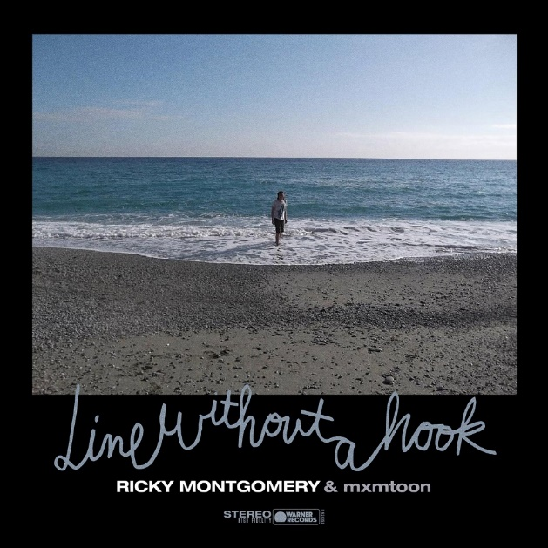
High-res photos + artwork available HERE

###

For more information, contact:
Jaime Rosenberg, Jaime.Rosenberg@warnerrecords.com
Ceri Roberts, Ceri.Roberts@warnerrecords.com

Press Materials:
press.warnerrecords.com/rickymontgomery

Follow Ricky Montgomery:
INSTAGRAM | TWITTER | YOUTUBE | TIKTOK

