EMBARGOED UNTIL THURSDAY 25th MARCH AT 2:15pm ET
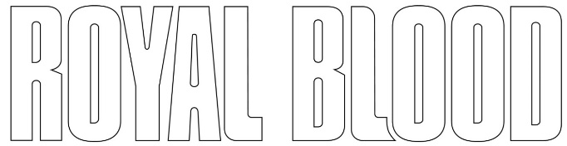
SHARE THE NEW SINGLE “LIMBO”
LISTEN HERE

ROYAL BLOOD WILL PERFORM THE TRACK VIRTUALLY AT THE
2021 BLOXY AWARDS FROM THE NEW ALBUM TYPHOONS WHICH FOLLOWS ON
APRIL 30TH

Click Here For Animated Trailer

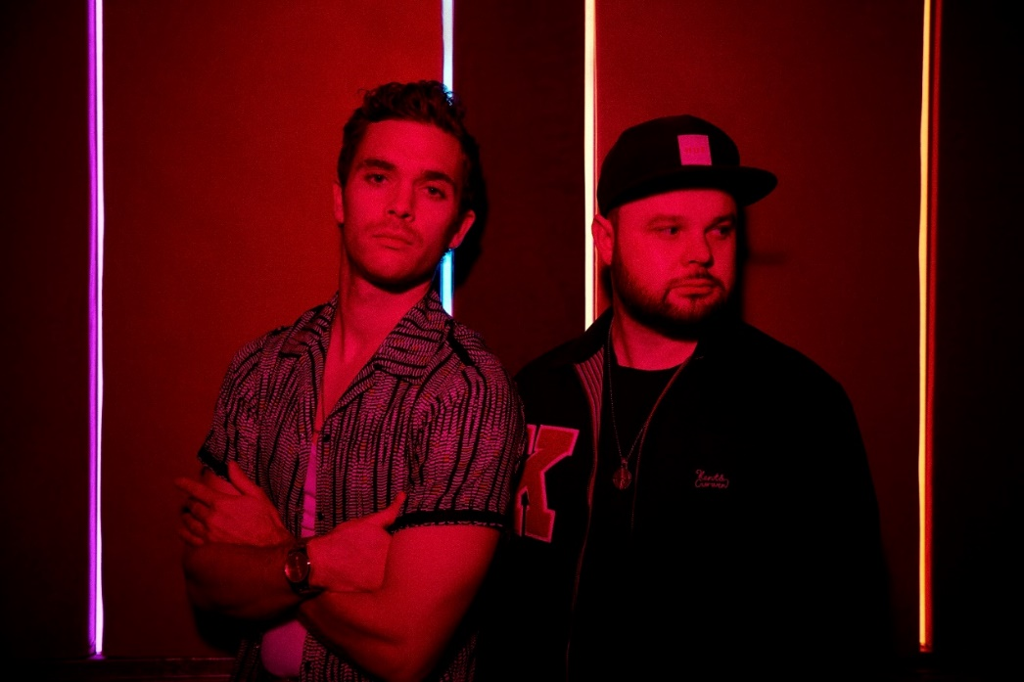
(Download high res photo by Mads Perch here)

March 25, 2021 – (Los Angeles, CA) -- Anticipation for Royal Blood’s forthcoming third album Typhoons continues to build as the duo today share their brand-new single “Limbo” which follows “Trouble’s Coming” and “Typhoons” – both of which were playlisted at Radio 1 in the UK, accumulating over 36 million streams to date. In the US, “Limbo” will surely follow “Trouble’s Coming” to the top the Rock charts. At present, “Typhoons” is the #2 Most Added at Rock Radio upon release. Click here to stream “Limbo.”

The band’s return has been further heralded with “Trouble’s Coming” hitting #1 on US rock radio (their fourth single to achieve that feat) and achieving the highest US alternative radio chart position of their career to date. It has also provided their biggest moment so far in Canada, where it became their first #1 on the Rock chart and remains at #3 after a 24-week run. Royal Blood’s international profile has been further amplified by some high impact playlist covers, including Rock This and NME’s Best New Tracks at Spotify, and Rock Scene at Amazon Music

Arguably the most boundary-pushing moment on the upcoming album, “Limbo” wields the two furthest extremes of the Royal Blood sound into a song that feels absolutely natural. The luminous mirror ball synth that shines from the hook stands out as being a bold step into the unknown, but the tight, battering rhythms of the verses feel like Royal Blood at their most primal. And by the time those two elements coalesce into the song’s powerful finale, it’s apparent that the duo has created something remarkably different while staying true to the band’s roots.

Royal Blood commented, “It is without a doubt the most ambitious and wildest we have allowed ourselves to be and we can’t wait to invite you this far down the rabbit hole with us.”

Royal Blood will perform “Limbo” for the first time when they appear as avatars during a three-song virtual show in a space-themed venue at the 2021 Bloxy Awards. The ceremony, Roblox’s celebration of the passion, talent, and creativity of the globally massive Roblox community of creators and players, will take place at noon PDT on March 27th on the Roblox Platform.

“Limbo,” “Typhoons,” and “Trouble’s Coming” are all provided as instant downloads for fans who pre-order the album here. It will be released on digital, vinyl and CD formats. The Official Royal Blood Store offers a deluxe vinyl edition that will be limited to a one-time run of 8000 copies worldwide. Elsewhere, Amazon and select indie stores will both stock their own exclusive coloured vinyl editions, while HMV will package the standard vinyl with an exclusive art print. A cassette is also available from the official Royal Blood Store. A special Zoetrope vinyl edition issued by Blood Records sold-out all 3000 copies of its one-off pressing in just four hours.

Royal Blood have achieved two UK #1 albums, in the process selling over 2 million albums worldwide with their 2014 double-Platinum self-titled debut album and the similarly successful follow-up, 2017’s How Did We Get So Dark? Their acclaim has included the BRIT Award for “Best British Group” plus further accolades at the NME and Kerrang! Awards as well as a Mercury Prize nomination. What’s more, they’ve made a major international impact, hitting the Top 10 in a further seven territories and peaking at #2 on the US Alternative Album chart. Further US success has included three #1 hits at Rock Radio, plus four Top 20 records at Alternative Radio and commanding critical praise in influential media outlets such as Rolling Stone, Loudwire, Guitar World and many more. With Typhoons, Royal Blood are destined to achieve their greatest heights yet.

# # #

Royal Blood: Mike Kerr (vocals, bass, keys, piano) and Ben Thatcher (drums)

For more information please contact:
Rick Gershon at Warner Records rick.gershon@warnerrecords.com

Follow Royal Blood:
Website | Facebook | YouTube | Twitter | Instagram | Spotify | Apple Music | Press Materials

