CONFIRMED FOR SATURDAY NIGHT LIVE DEBUT PERFORMANCE ON FEBRUARY 16TH WITH HOST
DON CHEADLE

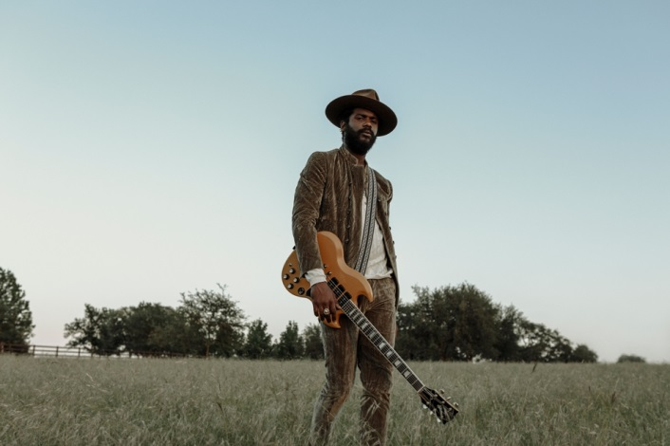
(Photo credit: Frank Maddocks)

February 1, 2019 (Los Angeles, CA) – Grammy Award winner Gary Clark Jr. will make his “SNL” debut as musical guest. Clark’s new Warner Bros. Records album, THIS LAND will be released February 22nd.

Clark’s powerful new single “This Land” is available now. The equally affecting video for track was filmed in Clark’s hometown of Austin and directed by Savanah Leaf. The headline-grabbing short film has already exceeded over one million YouTube views in just a matter of days. Click here to view and share. Click here to purchase and stream “This Land.” Click here to pre-order the album THIS LAND.
All pre-orders will receive and instant download of album track “I Walk Alone,” today. Additional instant Grat tracks to follow and full album digitally delivered on day of release.

Gary Clark Jr. and his family are the face of the recently launched 2019 VARVATOS global media campaign. Click here for further details.
# # #
Contact Rick Gershon Warner Bros. Records Publicity:
818-953-3473 / rick.gershon@wbr.com

Follow Gary Clark Jr.:
Official: garyclarkjr.com
Facebook: facebook.com/GaryClarkJr
Twitter: @GaryClarkJr
YouTube: www.youtube.com/user/garyclarkjr

