SAWEETIE RELEASES HER DEBUT EP HIGH MAINTENANCE ON ICY/ARTISTRY RECORDS/WARNER BROS. RECORDS

PERFORMED AT THE FADER FORT & MORE AT SXSW

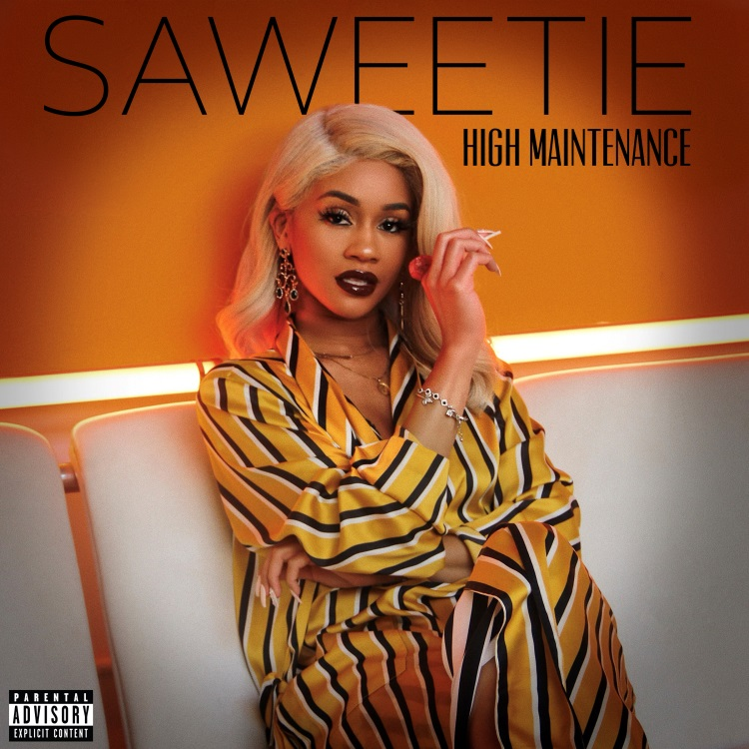

March 16, 2018 (Burbank, CA) – Building on widespread anticipation from fans everywhere, California rapper SAWEETIE uncovers her debut EP High Maintenance today via her own ICY label imprint in partnership with Artistry Worldwide and Warner Bros. Records. Not only does it include the runaway breakout hit “ICY,” but it also boasts a total of eight new bangers from the MC. Get it HERE.

Check out the full track listing below.

Last week, SAWEETIE turned up with a fiery “ANTI” (Freestyle) music video—originally premiered by Rap-Up. Cruising in a classic car, she unloads a barrage of rhyme fury in the grainy seventies-style clip. Prior to the arrival of the EP, she appeared in CR Fashion Book, and VIBE claimed, “The fierce competitor is out to show listeners that women in rap don’t need to follow anyone’s blueprint.” She’s living up to those words!

Featuring production from heavy hitters like Zaytoven and Cash Money AP, High Maintenance properly introduces SAWEETIE. From the infectious energy and deft wordplay of “B.A.N.” to a wavy send-off on the lush and lively “Too Many,” it highlights every facet of this formidable force.

To celebrate High Maintenance’s impact, SAWEETIE took the stage at The FADER Fort and both the Pandora and HipHopDX showcases at SXSW in Austin, TX and brought the house down.

High Maintenance and SAWEETIE are here to stay.

High Maintenance EP Track list:
1. B.A.N.
2. AGUA
3. Good Good
4. Icy Grl
5. High Maintenance
6. 23
7. Respect
8. Too Many

Flaunting nineties rhyme reverence, fashion-forward fire, and endless charisma, SAWEETIE—born Diamonté Harper—can go bar-for-bar with the best of ‘em. Drawing on a passion for poetry and numerous years of rapping in the car, she turned her love for words into vivid verses. Born in Santa Clara and raised in Sacramento, the California native attended USC. Initially, she deferred her rap dreams to achieve a degree in Communications before being discovered at a Downtown Los Angeles Puma event by current manager Max Gousse [Beyoncé, YG, Ty Dolla $ign]. At Artistry Studios, she produced and recorded her 2017 knockout viral smash “ICY GRL.” Driven by a bulletproof flow and one clever line after another, it has racked up more than 18 million YouTube views and over 9 million Spotify streams and soared to #1 onMusical.ly. She also earned the early endorsement of gatekeepers such as Vibe, XXL, HipHopDX, and MTV. With a new partnership with Warner Bros. Records and Artistry Records for her label Icy, she’s rewriting the rule book and breaking the stereotype of the female emcee. Her forthcoming debut EP, features production courtesy of Zaytoven, Hassan, Saweetie, Cash Money AP, and Gousse. As a new CAA signee, she’ll be touring nationally throughout 2018.

