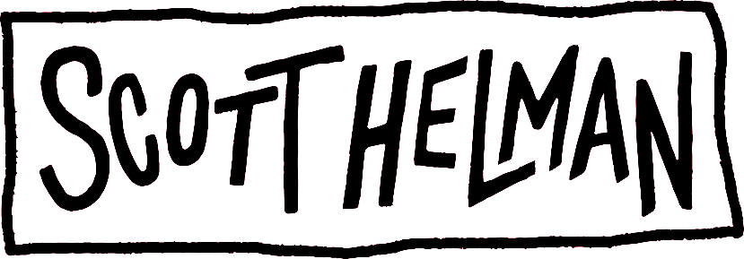

Hi, I’m Scott :)

When I was 15, I put some songs on YouTube and someone at a record label deemed them OK enough to offer me a deal. In a whirlwind 3 years I turned the pressure of my teenage life into an EP titled after a street I was living on in Toronto - Augusta. What happened after was beyond my wildest dreams: people actually liked it.

Since then I’ve put out another album titled after a street I was living on in Montreal - Hotel De Ville – and a 3-song EP titled Hang Ups. These were explorations of my limits, and my abilities as a songwriter.

After some incredible moments – seeing the world, making mistakes, getting my heart broken and finding true love – I got back into the studio and set my sights on creating my best body of work yet.

Then my Papa died. He was my best friend, my biggest fan, and my wisest teacher. It reminded me of what was important: that life is short, precious, and beautiful.

I had a stack of songs, some good, some OK, some bad, and some that made my hair stand on its head from tears or laughter (or both). I picked the best of the bunch, and the ones he would have loved (he was very picky!), and put them together for you to hear. And now the first half of this album series is out everywhere, and it’s named after the park just down the street from his house – Nonsuch Park – where things made sense, jokes made you wheeze, truths were revealed, and love was of highest importance.

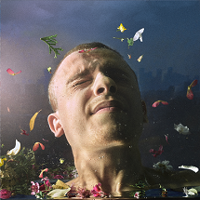
Nonsuch Park (sa)
Available Now
Website | Instagram | Twitter | YouTube | TikTok

