SCOTT HELMAN RELEASES OFFICIAL VIDEO “HANG UPS”

EUROPEAN TOUR WITH VANCE JOY BEGINS TODAY, FOLLOWED BY U.S. HEADLINE TOUR

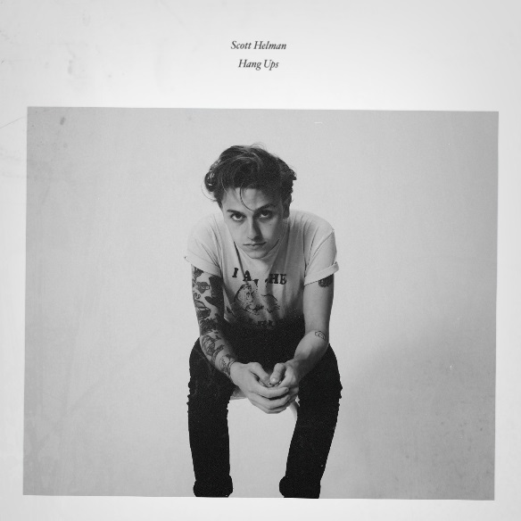

October 26, 2018 (Los Angeles, CA) – Canadian recording artist Scott Helman has released the official video for his latest single, “Hang Ups.” The video was directed by Scott’s longtime collaborator Ben Knetchel and features Scott literally bouncing off the walls. To celebrate, Scott embarks on a European tour with Vance Joy today, followed by a headlining tour in the United States this December. Full itinerary below.

Watch/Share “Hang Ups” Video:
https://youtu.be/gS_Kb6J6IT0

Stream/Download “Hang Ups”
https://scotthelman.lnk.to/SHHangUps

“‘Hang Ups’ was inspired by a FaceTime with my girlfriend which ended in a big fight,” Scott recalls. “Afterwards, I had an intense moment of anxiety, hoping I didn’t do too much damage. As someone with ADHD, I usually have 800 things going on in my brain at once. With the song, wanted to paint a picture of the feeing after a conversation where everything comes out wrong.”

“Hang Ups” along with the song “Dostoevsky,” which come from Scott’s newly released 3-track EP Hang Ups, were recorded earlier this Fall with producer Thomas “Tawgs” Salter who also produced Scott’s debut EP Augusta and fell-length album Hôtel De Ville. The third song, “Lifeguard” was produced by Brian Howes and Jason Van Poederooyen (Mother Mother, Simple Plan, Hinder). All three songs are available to stream or download HERE.

Earlier this summer, Scott Helman joined Vance Joy on five Canadian tour dates. The acts hit it off so well that before the final date, Vance had asked Scott to join him in Europe this fall.

Scott Helman Tour Dates:

With Vance Joy:
10/25 Madrid, ES Teatro Kapitol
10/26 Barcelona, ES Bikini
10/29 Paris, FR Elysee Montmartre
10/30 Brussels, BE La Madeleine
11/02 - 03 Amsterdam, NL Paradiso
11/05 Leipzig, DE Taubchenthal
11/06 Stuttgart, DE Wizemann
11/07 Bochum, DE Zeche
11/09 Zurich, CH Komplex 457
11/10 - 11 Vienna, AT WUK
11/16 – 17 Dublin, IE Olympia Theatre

Headline U.S. dates:
11/30 Boston, MA Café 939
12/01 New York City, NY Rockwood Music Hall Stage 2
12/02 Washington, D.C. Songbyrd
12/04 Cleveland, OH Beachland Tavern
12/05 Pontiac, MI The Pike Room
12/06 Chicago, IL Schubas Tavern
12/08 Buffalo, NY Iron Works

###

For further information, contact:
Jaime Rosenberg / Jaime.Rosenberg@wbr.com

Follow Scott Helman:
Website: www.scotthelmanmusic.com
Facebook: Facebook.com/scotthelmanmusic
Instagram: @ScottHelman
Twitter: @ScottHelman
YouTube: youtube.com/scotthelmanmusic

Press Materials HERE

