**SHAWN WASABI TO APPEAR ON TWITCH.TV’S HIT SHOW**

***ANIMAL TALKING* TONIGHT**

**DEBUT ALBUM *MANGOTALE* AVAILABLE NOW VIA**

**FACET/WARNER RECORDS**

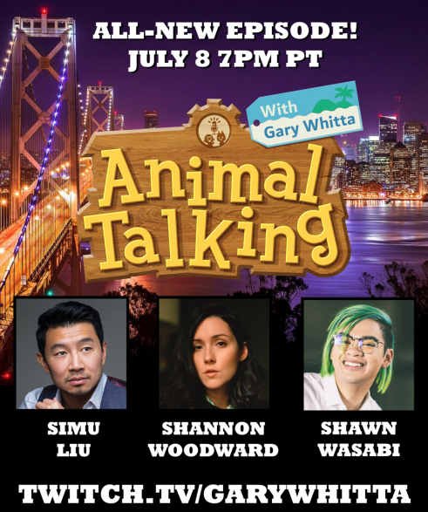

**#AnimalTalking**

**July 8, 2020 (Los Angeles, CA) –** International pop sensation[**Shawn Wasabi**](https://www.shawnwasabi.com/)will mark his virtual TV debut on Twitch TV’s smash hit series ***Animal Talking with Gary Whitta***, tonight at 7:00 PM PT.

Go to: [Twitch.tv/GaryWhitta](https://www.twitch.tv/garywhitta) for details.

Wasabi will join the all-avatar cast of “2020’s hottest talk show” performing [**“Animal Crossing”**](https://www.youtube.com/watch?v=AUE9s4XbT_k) and his current single [**“Lemons (ft. kennedi)”**](https://www.youtube.com/watch?v=0_1MxVlid7s)before taking the couch for a chat with Whitta from his virtual basement studio. Both tracks are featured on Shawn’s acclaimed debut full-length album ***MANGOTALE***, available now on Facet/Warner Records.

Click [**here**](https://shawnwasabi.lnk.to/MANGOTALE)to stream ***MANGOTALE.***

Wasabi explains the story behind ***MANGOTALE***, *“This* *is my first full-length project & I’m incredibly excited for people to listen to it! I produced almost the entire thing on my laptop at home! I’ve changed, developed & grown so much over the last five years - my understanding of the world, of myself & my personality; being disassembled & reassembled; making friends; the people I’ve interacted with & my different musical inspirations/mentors. I feel like this project perfectly expresses that shift while also channeling the energy & emotion I had in those different chapters of my life.* ***MANGOTALE*** *also flexes a lot of my musical range between collaborative pop energy production and weird knob-twiddling audio manipulation sound design.”*

Facet Co-Founder Justin Tranter adds: *“What Wasabi has done on* ***MANGOTALE*** *blows my mind. It’s a high-level production masterpiece grounded by a collection of the most charming joyful songs maybe ever. Just like Shawn himself, the high-level musicianship never comes off as pretentious because he is smiling and laughing the entire time.”*

Wasabi has crafted a versatile collection of polished pop cuts reinforced by an all-female crew of singer-songwriters including **kennedi**, **raychel jay**, **Tia Scola** and more. The 12-track album is the perfect stay-at-home summer soundtrack. Fans and critics have responded with equal excitement:

“Step aside, regular instruments. There’s a new guy in town…Shawn Wasabi’s beat making proceeds to blow everybody’s mind.” – ***Teen Vogue***

[“’Animal](https://nam04.safelinks.protection.outlook.com/?url=https%3A%2F%2Fopen.spotify.com%2Ftrack%2F0qa8whdqO7POYjXqx0Wsrt%3Fsi%3Duc9mI5-rRFO0O6Z3NE_OnA&data=02%7C01%7CRick.Gershon%40warnerrecords.com%7C1c07c1516d194bf9378908d80416cd42%7C8367939002ec4ba1ad3d69da3fdd637e%7C0%7C0%7C637263843311569674&sdata=CJPzS700WC%2Fi1j7yPcsz8V4%2B6ZqG%2Fq3NfqemWVNRKUc%3D&reserved=0) Crossing’ and [‘Lemons’](https://nam04.safelinks.protection.outlook.com/?url=https%3A%2F%2Fopen.spotify.com%2Ftrack%2F08iZ1xoqxBCzoZJjXdZKKa%3Fsi%3DcgOEJu7NRNyuhyvurxZEQA&data=02%7C01%7CRick.Gershon%40warnerrecords.com%7C1c07c1516d194bf9378908d80416cd42%7C8367939002ec4ba1ad3d69da3fdd637e%7C0%7C0%7C637263843311579669&sdata=SAieX8%2FJXPFXcFcb4AP7DaTqwYs0ZeOF42WaspAGFdw%3D&reserved=0) are both bubbly summer anthems.” – ***PAPER***

“Funky beats for those days when you’re happy just because or for when you’re actually, you know, playing Animal Crossing.” – ***Nylon***

“Even if you think you don’t know who Shawn Wasabi is, you’ve probably at the very least seen his hands. Millions of viewers were transfixed by Shawn’s ability to mash-up over 130 of his favorite sounds

into a single performance on an at-the-time never-before-seen 64-button midi-controller…it’s about to be stuck in your head all day.” – ***Uproxx***

Each track on the album is visually represented by a character from **Mango Island**, designed by illustrator Ann Alonso. From princess peach to Marble Tea to Halo Halo, Wasabi has created his own idyllic paradise for fans to explore when they listen to ***MANGOTALE***.

***MANGOTALE* Tracklist:**

1. princess peach

2. HALO HALO (feat. Chevy)

3. LEMONS (feat. kennedi)

4. MEDICINE (feat. Tia Scola)

5. MANGO LOVE (feat. Satica)

6. ANIMAL CROSSING

7. SNACK (feat. raychel jay)

8. MARBLE TEA

9. toyko tea (feat. Spacegirl Gemmy)

10. LOVE POTION (feat. raychel jay)

11. HOME RUN (feat. raychel jay)

12. IGLOO

**Contacts:**

**Rick Gershon** / Warner Records: [Rick.Gershon@warnerrecords.com](mailto:Rick.Gershon@warnerrecords.com)

**Kelsi Ring** / INFAMOUS PR: [kring@infamouspr.com](mailto:kring@infamouspr.com)

**Connect with Shawn Wasabi**

[Facebook](https://www.facebook.com/ShawnWasabi/) | [Instagram](https://www.instagram.com/shawnwasabi/) | [Twitter](https://twitter.com/shawnwasabi) | [Spotify](https://open.spotify.com/artist/1DLKitfb8fshL0DtCecRpY) | [SoundCloud](https://soundcloud.com/sssshawnnnn) | [YouTube](https://www.youtube.com/user/sssShawnnnn/featured)

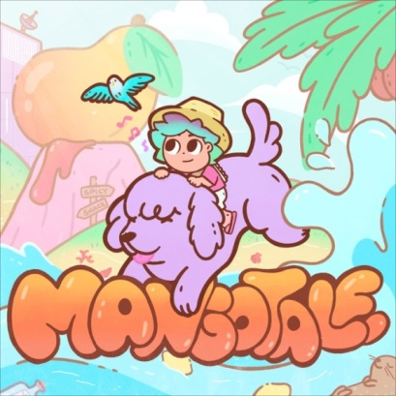

(Click [here](https://press.warnerrecords.com/shawn-wasabi/) for hi-res artwork)

