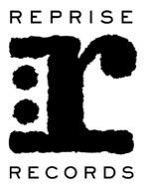
MASTODON’S “STAIRWAY TO NICK JOHN”
RELEASED WORLDWIDE TODAY

MASTODON COVER ICONIC LED ZEPPELIN ANTHEM “STAIRWAY TO HEAVEN” IN HOMAGE TO LATE, LONGTIME MANAGER NICK JOHN WITH PROCEEDS TO BENEFIT HIRSCHBERG FOUNDATION FOR PANCREATIC CANCER RESEARCH

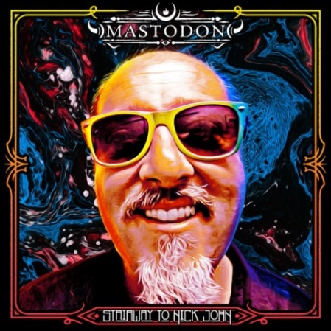

May 17, 2019 (Los Angeles, CA) – Today, Mastodon release their ultimate tribute to longtime manager and close friend Nick John by releasing their version of Led Zeppelins’ iconic “Stairway To Heaven” under the banner of “Stairway To Nick John.”

The original Record Store Day limited edition 10” vinyl pressing of “Stairway To Nick John” sold out instantly. Now, it’s widely available for the first time through all digital retailers and features the studio version on the A-side and a live version on the B-side.

This is a statement from Mastodon: “In early September 2018 we lost one of our closest friends and our biggest fan, our manager Nick John. He was essentially the band’s Dad. From our highest highs to our lowest lows he was always there. Every single move we made went through him first as our trust in him was marrow deep. His favorite band besides us and Gojira, was Led Zeppelin. We were asked to perform “Stairway to Heaven” at his funeral. Afterwards, finding out that someone had recorded it, we figured we should record a studio version and release it on RSD as a tribute to Nick with all the proceeds to be donated to pancreatic cancer research. We would not be the band we are today without the help of Nick John. We miss him dearly and think of him always. We love you buddy!”

Proceeds will benefit the Hirshberg Foundation for Pancreatic Cancer Research. Click here for further information.

On May 28th, Mastodon will begin an extensive U.S. co-headline tour with Coheed And Cambria under the banner of “The Unheavenly Skye Tour.” Each night Mastodon will perform their 2009 groundbreaking album Crack The Skye in its entirety. Tickets are on sale now. For additional ticket information go to: mastodonrocks.com and www.livenationentertainment.com.

# # #

For all Mastodon inquiries, please contact:
National: Rick Gershon at Warner Bros. / Reprise Records
818-953-3473 / rick.gershon@wbr.com
Regional: Bre Flores at Warner Bros. / Reprise Records
818-953-3638 / breanne.flores@wbr.com

Follow Mastodon:
Website: mastodonrocks.com
Facebook: facebook.com/Mastodon
YouTube: youtube.com/mastodonmusic
Twitter: @mastodonmusic
Instagram: @mastodonrocks

Press materials:
http://press.wbr.com/mastodon

