SHAWN WASABI ANNOUNCES THE RELEASE OF HIS DEBUT ALBUM
MANGOTALE OUT TODAY VIA FACET/WARNER RECORDS
Featuring Twelve Tracks and All-Female Vocals From Chevy, kennedi,
raychel jay, Satica, Spacegirl Gemmy and Tia Scola

Click HERE To Stream MANGOTALE
Click HERE To View and Share the “Medicine” Visualizer

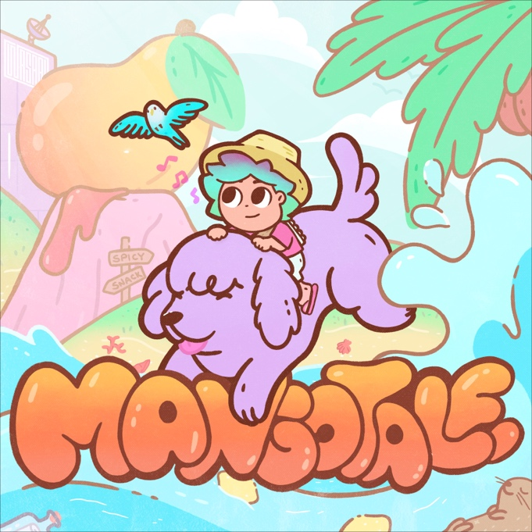
(Click here for hi-res artwork)

May 29, 2020 (Los Angeles, CA) – For the last five years, Shawn Wasabi fans have eagerly awaited a full-length project from the multifaceted artist, creator and weird kid forever. Today, Wasabi brings the world his long-anticipated debut album, MANGOTALE, a body of work that reflects personal growth, musical maturity and this summer’s biggest pop anthems. Out today on Facet/Warner Records, Wasabi has crafted a versatile collection of polished pop cuts reinforced by an all-female crew of singer-songwriters including kennedi, raychel jay, Tia Scola and more. The 12-track album includes today’s new single, “Medicine,” the project is the perfect stay-at-home soundtrack.

Click here to stream MANGOTALE and here to view and share the “Medicine” visualizer.

On the story behind MANGOTALE, Shawn writes: “MANGOTALE is my first full-length project & I’m incredibly excited for people to listen to it! I produced almost the entire thing on my laptop at home! I’ve changed, developed & grown so much over the last five years - my understanding of the world, of myself & my personality; being disassembled & reassembled; making friends; the people I’ve interacted with & my different musical inspirations/mentors. I feel like this project perfectly expresses that shift while also channeling the energy & emotion I had in those different chapters of my life. MANGOTALE also flexes a lot of my musical range between collaborative pop energy production and weird knob-twiddling audio manipulation sound design.”

Facet Co-Founder Justin Tranter adds: “What Wasabi has done on MANGOTALE blows my mind. It’s a high-level production masterpiece grounded by a collection of the most charming joyful songs maybe ever. Just like Shawn himself, the high-level musicianship never comes off as pretentious because he is smiling and laughing the entire time.”

MANGOTALE kicks off with new track “princess peach,” a nostalgic Nintendo-inspired instrumental intro followed by “Halo Halo (ft. Chevy),” a catchy love song about seeing that special someone again after quarantine. Sweet turns to sour with the bitter beloved single “Lemons (ft. kennedi),” followed by a dose of “Medicine (ft. Tia Scola),” a sultry cut about feeling the good kind of sick – love sick. Halfway through the album come two of Wasabi’s biggest releases, the timely and addictive “Animal Crossing” and the flavorful favorite, “Snack.” The boldest in the bunch, “tokyo tea (ft. Spacegirl Gemmy)” fuses elements of future bass with eccentric rap stylings, an ode to Wasabi’s effortless versatility and kitschy electronic sound. Closing out the album, the dream-pop cut “Love Potion (ft. raychel jay)” precedes the playful tongue-in-cheek hit, “Home Run (ft. raychel jay),” finishing with the languid instrumental outro “Igloo,” featuring subdued vocals from Wasabi himself.

Since his record-setting release of “Marble Soda” in 2015, Shawn Wasabi has become the internet’s favorite creative character. Having evolved from a bedroom YouTube sensation to an established pop hitmaker, MANGOTALE is a testament to Wasabi’s respected reputation as a songwriter and unrivaled skills as a producer. The album speaks to Wasabi’s Filipino roots, referencing cultural cornerstones that are at the core of his craft. He also timed the release of MANGOTALE to Asian Pacific American Heritage Month, celebrating his identity by sharing his music with the world.

Each track on the album is visually represented by a character from Mango Island, designed by illustrator Ann Alonso. From princess peach to Marble Tea to Halo Halo, Wasabi has created his own idyllic paradise for fans to explore when they listen to MANGOTALE.

MANGOTALE Tracklist:
1. princess peach
2. HALO HALO (feat. Chevy)
3. LEMONS (feat. kennedi)
4. MEDICINE (feat. Tia Scola)
5. MANGO LOVE (feat. Satica)
6. ANIMAL CROSSING
7. SNACK (feat. raychel jay)
8. MARBLE TEA
9. toyko tea (feat. Spacegirl Gemmy)
10. LOVE POTION (feat. raychel jay)
11. HOME RUN (feat. raychel jay)
12. IGLOO

Connect with Shawn Wasabi
Facebook | Instagram | Twitter | Spotify | SoundCloud | YouTube

# # #
Contacts:
Rick Gershon / Warner Records
Rick.Gershon@warnerrecords.com

Kelsi Ring / INFAMOUS PR
kring@infamouspr.com

