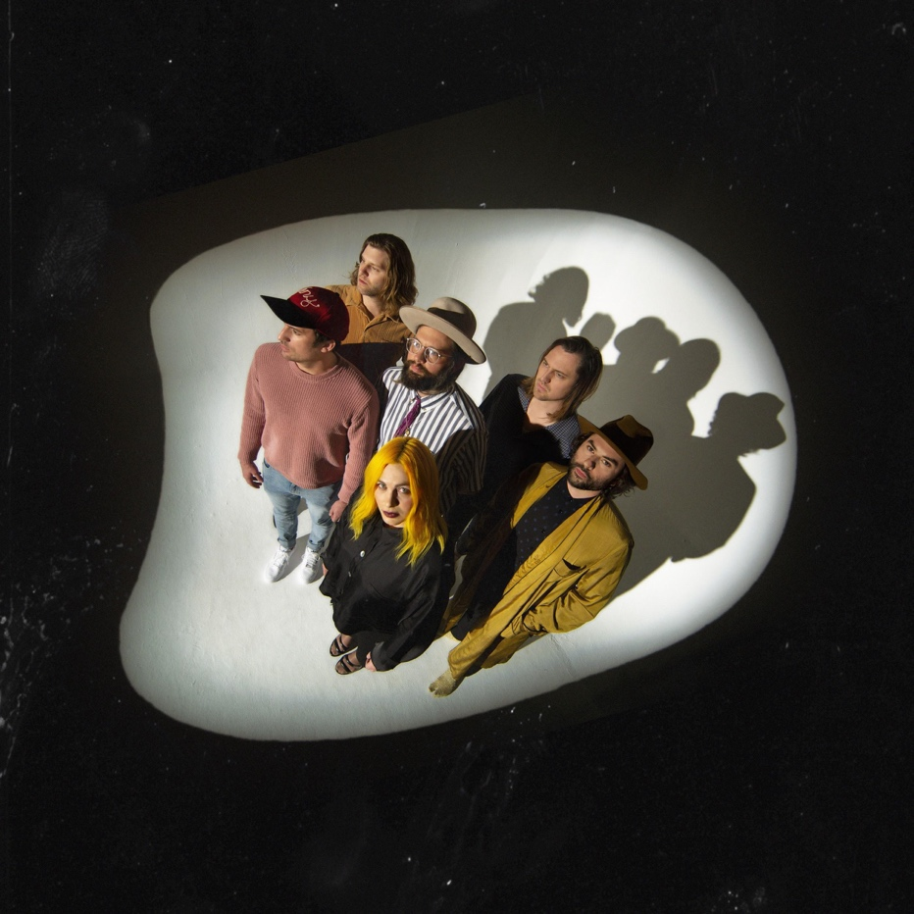

THE HEAD AND THE HEART ANNOUNCE NUGS.TV LIVESTREAM PERFORMANCE FROM
RED ROCKS AMPHITHEATRE JULY 17 & 18

PERFORMING ON JIMMY KIMMEL LIVE! AUGUST 1

July 17, 2019 (Los Angeles, CA) - Earlier this year The Head and The Heart released their newest album Living Mirage on Reprise Records / Warner Records to critical praise. The first single “Missed Connection” quickly rose to #1 at AAA, and is still growing at Alternative, where it currently sits at #2. Since then, The Head and The Heart have been bringing their high energy live show out on the road for a 38-city tour. Tonight the band will perform the first of two shows at the breathtaking and legendary Red Rocks Amphitheatre, while fans at home are able to livestream the epic events via nugs.tv.

In addition, LA-based fans can go to 1iota for a chance to be a part of a live taping of The Head and The Heart’s Jimmy Kimmel Live! performance on the outdoor concert stage Thursday, August 1. Full list of tour dates available below.

About The Head and The Heart
The Head and The Heart returned this spring with their 4th full-length album, Living Mirage, featuring single “Missed Connection.” Initially self-released in 2011, The Head And The Heart’s self-titled breakout debut produced instant classics including “Rivers and Roads,” “Down In The Valley” and “Lost In My Mind” and is now Certified Gold. Their last two albums, 2013’s Let’s Be Still and 2016’s Signs of Light, settled into Billboard’s Top 10 albums chart, with Signs of Light securing the #1 position on Rock Album Charts. It also produced the song “All We Ever Knew” which reached #1 at Alternative, after holding the #1 spot at AAA for 9 straight weeks earlier that same year. They have appeared in Cameron Crowe’s Roadies, with music featured in countless other commercials, films and shows, among them Corona and Silver Linings Playbook. Having played consecutive sold-out Red Rocks shows and prime time mainstage slots at Coachella, Lollapalooza and Austin City Limits on the last campaign, the band have a headlining tour planned for 2019, including another two sold-out Red Rocks shows in July. In total, the band has performed 13 times on national television including appearances on Ellen, The Tonight Show Starring Jimmy Fallon, Austin City Limits and more.

Acclaim for Living Mirage

"Palpitating, genre-fluid." - Billboard

"A bittersweet but upbeat ode to reverie." - Paste Magazine

"“Missed Connection” notably finds the Head and the Heart embracing elements of pop, with light piano and synth stabs floating above swift drums and a chugging bass line." - Rolling Stone

"It’s still a singalong in the same vein as their best music, the band is just more nuanced than ever."
- UPROXX

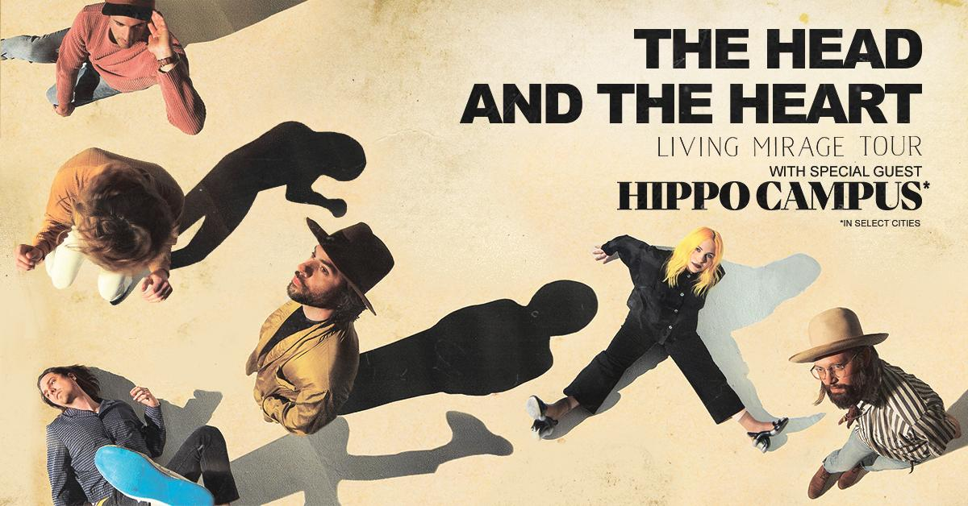

North American Tour Dates:
07/17/19 - Red Rocks Amphitheatre - Denver, CO * +^
07/18/19 - Red Rocks Amphitheatre - Denver, CO * +^
07/19/19 - The Great Saltair - Salt Lake City, UT *
07/22/19 - Comerica Theatre - Phoenix, AZ *
07/23/19 - Santa Barbara Bowl - Santa Barbara, CA *+
07/25/19 - Grand Theatre at The Grand Sierra Resort - Reno, NV *
07/26/19 - Bill Graham Civic Auditorium - San Francisco, CA *
09/06/19 - Murat Theatre at Old National Centre - Indianapolis, IN
09/08/19 - PNC Pavilion at Riverbend Music Center - Cincinnati, OH
09/10/19 - Jacobs Pavilion at Nautica - Cleveland, OH
09/11/19 - 20 Monroe Live - Grand Rapids, MI
09/13/19 - Chicago Theatre - Chicago, IL
09/15/19 - The Sylvee - Madison, WI
09/18/19 - The Armory - Minneapolis, MN
09/19/19 - Stephens Auditorium - Ames, IA
09/21/19 - Pilgrimage Music & Cultural Festival - Franklin, TN +^
09/23/19 - Avondale Brewing Company - Birmingham, AL
09/24/19 - The Fillmore - New Orleans, LA
09/26/19 - Thomas Wolfe Auditorium - Asheville, NC
09/27/19 - The Tabernacle - Atlanta, GA
09/29/19 - Charlotte Metro Credit Union Amphitheatre - Charlotte, NC
10/01/19 - Red Hat Amphitheater - Raleigh, NC
10/03/19 - The Anthem - Washington, DC
10/08/19 - The MET - Philadelphia, PA
10/09/19 - Palace Theatre - Albany, NY
10/11/19 - Toyota Presents Oakdale Theatre - Wallingford, CT
10/12/19 - Agganis Arena - Boston, MA
10/14/19 - UPMC Events Center - Moon Twp., PA
10/15/19 - The Fillmore Detroit presented by Cricket Wireless - Detroit, MI
10/16/19 - Palace Theatre - Columbus, OH
10/18/19 - Algonquin Commons Theatre - Ottawa, ON
10/19/19 - MTELUS - Montreal, QC
10/20/19 - Sony Centre for the Performing Arts - Toronto, ON

*Hippo Campus
+not a Live Nation date
^ tickets purchased for this date will not include the album

For more information about The Head and The Heart, please contact:
Kate Jackson, KateJ@grandstandhq.com
Katie Nelson, KatieN@grandstandhq.com
Bobbie Gale, Bobbie.Gale@warnerrecords.com
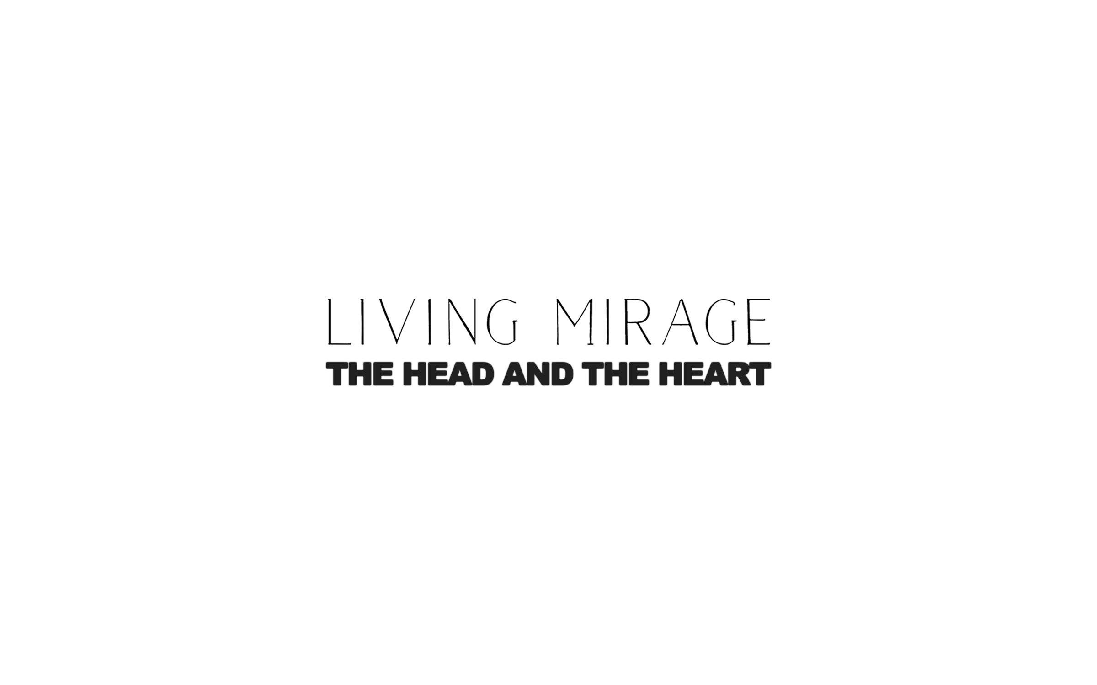

Website / Facebook / Twitter / Instagram / Youtube / Soundcloud

