Every Shade of Blue Album Bio

Now, with some time and perspective, Jonathan Russell feels he finally has a grip on where his band’s been, where it stands and, most importantly, where it’s headed. To hear him tell it, the vocalist/guitarist concludes that The Head And The Heart have finally broken through. Not in terms of creativity or sales numbers or anything of that sort. No, on a personal level. Yes, after 12 years as a band, he says, they’re at last functioning as a cohesive unit. “For a while there, it was almost a bit of a mirage that we were holding our shit together,” the singer-songwriter admits with blunt honesty, invoking the name of the band’s previous album, 2019’s Living Mirage. At the time, having been a band for roughly a decade, “we were sort of on this hamster wheel,” Russell continues. “We loved what we did but we never really had time to slow down and ask ourselves, “Are we doing this how we want to be doing this? Are we talking to one another? Does everyone feel as invested and respected as everyone else in this band?””

While the previous two years have taken so many of our lives to a scary standstill, for the Head And The Heart — a beloved band who has continually redefined itself and forever pushed the boundaries of its sonic creativity — it allowed them the time to slow down, reassess their priorities and look to the future. They engaged in group therapy. They opened themselves up to self-analysis. And, for the first time, they had truly honest and direct conversations with one another… without having to walk onstage immediately afterwards.

“It’s really been about rebuilding and healing and growth,” Russell says proudly of the group’s personal leap forward in recent times. “Just learning boundaries and learning to respect one another and ourselves.” Adds his Head and the Heart bandmate, violinist/guitarist/vocalist Charity Rose Thielen: “We aren’t all the way there quite yet, but we’re definitely the healthiest we’ve ever been.”

Such interpersonal growth has thankfully and excitedly translated to the group’s creative offering: such transparency and understanding, both Russell and Thielen agree, has allowed the Head And The Heart to make some of the boldest music of its already-impressive career. The stunning result is Every Shade of Blue, a wild and thrilling new album out April 29th via Reprise/Warner Records, that Thielen says is in many ways “representative of the diverse voices in the band that are so unique and different and sometimes even opposing.” She proudly calls the 16-track LP a “big swath of artistic expression” — and it’s exactly that: Every Shade of Blue has the unique ability to deftly wind its way along the emotional and musical spectrum, at turns rowdy and raucous while simultaneously delving into the melancholy and even mournful. Above all, it’s undoubtedly the band’s most progressive offering to date.

Russell admits it may have been easier on paper to concoct a “tidy 12-song album” that didn’t test The Head And The Heart’s musical mettle. But having amassed a healthy batch of songs, “I put up my hand and said, “Why don’t we put them all on the record?” he recalls with a laugh. And while, he admits, the result may have led to a tiny sacrifice in the sense of musical cohesion, “It hasn’t been a cohesive two years! We’ve had two presidents, we’ve had a pandemic, we’ve had children being born in the band. There was so much meandering as a narrative it just felt wrong to be like, “Here’s another tidy 12-song record by The Head And The Heart.” This was a wild time and a difficult time and a beautiful time and the album should reflect that.”

Every Shade of Blue was produced by a trio of acclaimed collaborators: GRAMMY-award winning songwriter, producer and engineer Jesse Shatkin (Sia, Pink, The Shins, Tegan and Sara) produced the near-entirety of the album, save for album tracks “Shadows,” “Don’t Show Your Weakness” and “Love We Make” which were produced by Andrew Sarlo (Big Thief, Wet), and “Paradigm,” produced by John Hill and Sammy Witte (Florence + The Machine, Portugal The Man, Cage The Elephant). Working with a diversity of producers, Thielen says, was a natural fit for the band: “Working with people like Jesse and Andrew, who come from these different worlds, feels representative of the different tastes in the band.”

Due to the pandemic, The Head and the Heart — which includes pianist Kenny Hensley, bassist Chris Zasche, drummer Tyler Williams and multi-instrumentalist Matt Gervais —worked remotely for much of the recording of Every Shade of Blue. Each band member had his or her own recording setup, and producers like Sarlo guided them along throughout the process. “It was a completely new frontier for us,” Russell admits, and yet listening to the album, the result is collage of songs that feel equal-parts courageous and comforting.

From the anthemic “Virginia (Wind In The Night),” an ode to Russell’s native state to which he’s recently relocated (“If it was solely up to me, I’d live here for the rest of my life,” he says), to the minimal but momentous “Tiebreaker,” Every Shade of Blue showcases The Head and the Heart’s unique ability to dip its toes into a variety of musical genres. It’s the band’s knack for supreme melody, however, that remains a constant. And it’s why many of the songs on Every Shade of Blue, including the slow-rolling title track, “Every Shade of Blue,” which Russell says has “a Sinatra vibe,” are undeniable pop-radio missiles. The band’s ability to create music that appeals to listeners’ common denominator, Russell says, is something he not only won’t shy away from but is immensely proud of. “Because,” he says, “ultimately, if that soccer mom picking her kids up on the way home from work is bopping her head along to one of our songs, and the kids are digging it too, then you’re welcome!”

Now The Head And The Heart is eager to bring their new songs to the stage: after more than two years away from the road, Thielen admits “it’s going to be a bit surreal at first” to be back performing live for fans. But seeing as she feels “it can be a really spiritual and powerful thing,” she’s unabashedly excited for it to all to come to fruition.

“I almost see this as a second-chance,” Russell says of what the future holds for The Head and the Heart. “It’s like, “Let’s make sure we really show what we went through and who we are and what we’re made of.””

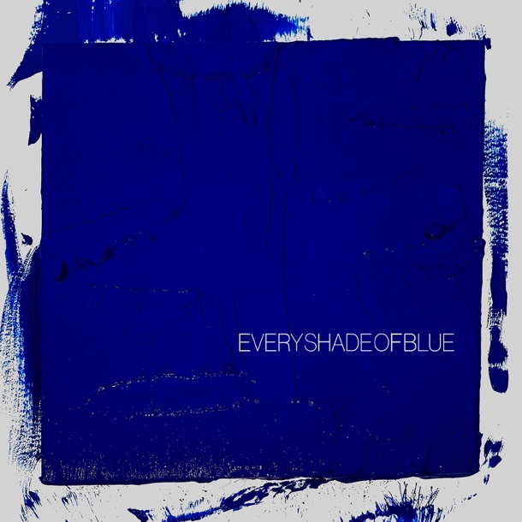

Contacts:
Rick Gershon Rick.Gershon@warnerrecords.com
Jenny Huynh Jenny.Huynh@warnerrecords.com

Follow The Head And The Heart:
Website / Instagram / Twitter / TikTok / Facebook

