THE HEAD AND THE HEART
FIFTH STUDIO ALBUM EVERY SHADE OF BLUE
OUT TODAY VIA WARNER RECORDS
STREAM THE ALBUM HERE

NORTH AMERICAN TOUR KICKS OFF NEXT MONTH

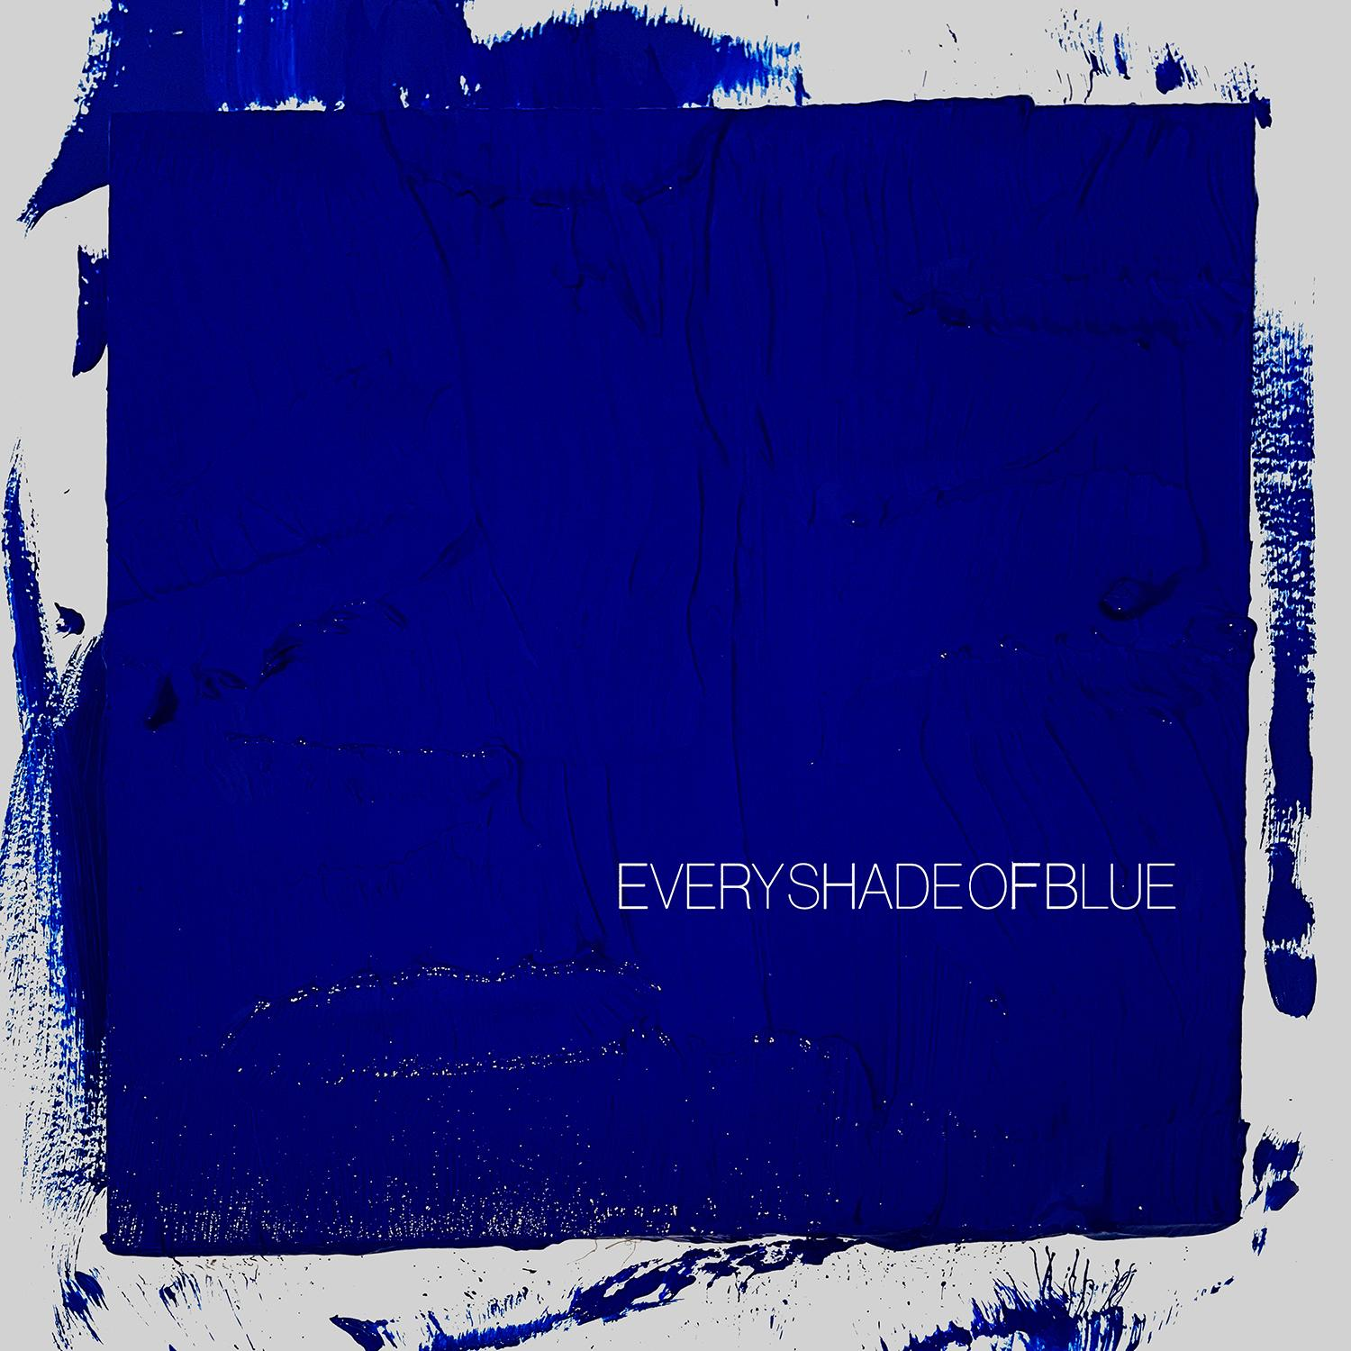
(Download high-res album art here)

April 29, 2022 - (Los Angeles, CA) - The Head And The Heart have released their fifth studio album Every Shade of Blue on Reprise/Warner Records. It is available to stream/purchase here.

Of the album, Charity Rose Thielen wrote:

“The past few years have been nothing if not transitional. The people we were at the beginning of the pandemic are not the same ones writing this now. Every Shade of Blue is a collection of songs that celebrates the beautiful mess that we were during this time of transformation. For us it represents that constant dance between the head and the heart, the push and pull of different ideas and voices that add up to be greater than the sum of their parts. It is a record that tries its best to reconcile who we once were with who we are now and hope one day to become.”

The band has launched a physical pre-order for the album on two 12” cobalt blue limited edition vinyl, exclusive to their webstore, which includes three bonus tracks exclusive to vinyl HERE, and on CD, HERE.

The Head And The Heart are also excited to announce that they will perform songs from the new album on Jimmy Kimmel Live! next Wednesday, May 4. Last month, the band returned to the The Tonight Show Starring Jimmy Fallon studios to perform their singles album title-track "Every Shade of Blue" and "Virginia (Wind In The Night)." Watch the performances below:

“Virginia (Wind In The Night)” continues to climb at Alternative radio from #24 to #20 this week and after two weeks at #1 at Triple A Radio. Additionally, “Every Shade of Blue” has over 3.9 million US streams.

While the previous two years have taken so many of our lives to a scary standstill, for The Head And The Heart — a beloved band who has continually redefined itself and forever pushed the boundaries of its sonic creativity — it allowed them the time to slow down, reassess their priorities and look to the future. They engaged in group therapy. They opened themselves up to self-analysis. And, for the first time, they had truly honest and direct conversations with one another… without having to walk onstage immediately afterwards.

“It’s really been about rebuilding and healing and growth,” Russell says proudly of the group’s personal leap forward in recent times. “Just learning boundaries and learning to respect one another and ourselves.” Adds his Head and the Heart bandmate, violinist/guitarist/vocalist Charity Rose Thielen: “We aren’t all the way there quite yet, but we’re definitely the healthiest we’ve ever been.”

Such interpersonal growth has thankfully and excitedly translated to the group’s creative offering: such transparency and understanding, both Russell and Thielen agree, has allowed the Head And The Heart to make some of the boldest music of its already-impressive career. The stunning result is Every Shade of Blue, that Thielen says is in many ways “representative of the diverse voices in the band that are so unique and different and sometimes even opposing.” She proudly calls the 16-track LP a “big swath of artistic expression” — and it’s exactly that: Every Shade of Blue has the unique ability to deftly wind its way along the emotional and musical spectrum, at turns rowdy and raucous while simultaneously delving into the melancholy and even mournful. Above all, it’s undoubtedly the band’s most progressive offering to date.

Russell admits it may have been easier on paper to concoct a “tidy 12-song album” that didn’t test The Head And The Heart’s musical mettle. But having amassed a healthy batch of songs, “I put up my hand and said, “Why don’t we put them all on the record?” he recalls with a laugh. And while, he admits, the result may have led to a tiny sacrifice in the sense of musical cohesion, “It hasn’t been a cohesive two years! We’ve had two presidents, we’ve had a pandemic, we’ve had children being born in the band. There was so much meandering as a narrative it just felt wrong to be like, “Here’s another tidy 12-song record by The Head And The Heart.” This was a wild time and a difficult time and a beautiful time and the album should reflect that.”

Every Shade of Blue was produced by a trio of acclaimed collaborators: GRAMMY-award winning songwriter, producer and engineer Jesse Shatkin (Sia, Pink, The Shins, Tegan and Sara) produced the near-entirety of the album, save for album tracks “Shadows,” “Don’t Show Your Weakness” and “Love We Make” which were produced by Andrew Sarlo (Big Thief, Wet), and “Paradigm,” produced by John Hill and Sammy Witte (Florence + The Machine, Portugal The Man, Cage The Elephant). Working with a diversity of producers, Thielen says, was a natural fit for the band: “Working with people like Jesse and Andrew, who come from these different worlds, feels representative of the different tastes in the band.”

Due to the pandemic, The Head and the Heart — which includes pianist Kenny Hensley, bassist Chris Zasche, drummer Tyler Williams and multi-instrumentalist Matt Gervais —worked remotely for much of the recording of Every Shade of Blue. Each band member had his or her own recording setup, and producers like Sarlo guided them along throughout the process. “It was a completely new frontier for us,” Russell admits, and yet listening to the album, the result is collage of songs that feel equal-parts courageous and comforting.

The Head And The Heart will set off on the Every Shade of Blue 2022 North American Tour on May 20th with many dates already sold out. Special guests joining the band in select cities include Shakey Graves, Dawes, Jade Bird and Hiss Golden Messenger. Tickets are on sale now.

EARLY ACCLAIM FOR EVERY SHADE OF BLUE:
"On their fifth album, the band rolls from “Virginia (Wind in the Night),” a tantalizing sway of a song residing on the alternative airplay chart, to the string-coated title track, which taps into our pandemic-lockdown realization of the fleeting nature of time (“It’s been a long year, the wrong year, to be left alone”)." - USA Today

"Let the chills wash over you." American Songwriter

"In the Jacqueline Justice-directed video, the band swim, dive around and tread water as they ride the lyric’s emotional waves of wanting to know all the facets of a significant other." - Rolling Stone on “Every Shade of Blue”

"This bittersweet track showcases the band playing to their strengths: a sturdy piano sound garnished with strings and perfectly paired with Jonathan Russell’s evocative lyrics." - SPIN on “Virginia (Wind In The Night)”

"An anthemic celebration with a catchy chorus." - Consequence on “Virginia (Wind In The Night)”

<VIRGINIA WIND IN THE NIGHT EMBED: https://www.youtube.com/watch?v=6LS4oKobHp0>

<EVERY SHADE OF BLUE EMBED: https://www.youtube.com/watch?v=YHuEpWXuBb0>

Every Shade of Blue Tracklist:
- Every Shade of Blue
- Tiebreaker
- Paradigm
- Virginia (Wind In The Night)
- Same Hurt
- Hurts (But It Goes Away)
- Don’t Show Your Weakness
- Love We Make
- Starstruck
- Love Me Still
- Shut Up
- Family Man
- Taking My Time (Wrong Woman)
- Enemy Lines
- Shadows
- GTFU

Every Shade Of Blue Tour 2022
5/20/22 - St. Petersburg, FL - Jannus Live *
5/22/22 - Gulf Shores, AL - Hangout Music Festival
5/24/22 - Kansas City, MO - Uptown Theater *
5/25/22 - Milwaukee, WI - Riverside Theater *
5/27/22 - Pittsburgh, PA - STAGE AE *
5/28/22 - Lewiston, NY - Artpark Amphitheater *
5/29/22 - Cleveland, OH - Agora Theatre *
5/31/22 - LaFayette, NY - Beak & Skiff Apple Orchards *
6/1/22 - Northampton, MA - The Pines Theater at Look Park *
6/3/22 - Shelburne, VT - Ben & Jerry's Concerts on the Green at Shelburne Museum * SOLD OUT
6/4/22 - Portland, ME - Thompson's Point *
6/6/22 - New York, NY - Pier 17 - The Rooftop * SOLD OUT
6/7/22 - New York, NY - Pier 17 - The Rooftop *
6/9/22 - Vienna, VA - Wolf Trap *
6/10/22 - Boston, MA - Leader Bank Pavilion *
7/16/22 - Beech Mountain, NC - Beech Mountain Summer Concert Series
8/1/22 - Austin, TX - ACL Live at The Moody Theater ^
8/2/22 - Austin, TX - ACL Live at The Moody Theater ^ SOLD OUT
8/4/22 - Houston, TX - Lawn at White Oak ^
8/5/22 - Dallas, TX - The Pavilion at Toyota Music Factory ^
8/6/22 - Oklahoma City, OK - The Criterion ^
8/8/22 - Salt Lake City, UT - Red Butte Garden ^ SOLD OUT
8/9/22 - Boise, ID - Outlaw Field at the Idaho Botanical Garden ^
8/11/22 - Missoula, MT - KettleHouse Amphitheater ^
8/12/22 - Seattle, WA - Marymoor Park ^ SOLD OUT
8/13/22 - Seattle, WA - Marymoor Park ^
8/16/22 - Portland, OR - McMenamins Edgefield ^
8/18/22 - Santa Barbara, CA - Santa Barbara Bowl ^
8/19/22 - Berkeley, CA - Greek Theatre ^
8/20/22 - Los Angeles, CA - Greek Theatre ^
8/22/22 - San Diego, CA - Humphreys Concerts By The Bay ^ SOLD OUT
8/23/22 - San Diego, CA - Humphreys Concerts By The Bay ^
9/9/22 - Abiquiu, NM - Ladder to the Moon
9/14/22 - Denver, CO - Mission Ballroom &
9/15/22 - Morrison, CO - Red Rocks Amphitheatre & - SOLD OUT
9/17/22 - Richmond, VA - Altria Theater #
9/18/22 - Asbury Park, NJ - Sea.Hear.Now
9/20/22 - Charlotte, NC - Charlotte Metro Credit Union Amphitheatre #
9/21/22 - Wilmington, NC - Live Oak Bank Pavilion at Riverfront Park #
9/22 - 9/25 - Dover, DE - Firefly Festival
9/23/22 - Columbus, OH - KEMBA Live! #
9/27/22 - Toronto, ON - RBC Echo Beach
9/29/22 - Detroit, MI - Oakland University - Meadow Brook Amphitheatre #
9/30/22 - Indianapolis, IN - TCU Amphitheater at White River State Park #
10/1/22 - Chicago, IL - Huntington Bank Pavilion at Northerly Island #
10/3/22 - Madison, WI - The Sylvee #
10/4/22 - Madison, WI - The Sylvee #
10/7/22 - Minneapolis, MN - Armory #
10/8/22 - St. Louis, MO - Saint Louis Music Park #
10/10/22 - Birmingham, AL - Avondale Brewing Company #
10/13/22 - St Augustine, FL - The Saint Augustine Amphitheatre #
10/14/22 - Atlanta, GA - Cadence Bank Amphitheatre at Chastain Park #
10/15/22 - Nashville, TN - Ascend Amphitheater #

* Jade Bird
^ Dawes
# Shakey Graves
& Hiss Golden Messenger

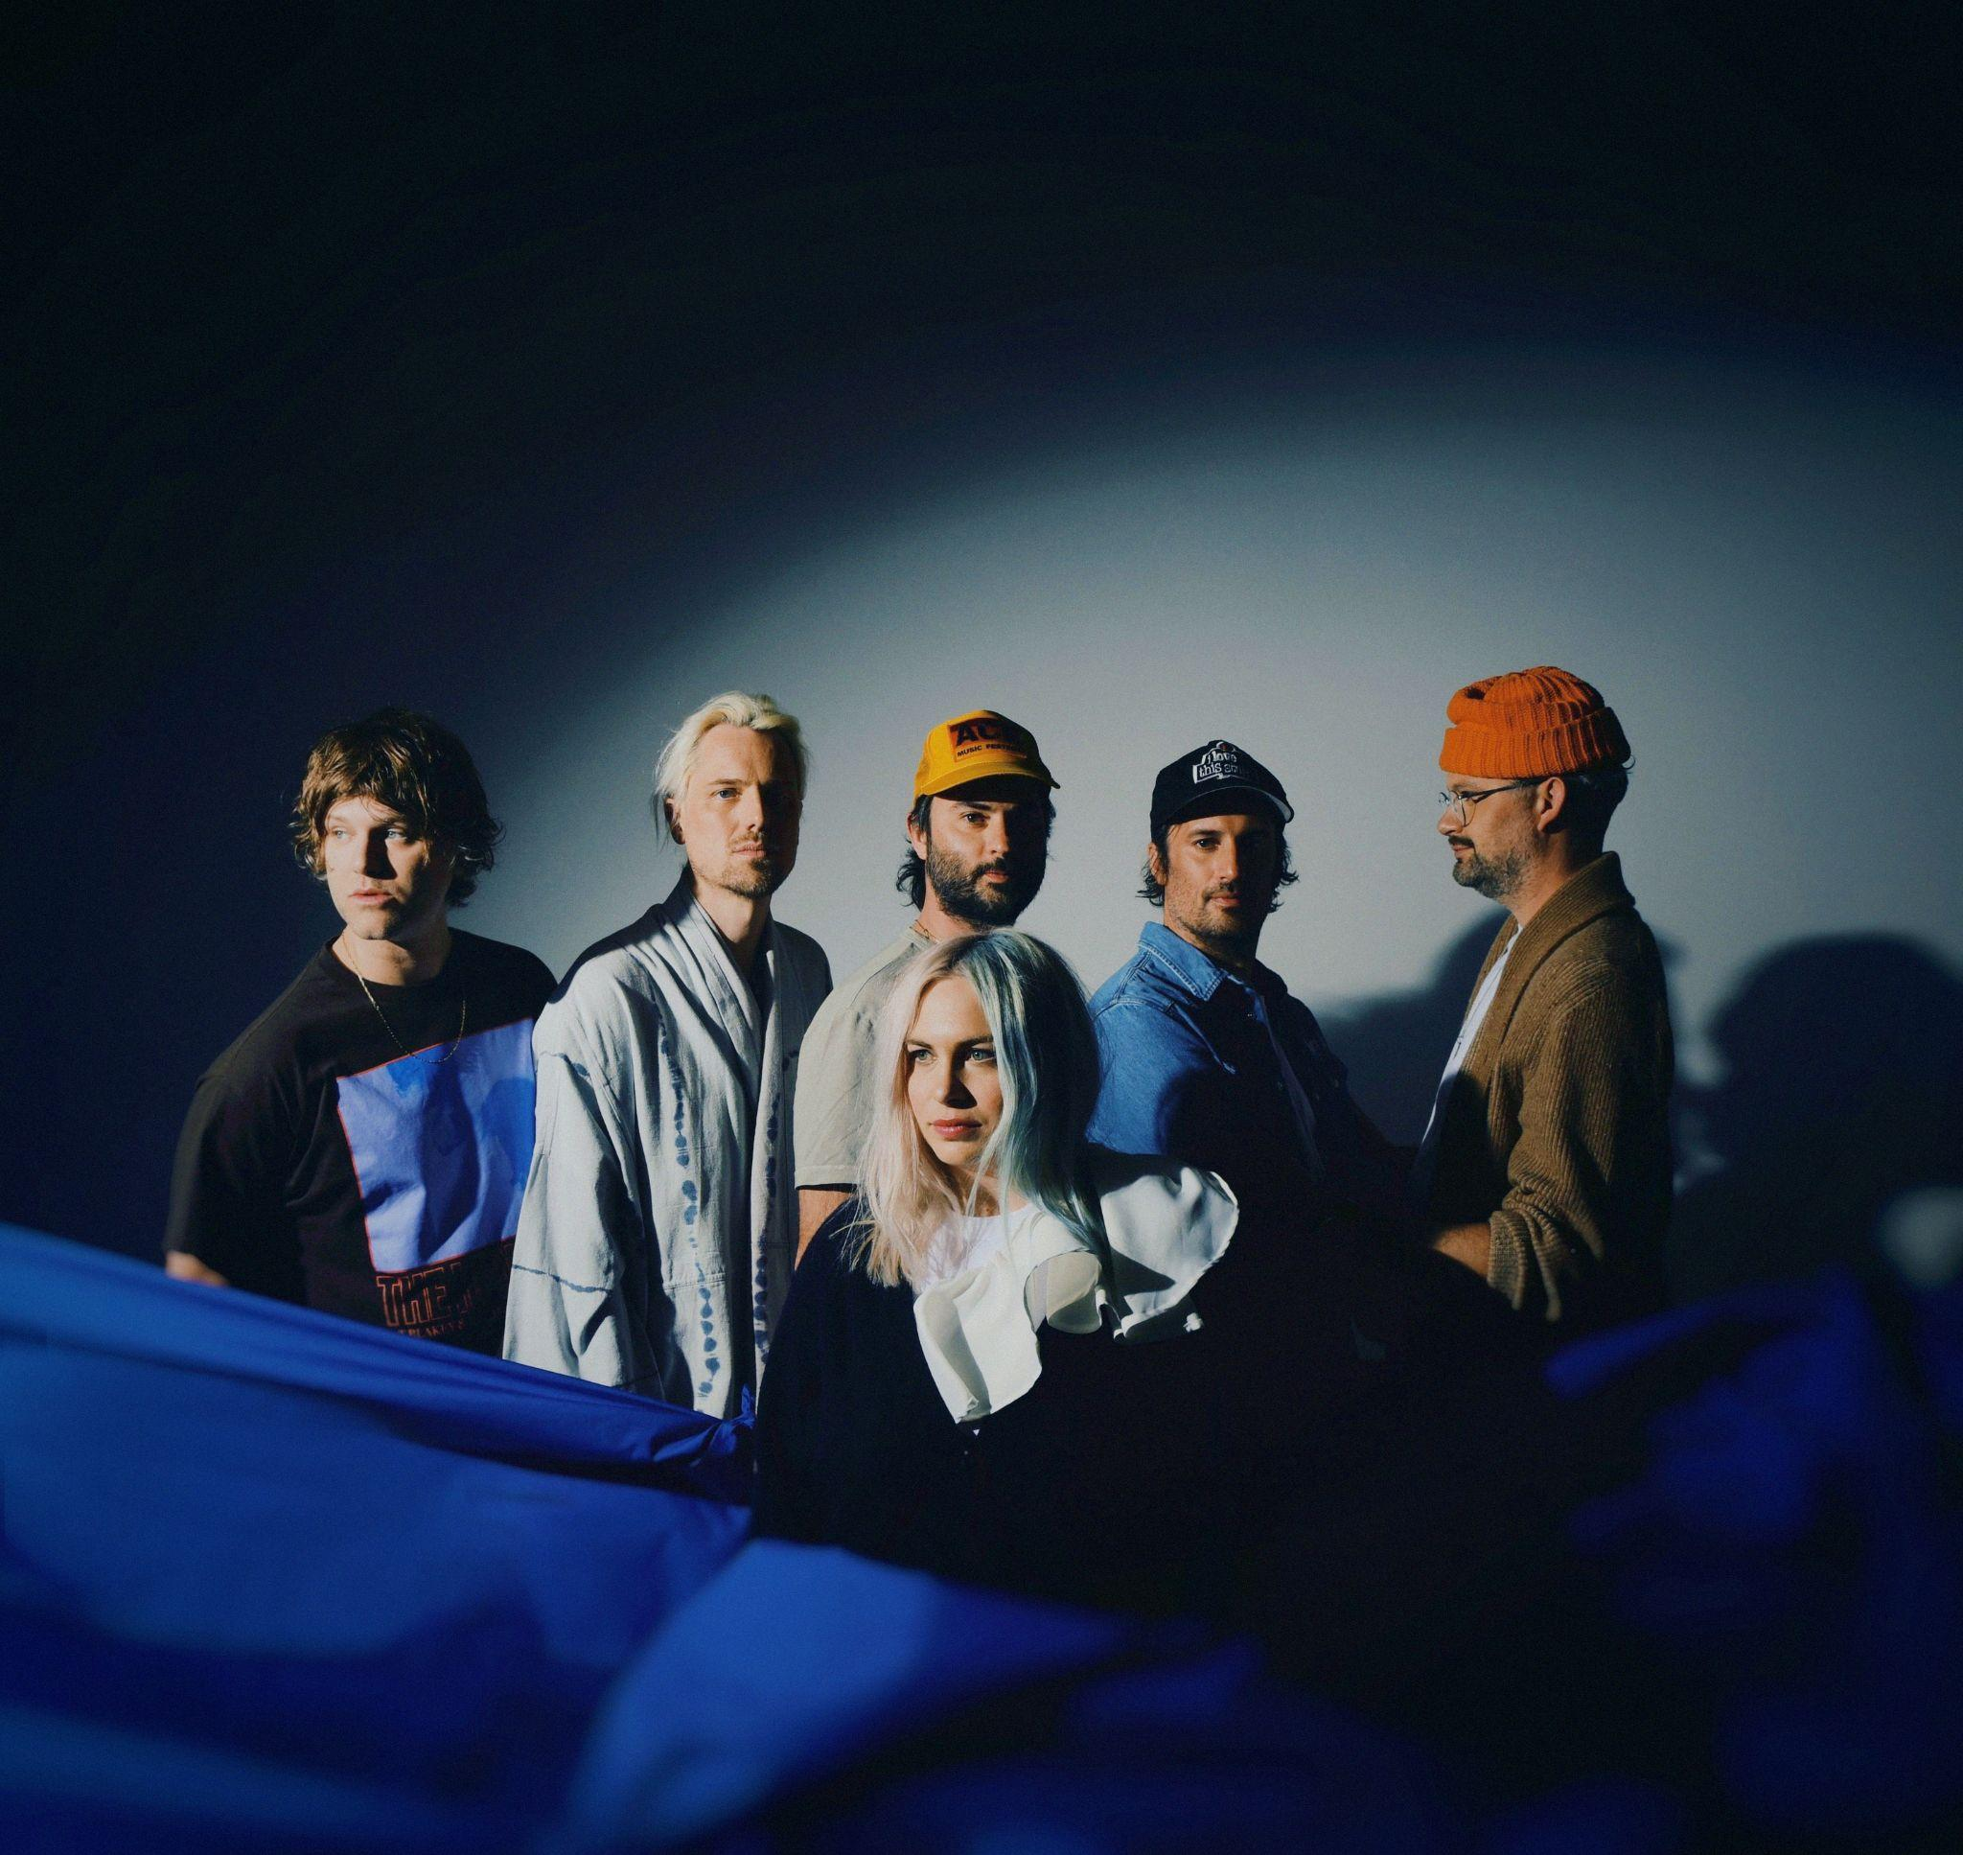
(Photo Credit: Shervin Lainez | high-res here)

About The Head And The Heart:
Initially self-released in 2011, The Head and The Heart’s self-titled breakout debut produced instant classics including “Rivers and Roads,” “Down in the Valley” and “Lost in My Mind” (#1 at AAA) and is now certified Gold. 2013’s Let’s Be Still and 2016’s Signs of Light settled into the top 10 of The Billboard 200 album chart, with Signs of Light securing the #1 position on Rock Album Charts, scoring the band’s first #1 at Alternative radio with “All We Ever Knew” and also holding the #1 spot at AAA for nine straight weeks. The band’s fourth full-length album, Living Mirage, was released to critical praise in 2019. “Missed Connection” reached the #1 position on the Alternative Chart as well as the Mediabase and BDS alternative charts, after having already achieved #1 on the AAA chart. The album’s breakout track, “Honeybee,” became a fan favorite with 153M+ total global streams and 1M+ global weekly streams. The Head and the Heart have appeared in Cameron Crowe’s Roadies, and their music has been featured in countless other commercials, films and TV, among them Corona, Silver Linings Playbook and more. The band is a touring powerhouse, having landed prime-time mainstage slots at Coachella, Lollapalooza and Austin City Limits. The Head and the Heart has performed 15 times on national television, including appearances on Ellen, The Tonight Show Starring Jimmy Fallon, The Late Show With Stephen Colbert, Austin City Limits and more. Every Shade of Blue is the band’s fifth studio album.

Contacts:

Grandstand Media
Kate Jackson katej@grandstandhq.com
Katie Nelson katien@grandstandhq.com

Warner Records
Rick Gershon Rick.Gershon@warnerrecords.com
Jenny Huynh Jenny.Huynh@warnerrecords.com

Follow The Head And The Heart:
Website / Instagram / Twitter / TikTok / Facebook

