The Head and the Heart Release “Honeybee (Live Acoustic)” Song + Video

December 6, 2019 (Los Angeles, CA) - The Head and the Heart have released the song and Kevin Gray directed video for “Honeybee (Live Acoustic),” a stripped down version of the song “Honeybee,” a front runner from the band’s fourth full-length album, Living Mirage, released on Warner Records / Reprise Records to critical praise earlier this year. Generating more than 14,000,000 listens, “Honeybee” is outpacing daily streams of ultimate fan favorite “Rivers and Roads" from their self-titled debut. The Head and the Heart had this to say about the release:

“We wanted to give you all a version of ‘Honeybee’ stripped of everything but vocals, acoustic guitar and piano, the way it was originally written. While on tour this Fall we found a charming old warehouse in Philly and took it over for a recording session with some friends. And we brought a camera crew along to capture the magic...”

“’Honeybee’ really captures the idea of living a life complacent with the familiar - maybe even taking the person closest to you for granted and regretting not expressing your love towards them until it’s too late,” commented Charity. “It’s a concept that connects with all of us and this song, sonically, for the band is intriguingly minimalist. It feels fresh.”

Video Credits:
Director of Photography: Kevin Gray /@kevin.m.gray
Camera Operator: Darby Irrgang / @darbage
1st Assistant Camera: Michael Toland / @michaeltoland
Sound Mixer: Jesse Kennedy / @dj_jessesgirl
Editor/ Colorist: Jonathan Vaders / @jonvaders

Upcoming Tour Dates:
12/06/19 - Golden 1 Center - Sacramento, CA (with The 1975)
12/07/19 - KROQ Almost Acoustic Christmas 2019 @ Honda Center - Anaheim, CA
12/10/19 - 107.7 The End - Deck The Hall Ball 2019 - Seattle, WA
12/12/19 - McMenamin’s Crystal Ballroom - Portland, OR
12/14/19 - Ford Park - Vail, CO
12/16/19 - Belly Up - Aspen, CO
05/15 - 05/17/20 - Hangout Music Festival - Gulf Shores, AL

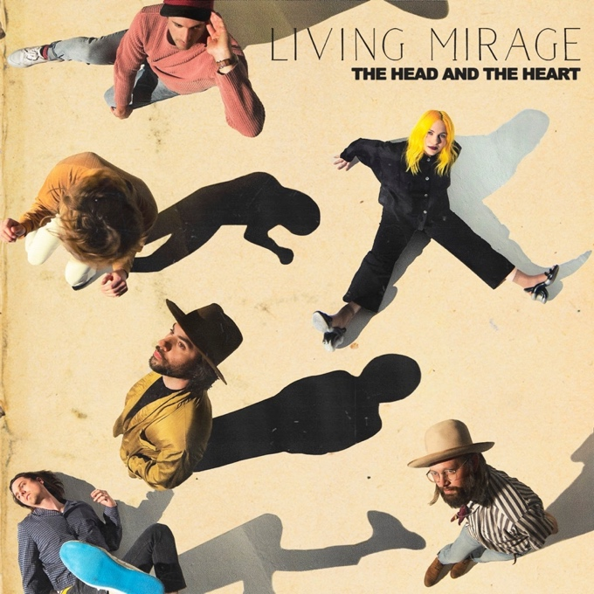

Living Mirage Tracklisting:
01. See You Through My Eyes
02. Missed Connection
03. People Need a Melody
04. Honeybee
05. Brenda
06. Running Through Hell
07. Up Against The Wall
08. Saving Grace
09. I Found Out
10. Living Mirage
11. Glory of Music

BUY / STREAM ALBUM

For more information about The Head and the Heart, please contact:
Kate Jackson, KateJ@grandstandhq.com
Katie Nelson, KatieN@grandstandhq.com

Website / Facebook / Twitter / Instagram / YouTube / Soundcloud

