RELEASE NEW TRACK “VIRGINIA (WIND IN THE NIGHT)” OFF FORTHCOMING ALBUM
EVERY SHADE OF BLUE
OUT APRIL 29, 2022

2022 NORTH AMERICAN TOUR ANNOUNCED
TICKETS ON SALE NOW

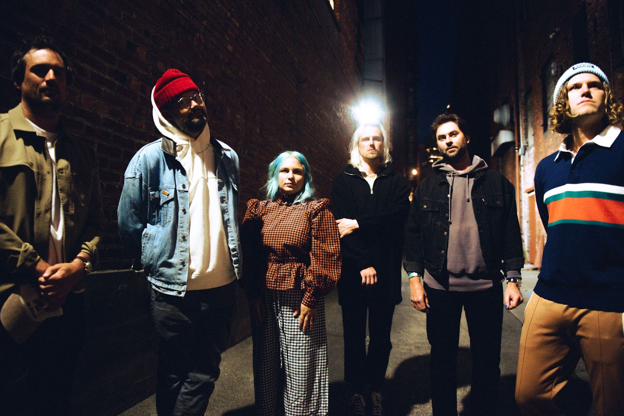
Photo credit: Jacqueline Justice | high-res here

(February 11, 2022) – Los Angeles, CA – The Head And The Heart have revealed “Virginia (Wind In The Night)”, the second released track from their forthcoming fifth studio album Every Shade of Blue out April 29th on Reprise/Warner Records. Listen to “Virginia (Wind In The Night)” HERE.

Jonathan Russell spoke about the inspiration behind the song, saying ​​”Being from Virginia, for me this song represents a long and winding relationship to place - a place that is grounding. I’m often drawing on my life through symbolism as a way into someone else’s psyche. It’s part of my search for a deeper connection without having to compare our experiences directly. There is a reason this song has two titles. One is literal and one is symbolic. Not everyone is from Virginia, I know that. But I bet you have walked home and heard the wind in the night.”

The band previously released the album’s title track and a music video directed by Jacqueline Justice. Rolling Stone described it saying, “the band swim, dive around and tread water as they ride the lyric’s emotional waves of wanting to know all the facets of a significant other." Listen to “Every Shade of Blue” HERE and watch the video HERE. Every Shade of Blue was produced by GRAMMY-award winning songwriter, producer and engineer Jesse Shatkin (Sia, Pink, The Shins, Tegan and Sara) except for album tracks “Shadows”, “Don’t Show Your Weakness” and “Love We Make” which were produced by Andrew Sarlo (Big Thief, Wet), and “Paradigm”, produced by John Hill and Sammy Witte (Florence + The Machine, Portugal The Man, Cage The Elephant), and mastered by Emily Lazar and Chris Allgood at The Lodge, NY.

Last month, The Head And The Heart announced the Every Shade of Blue 2022 North American Tour which kicks off May 20th. Special guests joining the band in select cities include Shakey Graves, Dawes and Jade Bird. Tickets for most shows are on sale now, with the 6/9 Vienna, VA show going on sale on 2/19 and the 8/8 Salt Lake City, UT show going on sale at a later date.

“It’s wild to think that by the time we get back on the road this year, it will have been over 2 and a half years since we last toured,” says the band. “We’re so excited to bring new songs to life on stage every night, traveling alongside artists who inspire us. We can’t wait to get out there, doing what we do with an even greater sense of gratitude.”

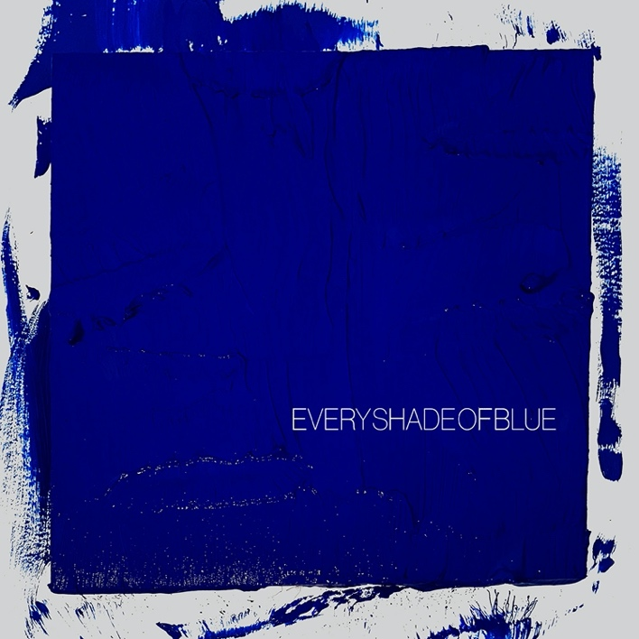
Download high-res album art here

Every Shade of Blue Tracklist:
- Every Shade of Blue
- Tiebreaker
- Paradigm
- Virginia (Wind In The Night)
- Same Hurt
- Hurts (But It Goes Away)
- Don’t Show Your Weakness
- Love We Make
- Starstruck
- Love Me Still
- Shut Up
- Family Man
- Taking My Time (Wrong Woman)
- Enemy Lines
- Shadows
- GTFU

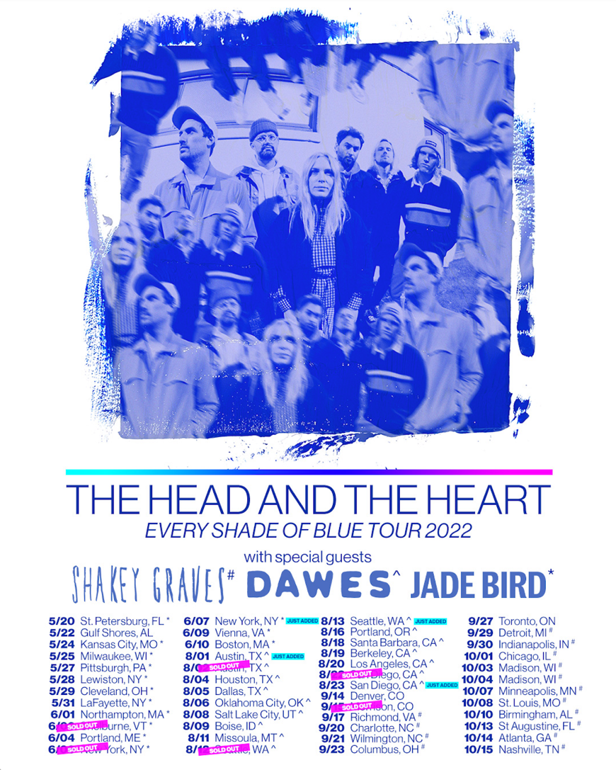

Every Shade Of Blue Tour 2022

Day Date City Venue
Fri 5/20/2022 St. Petersburg, FL Jannus Live *
Sun 5/22/2022 Gulf Shores, AL Hangout Music Festival
Tue 5/24/2022 Kansas City, MO Uptown Theater *
Wed 5/25/2022 Milwaukee, WI Riverside Theater *
Fri 5/27/2022 Pittsburgh, PA STAGE AE *
Sat 5/28/2022 Lewiston, NY Artpark Amphitheater *
Sun 5/29/2022 Cleveland, OH Agora Theatre *
Tue 5/31/2022 LaFayette, NY Beak & Skiff Apple Orchards *
Wed 6/1/2022 Northampton, MA The Pines Theater at Look Park *
Fri 6/3/2022 Shelburne, VT Ben & Jerry's Concerts on the Green at Shelburne Museum * - SOLD OUT
Sat 6/4/2022 Portland, ME Thompson's Point *
Mon 6/6/2022 New York, NY Pier 17 - The Rooftop * - SOLD OUT
Tues 6/7/2022 New York, NY Pier 17 - The Rooftop * - Just added!
Thu 6/9/2022 Vienna, VA Wolf Trap *
Fri 6/10/2022 Boston, MA Leader Bank Pavilion *
Mon 8/1/2022 Austin, TX ACL Live at The Moody Theater ^ - Just added!
Tues 8/2/2022 Austin, TX ACL Live at The Moody Theater ^ - SOLD OUT
Thu 8/4/2022 Houston, TX Lawn at White Oak ^
Fri 8/5/2022 Dallas, TX The Pavilion at Toyota Music Factory ^
Sat 8/6/2022 Oklahoma City, OK The Criterion ^
Mon 8/8/2022 Salt Lake City, UT Venue to be announced at a later date ^
Tue 8/9/2022 Boise, ID Outlaw Field at the Idaho Botanical Garden ^
Thu 8/11/2022 Missoula, MT KettleHouse Amphitheater ^
Fri 8/12/2022 Seattle, WA Marymoor Park ^ - SOLD OUT
Fri 8/13/2022 Seattle, WA Marymoor Park ^ - just added!
Tue 8/16/2022 Portland, OR McMenamins Edgefield ^
Thu 8/18/2022 Santa Barbara, CA Santa Barbara Bowl ^
Fri 8/19/2022 Berkeley, CA Greek Theatre ^
Sat 8/20/2022 Los Angeles, CA Greek Theatre ^
Mon 8/22/2022 San Diego, CA Humphreys Concerts By The Bay ^ - SOLD OUT
Tues 8/23/2022 San Diego, CA Humphreys Concerts By The Bay ^ - Just added!
Wed 9/14/2022 Denver, CO Mission Ballroom
Thu 9/15/2022 Morrison, CO Red Rocks Amphitheatre - SOLD OUT
Sat 9/17/2022 Richmond, VA Altria Theater #
Tue 9/20/2022 Charlotte, NC Charlotte Metro Credit Union Amphitheatre #
Wed 9/21/2022 Wilmington, NC Live Oak Bank Pavilion at Riverfront Park #
Fri 9/23/2022 Columbus, OH KEMBA Live! #
Tue 9/27/2022 Toronto, ON RBC Echo Beach
Thu 9/29/2022 Detroit, MI Oakland University - Meadow Brook Amphitheatre #
Fri 9/30/2022 Indianapolis, IN TCU Amphitheater at White River State Park #
Sat 10/1/2022 Chicago, IL Huntington Bank Pavilion at Northerly Island #
Mon 10/3/2022 Madison, WI The Sylvee #
Tue 10/4/2022 Madison, WI The Sylvee #
Fri 10/7/2022 Minneapolis, MN Armory #
Sat 10/8/2022 St. Louis, MO Saint Louis Music Park #
Mon 10/10/2022 Birmingham, AL Avondale Brewing Company #
Thu 10/13/2022 St Augustine, FL The Saint Augustine Amphitheatre #
Fri 10/14/2022 Atlanta, GA Cadence Bank Amphitheatre at Chastain Park #
Sat 10/15/2022 Nashville, TN Ascend Amphitheater #

* Jade Bird
^ Dawes
# Shakey Graves

More about The Head And The Heart
Initially self-released in 2011, The Head and The Heart’s self-titled breakout debut produced instant classics including “Rivers and Roads,” “Down In The Valley” and “Lost In My Mind” (#1 at AAA) and is now Certified Gold. 2013’s Let’s Be Still and 2016’s Signs of Light, settled into Billboard’s Top 10 albums chart, with Signs of Light securing the #1 position on Rock Album Charts, securing the band’s first #1 at Alternative position with “All We Ever Knew” and also held the #1 spot at AAA for nine straight weeks. The band’s fourth full-length album, Living Mirage, was released to critical praise in 2019. “Missed Connection” which secured the #1 position on the Alternative Chart and #1 at Mediabase and BDS alternative charts, already having achieved #1 on the AAA chart. The album’s breakout track, “Honeybee”, became a fan favorite with 153M+ total global streams and 1M+ global weekly streams. They have appeared in Cameron Crowe’s Roadies, with music featured in countless other commercials, films and TV, among them Corona, Silver Linings Playbook and more. The band has established their status as a touring powerhouse, having landed prime time mainstage slots at Coachella, Lollapalooza and Austin City Limits. In total, the band has performed 15 times on national television including appearances on Ellen, The Tonight Show Starring Jimmy Fallon, The Late Show With Stephen Colbert, Austin City Limits and more. Every Shade of Blue is the band’s fifth studio album.

Contacts:

Grandstand Media
Kate Jackson katej@grandstandhq.com
Katie Nelson katien@grandstandhq.com

Warner Records
Rick Gershon Rick.Gershon@warnerrecords.com
Jenny Huynh Jenny.Huynh@warnerrecords.com

Follow The Head And The Heart:
Website / Instagram / Twitter / TikTok / Facebook

