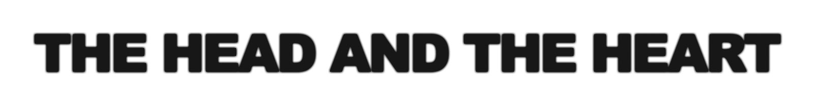
RELEASE NEW SINGLE “PEOPLE NEED A MELODY”

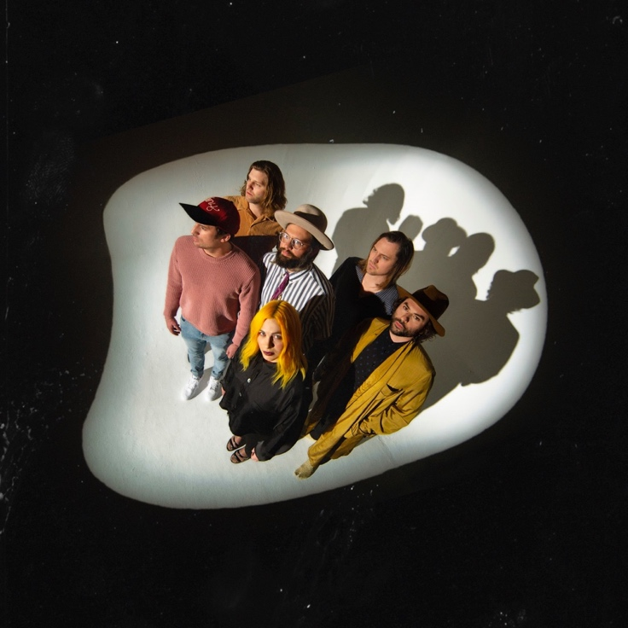
Click here for hi-res

NORTH AMERICAN TOUR ON SALE NOW

LIVING MIRAGE OUT MAY 17th
Album Available To Pre-Order Now

May 3, 2019 (Los Angeles, CA) - The Head And The Heart have shared the stunning “People Need a Melody,” the third track from their forthcoming album Living Mirage out May 17th via Warner Bros. Records / Reprise Records . Listen to the track here.

So pick yourself up kid
I can’t bare the weight
Let the light back in
‘Cause you’ve been walking blind
Now it’s all on you
Don’t you let it fade before your time goes
- “People Need a Melody”

The band will kick off a 38-city tour starting in Buffalo, NY on June 21st, making stops in Austin, Denver, Chicago, Atlanta and more, before wrapping in Toronto, ON October 20th. A full rundown of tour dates can be found below. Special guest Hippo Campus will join the July dates of the tour. Tickets are on sale now via LiveNation.com.

Tickets purchased online for select tour dates (as noted below) includes your choice of a CD or digital copy of the new album, Living Mirage, which will be released on May 17, 2019. Purchasers will receive instructions via email on how to redeem the album after ticket purchase.

Listen to “Honeybee” here.
Watch the video for “Missed Connection” here.

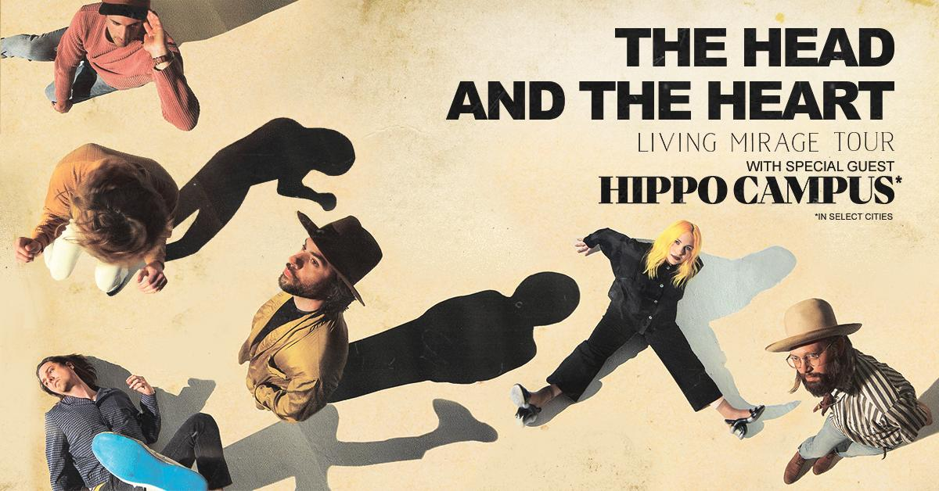

Summer/Fall North American Tour Dates:
06/21/19 - Alternative Buffalo’s Kerfuffle – Canalside – Buffalo, NY +^
06/23/19 - Alt 92.3 Summer Open - Forest Hills Stadium – New York, NY +^
07/05/19 - Summerfest - Milwaukee, WI +^
07/06/19 - Starlight Theatre - Kansas City, MO *
07/07/19 - Stifel Theatre - St. Louis, MO *
07/09/19 - ACL Live at The Moody Theater - Austin, TX *
07/10/19 - ACL Live at The Moody Theater - Austin, TX *
07/12/19 - The Pavilion at Toyota Music Factory - Dallas, TX *
07/13/19 - White Oak Music Hall - Houston, TX *
07/14/19 - Brady Theater - Tulsa, OK
07/17/19 - Red Rocks Amphitheatre - Denver, CO * +^
07/18/19 - Red Rocks Amphitheatre - Denver, CO * +^
07/19/19 - The Great Saltair - Salt Lake City, UT *
07/22/19 - Comerica Theatre - Phoenix, AZ *
07/23/19 - Santa Barbara Bowl - Santa Barbara, CA *+
07/25/19 - Grand Theatre at The Grand Sierra Resort - Reno, NV *
07/26/19 - Bill Graham Civic Auditorium - San Francisco, CA *
09/06/19 - Murat Theatre at Old National Centre - Indianapolis, IN
09/08/19 - PNC Pavilion at Riverbend Music Center - Cincinnati, OH
09/10/19 - Jacobs Pavilion at Nautica - Cleveland, OH
09/11/19 - 20 Monroe Live - Grand Rapids, MI
09/13/19 - Chicago Theatre - Chicago, IL
09/15/19 - The Sylvee - Madison, WI
09/18/19 - The Armory - Minneapolis, MN
09/19/19 - Stephens Auditorium - Ames, IA
09/23/19 - Avondale Brewing Company - Birmingham, AL
09/24/19 - The Fillmore - New Orleans, LA
09/21/19 - Pilgrimage Music & Cultural Festival - Franklin, TN +^
09/26/19 - Thomas Wolfe Auditorium - Asheville, NC
09/27/19 - The Tabernacle - Atlanta, GA
09/29/19 - Charlotte Metro Credit Union Amphitheatre - Charlotte, NC
10/01/19 - Red Hat Amphitheater - Raleigh, NC
10/03/19 - The Anthem - Washington, DC
10/08/19 - The MET - Philadelphia, PA
10/09/19 - Palace Theatre - Albany, NY
10/11/19 - Toyota Presents Oakdale Theatre - Wallingford, CT
10/12/19 - Agganis Arena - Boston, MA
10/14/19 - UPMC Events Center - Moon Twp., PA
10/15/19 - The Fillmore Detroit presented by Cricket Wireless - Detroit, MI
10/16/19 - Palace Theatre - Columbus, OH
10/18/19 - Algonquin Commons Theatre - Ottawa, ON
10/19/19 - MTELUS - Montreal, QC
10/20/19 - Sony Centre for the Performing Arts - Toronto, ON

*Hippo Campus
+not a Live Nation date
^ tickets purchased for this date will not include the album

About The Head and The Heart
The Head and The Heart return this spring with their 4th full-length album, Living Mirage, featuring newly released “Missed Connection”. Initially self-released in 2011, The Head And The Heart’s self-titled breakout debut produced instant classics including “Rivers and Roads”, “Down In The Valley” and “Lost In My Mind” and is now Certified Gold. Their last two albums, 2013’s Let’s Be Still and 2016’s Signs of Light, settled into Billboard’s Top 10 albums chart, with Signs of Light securing the #1 position on Rock Album Charts. It also produced the song “All We Ever Knew” which reached #1 at Alternative, after holding the #1 spot at AAA for 9 straight weeks earlier that same year. They have appeared in Cameron Crowe’s Roadies, with music featured in countless other commercials, films and show, among them Corona and Silver Linings Playbook. Having played consecutive sold-out Red Rocks shows and prime time mainstage slots at Coachella, Lollapalooza and Austin City Limits on the last campaign, the band have a headlining tour planned for 2019, including another two sold-out Red Rocks shows in July. In total, the band has performed 13 times on national television including appearances on Ellen, The Tonight Show With Jimmy Fallon, Austin City Limits and more.

For more information about The Head and The Heart, please contact:
Kate Jackson, KateJ@grandstandhq.com
Katie Nelson, KatieN@grandstandhq.com
Bobbie Gale Bobbie.Gale@wbr.com
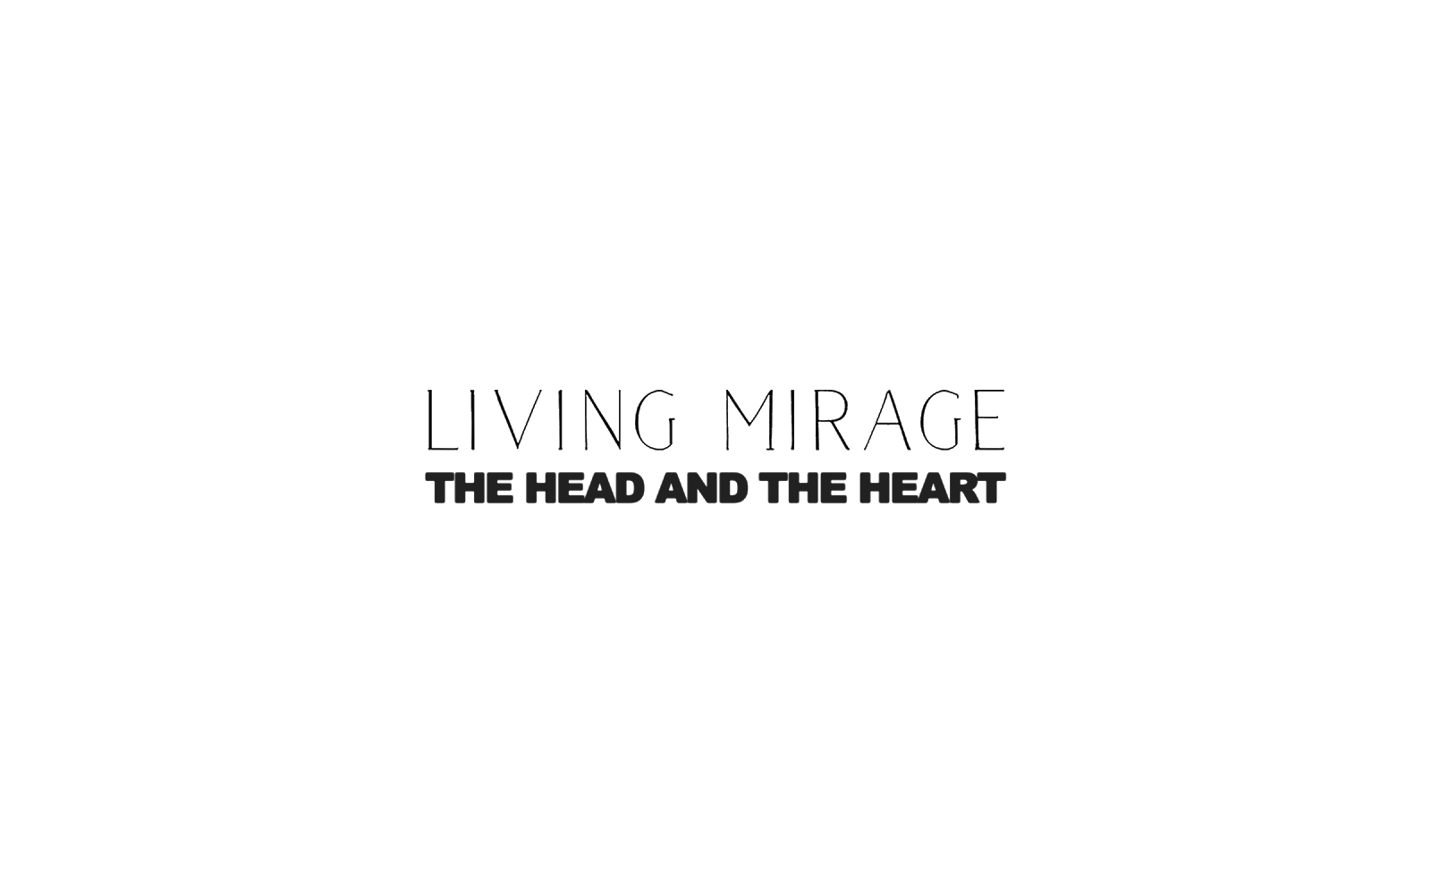

Website / Facebook / Twitter / Instagram / Youtube / Soundcloud

