The Head and the Heart Release Video for
“See You Through My Eyes”

October 17 (Los Angeles, CA) - The Head and the Heart have released the video for “See You Through My Eyes,” off Living Mirage, the band’s fourth full-length album, released on Warner Records / Reprise Records to critical praise earlier this year. The band had this to say about the video:

"See You Through My Eyes" is a song for anyone that needs to be reminded not to judge themselves. We made a video to try to illustrate stripping away the artificial reality of the everyday to get to the core universality of the human species.

“See You Through My Eyes” has been growing steadily at AAA, following on the heels of the breakout single “Missed Connection,” which recently secured multiple weeks at the #1 position on the Mediabase and BDS Alternative Radio Charts. The band is currently wrapping up a North American tour with three remaining date in Canada. List of dates below.

The band has been on the road in support of Living Mirage playing to packed rooms across the country. The Santa Barbara Independent stated, “It’s their heart that continues to capture audiences." The Bay Bridged said "The Head and The Heart put on an incredible show — one can tell from the energy they put forth that they truly enjoy performing their music. The richness of their sound, the depth of meaning to their songs and the mesmerizing stage presence is something to behold.”

“See You Through My Eyes” video credits:
Director: Tamar Levine
Producer: Evan Cholfin
Production Company: Stories International, Inc.

The Head and the Heart North American Tour Dates:

10/18/19 - Algonquin Commons Theatre - Ottawa, ON #
10/19/19 - MTELUS - Montreal, QC #
10/20/19 - Sony Centre for the Performing Arts - Toronto, ON #

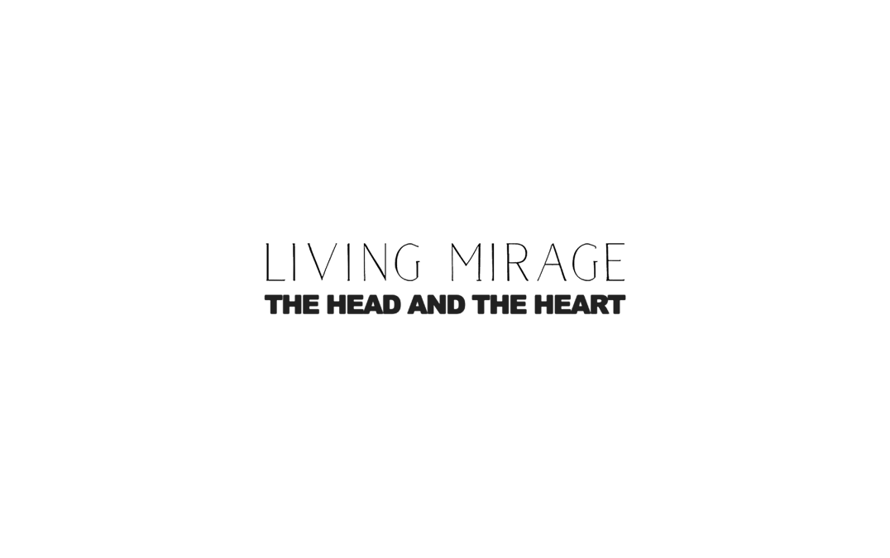

Website / Facebook / Twitter / Instagram / Youtube / Soundcloud

