ANNOUNCE NORTH AMERICAN TOUR

BAND RELEASES SPECIAL LIVESTREAM FROM LAST NIGHT’S INTIMATE BELASCO THEATER SHOW
Streaming NOW via Facebook, Twitter, YouTube & Live Nation

LIVING MIRAGE OUT MAY 17th
New Single “Missed Connection” Available To Download And Stream
Album Available To Pre-Order Now

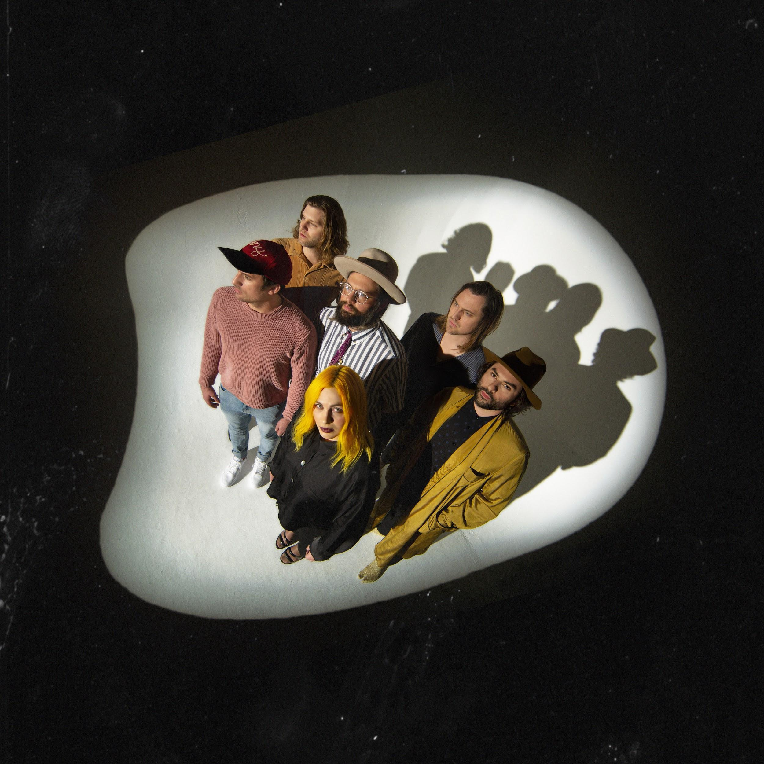
Photo Credit: Alex Currie
March 22, 2019 – (Los Angeles, CA) - The Head And The Heart have announced a North American tour for this spring and fall in support of their newly announced album Living Mirage which will be released on May 17th via Reprise Records / Warner Bros. Records. Produced by Live Nation, the 38-city outing will kick off June 21st in Buffalo, NY and make stops in Austin, Denver, Chicago, Atlanta and more, before wrapping October 20th in Toronto, ON. A full rundown of tour dates can be found below. Special guest Hippo Campus will join the July dates of the tour.

Tickets go on sale to the general public beginning Friday, March 29th at 10am local time at LiveNation.com. Citi is the official presale credit card for the tour. As such, Citi cardmembers will have access to purchase presale tickets beginning Tuesday, March 26th at 10am local time until Thursday, March 28th at 10pm local time through Citi’s Private Pass program. For complete presale details visit www.citiprivatepass.com. A special fan presale will also be available beginning Monday, March 25th at 10am local time until Thursday, March 28th at 10pm local time.

Every ticket purchased online for The Head and The Heart includes your choice of a CD or digital copy of the new album, Living Mirage, released on 5/17/19. You’ll receive instructions via email on how to redeem your album after ticket purchase.

In celebration of Living Mirage, The Head and The Heart performed a special sold out concert for fans at The Belasco Theater in Los Angeles last night. You can stream the whole show on The Head and The Heart’s Facebook, Twitter and YouTube as well as Live Nation’s Facebook page.
“Missed Connection,” the first single from the new album, is now available to download, stream or watch the lyric video. Pre-order Living Mirage here.

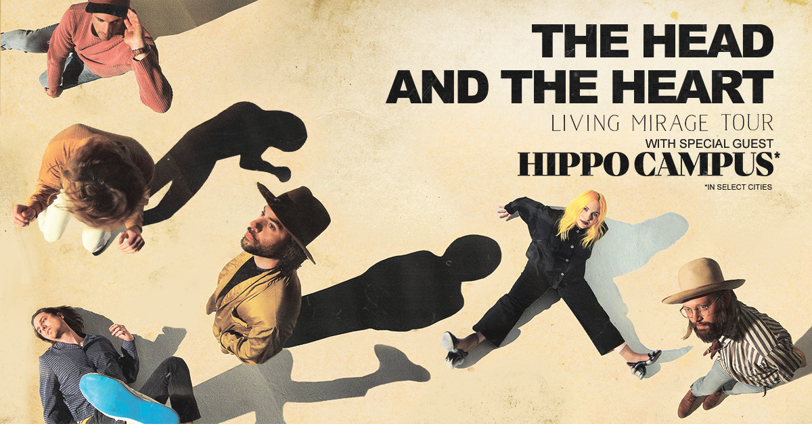

Summer/Fall North American Tour Dates:
04/14/19 - High Water Fest at Riverfront Park - North Charleston, SC
04/16/19 - Bijou Theatre - Knoxville, TN
04/17/19 - Greenfield Lake Amphitheatre - Wilmington, NC
04/19/19 - Hargray Capitol Theatre - Macon, GA
04/20/19 - Walker Theatre – Memorial Auditorium - Chattanooga, TN
04/21/19 - Manchester Music Hall - Lexington, KY
04/23/19 - Druid City Music Hall - Tuscaloosa, AL
04/24/19 - The Lyric Oxford - Oxford, MS
04/26/19 - New Orleans Jazz & Heritage Festival - New Orleans, LA+
06/21/19 - Alternative Buffalo’s Kerfuffle – Canalside – Buffalo, NY+
06/23/19 - Alt 92.3 Summer Open - Forest Hills Stadium – New York, NY+
07/06/19 - Starlight Theatre - Kansas City, MO *
07/07/19 - Stifel Theatre - St. Louis, MO *
07/09/19 - ACL Live at The Moody Theater - Austin, TX *
07/12/19 - The Pavilion at Toyota Music Factory - Dallas, TX *
07/13/19 - White Oak Music Hall - Houston, TX *
07/14/19 - Brady Theater - Tulsa, OK
07/17/19 - Red Rocks Amphitheatre - Denver, CO *+
07/18/19 - Red Rocks Amphitheatre - Denver, CO *+
07/19/19 - The Great Saltair - Salt Lake City, UT *
07/22/19 - Comerica Theatre - Phoenix, AZ *
07/23/19 - Santa Barbara Bowl - Santa Barbara, CA *+
07/25/19 - Grand Theatre at The Grand Sierra Resort - Reno, NV *
07/26/19 - Bill Graham Civic Auditorium - San Francisco, CA *
08/16/19 - Woodstock 50 - Glen, NY+
09/06/19 - Murat Theatre at Old National Centre - Indianapolis, IN
09/08/19 - PNC Pavilion at Riverbend Music Center - Cincinnati, OH
09/10/19 - Jacobs Pavilion at Nautica - Cleveland, OH
09/11/19 - 20 Monroe Live - Grand Rapids, MI
09/13/19 - Chicago Theatre - Chicago, IL
09/18/19 - The Armory - Minneapolis, MN
09/19/19 - Stephens Auditorium - Ames, IA
09/21/19 - Pilgrimage Music & Cultural Festival - Franklin, TN+
09/26/19 - Thomas Wolfe Auditorium - Asheville, NC
09/27/19 - The Tabernacle - Atlanta, GA
09/29/19 - Charlotte Metro Credit Union Amphitheatre - Charlotte, NC
10/01/19 - Red Hat Amphitheater - Raleigh, NC
10/03/19 - The Anthem - Washington, DC
10/08/19 - The MET - Philadelphia, PA
10/09/19 - Palace Theatre - Albany, NY
10/11/19 - Toyota Presents Oakdale Theatre - Wallingford, CT
10/12/19 - Agganis Arena - Boston, MA
10/14/19 - UPMC Events Center - Moon Twp., PA
10/15/19 - The Fillmore Detroit presented by Cricket Wireless - Detroit, MI
10/16/19 - Palace Theatre - Columbus, OH
10/18/19 - Algonquin Commons Theatre - Ottawa, ON
10/19/19 - MTELUS - Montreal, QC
10/20/19 - Sony Centre for the Performing Arts - Toronto, ON

*Hippo Campus
+not a Live Nation date

About The Head and The Heart
The Head and The Heart return this spring with their 4th full-length album, Living Mirage, featuring newly released “Missed Connection”. Initially self-released in 2011, The Head And The Heart’s self-titled breakout debut produced instant classics including “Rivers and Roads”, “Down In The Valley” and “Lost In My Mind” and is now Certified Gold. Their last two albums, 2013’s Let’s Be Still and 2016’s Signs of Light, settled into Billboard’s Top 10 albums chart, with Signs of Light securing the #1 position on Rock Album Charts. It also produced the single “All We Ever Knew” which reached #1 at Alternative, after holding the #1 spot at AAA for 9 straight weeks earlier that same year. They have appeared in Cameron Crowe’s Roadies, with music featured in countless other commercials, films and show, among them Corona and Silver Linings Playbook. Having played consecutive sold-out Red Rocks shows and prime time mainstage slots at Coachella, Lollapalooza and Austin City Limits on the last campaign, the band have a headlining tour planned for 2019, including another two sold-out Red Rocks shows in July. In total, the band has performed 13 times on national television including appearances on Ellen, The Tonight Show With Jimmy Fallon, Austin City Limits and more.

About Live Nation Entertainment
Live Nation Entertainment (NYSE: LYV) is the world’s leading live entertainment company comprised of global market leaders: Ticketmaster, Live Nation Concerts, and Live Nation Sponsorship. For additional information, visit www.livenationentertainment.com.

For more information about The Head and The Heart, please contact:
Kate Jackson, KateJ@grandstandhq.com
Katie Nelson, KatieN@grandstandhq.com
Bobbie Gale Bobbie.Gale@wbr.com

For Live Nation U.S. Concerts, please contact:
Emily Bender, EmilyBender@livenation.com
Monique Sowinski, MoniqueSowinski@livenation.com

Website / Facebook / Twitter / Instagram / Youtube / Soundcloud

