RELEASE NEW SONG “HONEYBEE”
TODAY, FRIDAY APRIL 5th

THE HEAD AND THE HEART TO PERFORM
“LIVE FROM HERE”
IN DALLAS TOMORROW, SATURDAY APRIL 6TH

NORTH AMERICAN TOUR ON SALE NOW

LIVING MIRAGE OUT MAY 17th
Album Available To Pre-Order Now

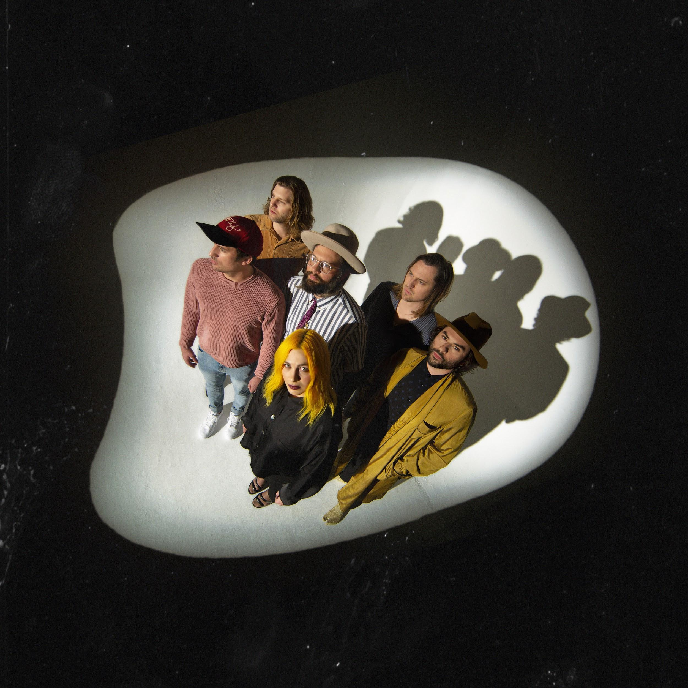
Photo Credit: Alex Currie

April 5, 2019 – (Los Angeles, CA) - The Head And The Heart have released their new song “Honeybee” today from their forthcoming album Living Mirage which will be released May 17th via Warner Bros.Records / Reprise Records. Purchase/stream “Honeybee” here. You can also watch the visualizer for “Honeybee” here and acoustic/unplugged version of the song via the video below.

[STRIPPED VIDEO EMBED]

Songwriter and vocalist Jon Russell etched out the sauntering “Honeybee,” in Joshua Tree during the band’s first writing session. Then an a-cappella floor stomp about rescuing a decaying relationship, during a writing workshop in Los Angeles. Jon subsequently traveled to Seattle to flesh-out tracks with Matt Gervais and Charity Rose Thielen, who notably finessed the sweetly harmonic bridge to “Honeybee.” The entire band later convened in Nashville, reinvigorated by the music’s unscripted direction.

“Honeybee really captures the idea of living a life complacent with the familiar - maybe even taking the person closest to you for granted and regretting not expressing your love towards them until it’s too late,” commented Charity. “It’s a concept that connects with all of us and this song, sonically, for the band is intriguingly minimalist. It feels fresh.”

“Missed Connection,” the first single from the new album, was released two weeks ago where it was #1 Most added at AAA last week (already sitting at #11 on Mediabase AAA chart) and #1 Most added at Alternative this week, and in the most added category 2 weeks in a row (already charting at Alternative radio after just 2 weeks.) ”Missed Connection” is now available to download, stream or watch the lyric video. Pre-order Living Mirage here.

The band will kick off a 38-city tour starting in Buffalo, NY on June 21st, making stops in Austin, Denver, Chicago, Atlanta and more, before wrapping October 20th in Toronto, ON. A full rundown of tour dates can be found below. Special guest Hippo Campus will join the July dates of the tour. Tickets are on sale now via LiveNation.com.

The Head And The Heart will appear on Live From Here on Saturday, April 6. Fans can tune in to livefromhere.org to catch the performance.

Ticket purchased online for select tour dates (as noted below) includes your choice of a CD or digital copy of the new album, Living Mirage, which will be released on May 17, 2019. Purchasers will receive instructions via email on how to redeem your album after ticket purchase.

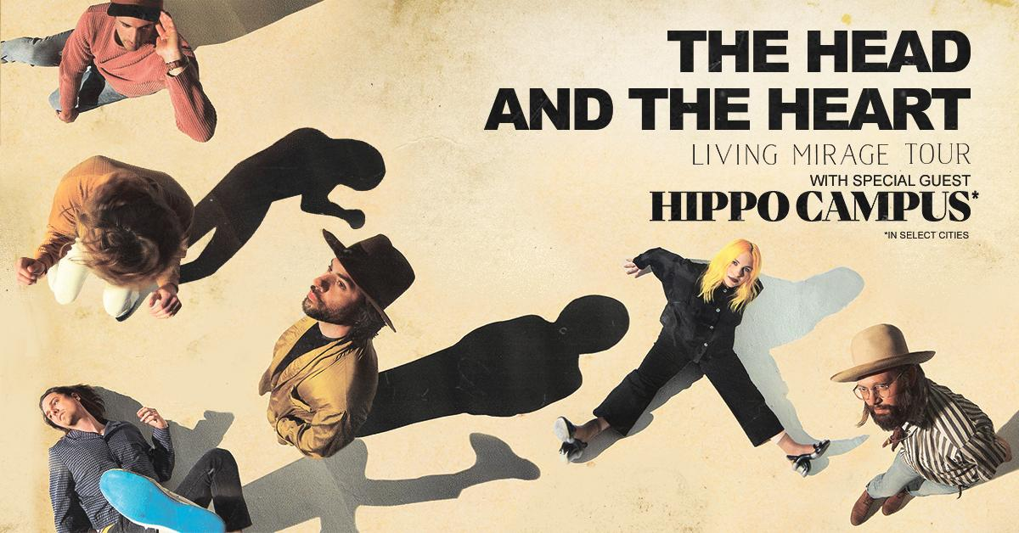

Summer/Fall North American Tour Dates:
04/14/19 - High Water Fest at Riverfront Park - North Charleston, SC ^
04/16/19 - Bijou Theatre - Knoxville, TN ^
04/17/19 - Greenfield Lake Amphitheatre - Wilmington, NC ^
04/19/19 - Hargray Capitol Theatre - Macon, GA ^
04/20/19 - Walker Theatre – Memorial Auditorium - Chattanooga, TN ^
04/21/19 - Manchester Music Hall - Lexington, KY ^
04/23/19 - Druid City Music Hall - Tuscaloosa, AL ^
04/24/19 - The Lyric Oxford - Oxford, MS ^
04/26/19 - New Orleans Jazz & Heritage Festival - New Orleans, LA +^
06/21/19 - Alternative Buffalo’s Kerfuffle – Canalside – Buffalo, NY +^
06/23/19 - Alt 92.3 Summer Open - Forest Hills Stadium – New York, NY +^
07/06/19 - Starlight Theatre - Kansas City, MO *
07/07/19 - Stifel Theatre - St. Louis, MO *
07/09/19 - ACL Live at The Moody Theater - Austin, TX *
07/12/19 - The Pavilion at Toyota Music Factory - Dallas, TX *
07/13/19 - White Oak Music Hall - Houston, TX *
07/14/19 - Brady Theater - Tulsa, OK
07/17/19 - Red Rocks Amphitheatre - Denver, CO * +^
07/18/19 - Red Rocks Amphitheatre - Denver, CO * +^
07/19/19 - The Great Saltair - Salt Lake City, UT *
07/22/19 - Comerica Theatre - Phoenix, AZ *
07/23/19 - Santa Barbara Bowl - Santa Barbara, CA *+
07/25/19 - Grand Theatre at The Grand Sierra Resort - Reno, NV *
07/26/19 - Bill Graham Civic Auditorium - San Francisco, CA *
08/16/19 - Woodstock 50 - Glen, NY +^
09/06/19 - Murat Theatre at Old National Centre - Indianapolis, IN
09/08/19 - PNC Pavilion at Riverbend Music Center - Cincinnati, OH
09/10/19 - Jacobs Pavilion at Nautica - Cleveland, OH
09/11/19 - 20 Monroe Live - Grand Rapids, MI
09/13/19 - Chicago Theatre - Chicago, IL
09/18/19 - The Armory - Minneapolis, MN
09/19/19 - Stephens Auditorium - Ames, IA
09/21/19 - Pilgrimage Music & Cultural Festival - Franklin, TN +^
09/26/19 - Thomas Wolfe Auditorium - Asheville, NC
09/27/19 - The Tabernacle - Atlanta, GA
09/29/19 - Charlotte Metro Credit Union Amphitheatre - Charlotte, NC
10/01/19 - Red Hat Amphitheater - Raleigh, NC
10/03/19 - The Anthem - Washington, DC
10/08/19 - The MET - Philadelphia, PA
10/09/19 - Palace Theatre - Albany, NY
10/11/19 - Toyota Presents Oakdale Theatre - Wallingford, CT
10/12/19 - Agganis Arena - Boston, MA
10/14/19 - UPMC Events Center - Moon Twp., PA
10/15/19 - The Fillmore Detroit presented by Cricket Wireless - Detroit, MI
10/16/19 - Palace Theatre - Columbus, OH
10/18/19 - Algonquin Commons Theatre - Ottawa, ON
10/19/19 - MTELUS - Montreal, QC
10/20/19 - Sony Centre for the Performing Arts - Toronto, ON

*Hippo Campus
+not a Live Nation date
^ tickets purchased for this date will not include the album

About The Head and The Heart
The Head and The Heart return this spring with their 4th full-length album, Living Mirage, featuring newly released “Missed Connection”. Initially self-released in 2011, The Head And The Heart’s self-titled breakout debut produced instant classics including “Rivers and Roads”, “Down In The Valley” and “Lost In My Mind” and is now Certified Gold. Their last two albums, 2013’s Let’s Be Still and 2016’s Signs of Light, settled into Billboard’s Top 10 albums chart, with Signs of Light securing the #1 position on Rock Album Charts. It also produced the song “All We Ever Knew” which reached #1 at Alternative, after holding the #1 spot at AAA for 9 straight weeks earlier that same year. They have appeared in Cameron Crowe’s Roadies, with music featured in countless other commercials, films and show, among them Corona and Silver Linings Playbook. Having played consecutive sold-out Red Rocks shows and prime time mainstage slots at Coachella, Lollapalooza and Austin City Limits on the last campaign, the band have a headlining tour planned for 2019, including another two sold-out Red Rocks shows in July. In total, the band has performed 13 times on national television including appearances on Ellen, The Tonight Show With Jimmy Fallon, Austin City Limits and more.

For more information about The Head and The Heart, please contact:
Kate Jackson, KateJ@grandstandhq.com
Katie Nelson, KatieN@grandstandhq.com
Bobbie Gale Bobbie.Gale@wbr.com

Website / Facebook / Twitter / Instagram / Youtube / Soundcloud

