THE HEAD AND THE HEART AND AMAZON MUSIC RELEASE LIVE VERSION & VIDEO OF “HONEYBEE” FROM THE BANDS' PIKE PLACE MARKET ROOFTOP PERFORMANCE IN THEIR SEATTLE HOMETOWN

The Head and The Heart - Live from Pike Place Market (Amazon Original) Vinyl Available Friday, April 2nd – Pre-Order HERE

#1 Alternative Radio Single “Honeybee” is Featured on Critically-Acclaimed 2019 Album Living Mirage

Watch THATH Perform Living Mirage + More in the Film Rivers And Roads: The Head And The Heart - Live From Pike Place Market Exclusively on Prime Video

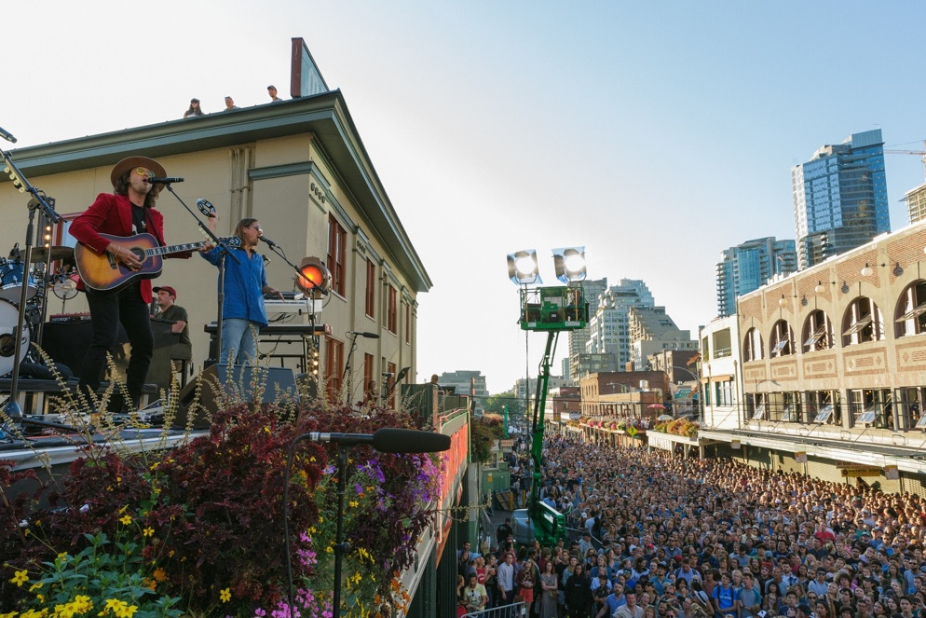
Download Press Photo // Credit: Carlos Cruz

Listen to Living Mirage: The Complete Recordings Deluxe Album HERE

Stream Or Purchase The Live Album Available Digitally And On Vinyl Via Amazon Music HERE

ABOUT RIVERS AND ROADS: THE HEAD AND THE HEART - LIVE FROM PIKE PLACE MARKET:
Premiered on January 22, 2021 and accompanied with a live album, the film chronicles The Head and The Heart’s return to their Seattle roots to perform a rooftop concert at the city’s infamous Pike Place Market in front of 30,000 hometown fans, two stories above where they originally started busking for tips ten years ago. Presented by Amazon Music, the high-energy, nine-song concert is interspersed with documentary footage and a series of intimate and revealing interviews with the band, including former and founding member Josiah Johnson, and early supporters and friends such as Sub Pop Records’ Stuart Meyer and CEO Megan Jasper.

ABOUT THE HEAD AND THE HEART:
Living Mirage is the band’s fourth full-length album released on Warner Records / Reprise Records to critical praise in 2019. The bands breakout hit “Honeybee” secured the #1 position on the Alternative Chart this past August as well as #1 on the AAA chart. This marks the band’s second #1 off Living Mirage and their third time with a song at #1 at Alternative, having previously landed the position for “All We Ever Knew” (Signs of Light), which also held the #1 spot at AAA for nine straight weeks in 2016. “Honeybee” is the band’s highest streaming song on Living Mirage with over 70 million streams globally, U.S. streams over 46 million, and over 126 million impressions on TikTok to date.

Initially self-released in 2011, The Head and The Heart’s self-titled breakout debut produced instant classics including “Rivers and Roads,” “Down In The Valley” and “Lost In My Mind” (#1 at AAA) and is now Certified Gold. Their last two albums, 2013’s Let’s Be Still and 2016’s Signs of Light, settled into Billboard’s Top 10 albums chart, with Signs of Light securing the #1 position on Rock Album Charts. They have appeared in Cameron Crowe’s Roadies, with music featured in countless other commercials, films and TV, among them Corona, Silver Linings Playbook and more. The band has established their status as a touring powerhouse, having landed prime time mainstage slots at Coachella, Lollapalooza and Austin City Limits. In total, the band has performed 15 times on national television including appearances on Ellen, The Tonight Show Starring Jimmy Fallon, The Late Show With Stephen Colbert, Austin City Limits with more.

FOLLOW THE HEAD AND THE HEART:
Website / Facebook / Twitter / Instagram / YouTube / Soundcloud

