THE FLAMING LIPS ADD THREE MORE SHOWS IN
SOUTHERN CALIFORNIA AND ARIZONA TO 2021 TOUR

TICKETS VIA VENUE PRE-SALE BEGINS JUNE 16 & 18 AT 10:00AM LOCAL TIME
GENERAL PUBLIC TICKETS ON SALE JUNE 19 10:00AM LOCAL TIME

THE SOFT BULLETIN COMPANION TO BE RELEASED IN JULY 16

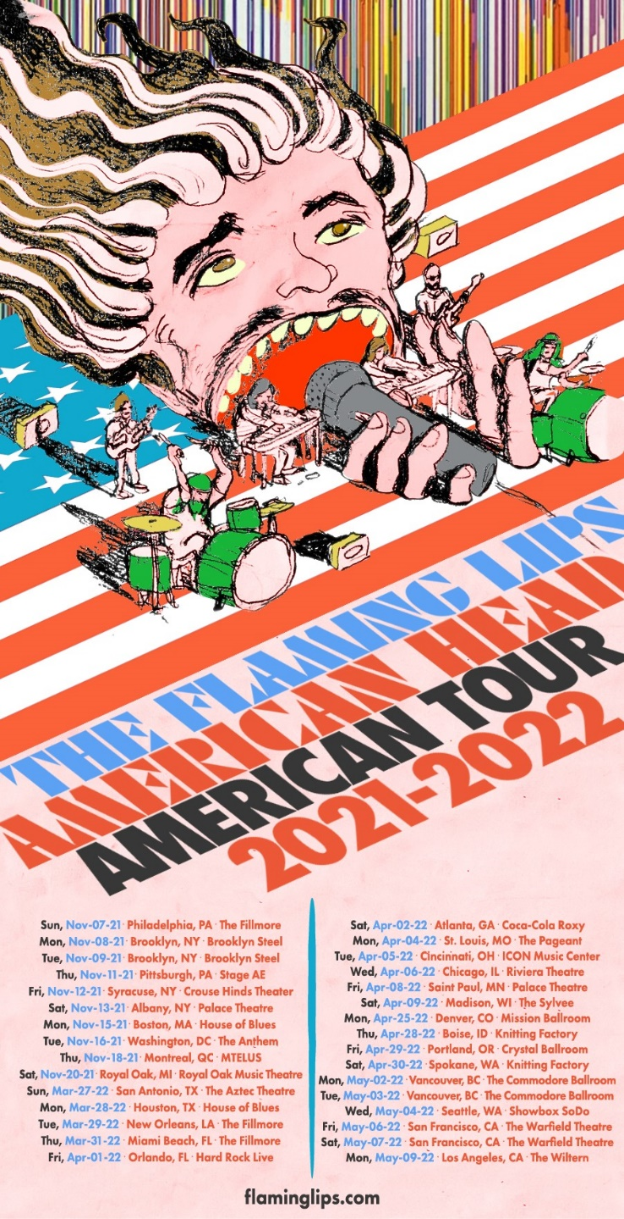

June 14, 2021 – (Los Angeles, CA.) – The Flaming Lips have confirmed three more shows to their 2021 US tour. August 23 in Tempe, AZ, August 24 in Tucson, AZ and August 26 in Costa Mesa, CA.
Tickets for Costa Mesa via venue pre-sale begin Wednesday June 16, at 10:00AM local time. Public on-sale begins Saturday June 19, at 10:00AM local time. Tickets for Arizona via venue pre-sale begin Friday June 18, at 10:00AM local time. Public on-sale begins Saturday June 19, at 10:00AM local time. Tickets for all other shows listed below are on sale now. Click here for additional details.

*Indicates newly added date
2021:
Fri Aug 20 Ogden Amphitheatre Ogden, UT
Sat Aug 21 Psycho Las Vegas Las Vegas, NV
*Mon Aug 23 Marquee Theatre Tempe, AZ
*Tue Aug 24 Rialto Theatre Tucson, AZ
*Thur Aug 26 OC Fair/Pacific Amphitheatre Costa Mesa, CA
Sun Nov 07 The Fillmore Philadelphia, PA
Mon Nov 08 Brooklyn Steel Brooklyn, NY
Tue Nov 09 Brooklyn Steel Brooklyn, NY
Thu Nov 11 Stage A&E Pittsburgh, PA
Fri Nov 12 Crouse Hinds Theater Syracuse, NY
Sat Nov 13 Palace Theater Albany, NY
Mon Nov 15 House of Blues Boston, MA
Tue Nov 16 The Anthem Washington, DC
Thu Nov 18 MTELUS Montreal, QC
Sat Nov 20 Royal Oak Music Theater Royal Oak, MI

2022:
Sun Mar 27 The Aztec Theatre San Antonio, TX
Mon Mar 28 House Of Blues Houston, TX
Tue Mar 29 The Fillmore New Orleans, LA
Thu Mar 31 The Fillmore Miami Beach, FL
Fri Apr 01 Hard Rock Live Orlando, FL
Sat Apr 02 Coca-Cola Roxy Atlanta, GA
Mon Apr 04 The Pageant St. Louis, MO
Tue Apr 05 ICON Music Center Cincinnati, OH
Wed Apr 06 Riviera Theatre Chicago. IL
Fri Apr 08 Palace Theatre St. Paul. MN
Sat Apr 09 The Sylvee Madison, Wi
Mon Apr 25 Mission Ballroom Denver, CO
Thu Apr 28 Knitting Factory Boise, ID
Fri Apr 29 Crystal Ballroom Portland, OR
Sat Apr 30 Knitting Factory Spokane, WA
Mon May 02 Commodore Ballroom Vancouver, BC
Tue May 03 Commodore Ballroom Vancouver, BC
Wed May 04 Showbox SoDo Seattle, WA
Fri May 06 Warfield Theatre San Francisco, CA
Sat May 07 Warfield Theatre San Francisco, CA
Mon May 09 The Wiltern Los Angeles, CA
Wed May 25 Stylus Leeds, UK
Thu May 26 O2 Academy Liverpool Liverpool, UK
Mon May 30 Waterside Theatre Aylesbury, UK
Wed June 01 De La Warr Pavilion Bexhill, UK
Thu June 02 O2 Forum Kentish Town London, UK
Fri July 22 Galway Int’l Arts Fest. Galway IRE

Click here for additional ticket information.

Following its Record Store Day 2021 vinyl release, The Lips will issue The Soft Bulletin Companion globally on July 16 and will be available on all formats. One of their most highly sought-after rarities, The Soft Bulletin Companion was originally assembled by Lips management 22 years ago as a promo-only 13-track CD to accompany the band’s 1999 groundbreaking album The Soft Bulletin. It consisted of unreleased material, outtakes, early mixes, B-sides, international bonus tracks, and stereo versions of tunes from Zaireeka, and given out to family, friends, and a handful of radio programmers. Among the hidden audio treasures, “The Captain” emerged as a fan favorite.

# # #

For further information please Contact:
Rick Gershon at Warner Records
Rick.Gershon@warnerrecords.com

Follow The Flaming Lips
Website | YouTube | Twitter | Instagram | Facebook | Spotify | Publicity Materials
