THE FLAMING LIPS’ NEW ALBUM AMERICAN HEAD
OUT TODAY VIA WARNER RECORDS

WATCH THE FLAMING LIPS PERFORM ON
THE TONIGHT SHOW STARRING JIMMY FALLON TONIGHT!

NEW VIDEO “GOD AND THE POLICEMAN” HERE

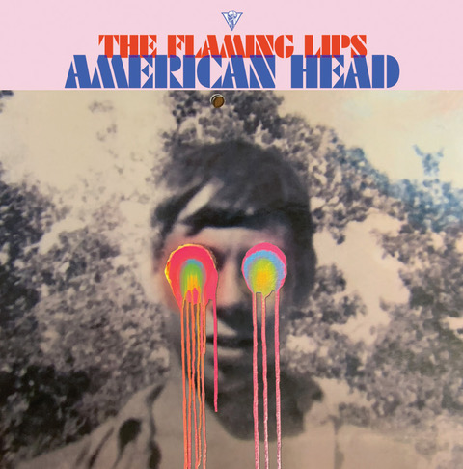
(Click HERE for hi-res artwork)

September 11, 2020 (Los Angeles, CA) – Multiple GRAMMY Award®-winning American Legends The Flaming Lips release their long-awaited new studio album, AMERICAN HEAD today via Warner Records. Produced, as always, by longtime collaborator Dave Fridmann and The Lips, the album is comprised of thirteen new cinematic tracks. Among them, “God and the Policeman” featuring backing vocals from country superstar Kacey Musgraves. The Lips have filmed a new video for the track in Oklahoma and Texas, directed by Wayne Coyne and Blake Studdard for AtriaCreative.co.
Click here to view and share the video for “God and the Policeman.”

To celebrate the release, The Flaming Lips will perform “God and the Policeman” on The Tonight Show Starring Jimmy Fallon tonight. Tune into NBC stations at 11:35 PM PT / 10:35PM CT. Click here for broadcast details.

AMERICAN HEAD is available now on black vinyl double LP, digital and CD versions. A limited-edition colored vinyl double LP (one LP blue, one LP pink) will be available on October 2nd. Additionally, there will be a limited edition, colored vinyl with exclusive art print signed by Wayne Coyne in a printed plastic sleeve available exclusively on The Flaming Lips’ website. Click here to pre-order / pre-save American Head black vinyl, CD or digitally. Click here to pre-order the limited edition colored vinyl double LP, and click here to order bundle packages and new merch.
Wayne Coyne explains his thoughts on AMERICAN HEAD in a story titled “We’re An American Band.” Excerpt below:

“The Flaming Lips are from Oklahoma. We never thought of ourselves as an AMERICAN band. I know growing up (when I was like 6 or 7 years old) in Oklahoma I was never influenced by, or was very aware of any musicians from Oklahoma. We mostly listened to the Beatles and my mother loved Tom Jones (this is in the 60’s)... it wasn’t till I was about 10 or 11 that my older brothers would know a few of the local musician dudes.
So... for most of our musical life (as The Flaming Lips starting in 1983) we’ve kind of thought of ourselves as coming from ‘Earth’... not really caring WHERE we were actually from. So for the first time in our musical life we began to think of ourselves as ‘AN AMERICAN BAND’… telling ourselves that it would be our identity for our next creative adventure. We had become a 7-piece ensemble and were beginning to feel more and more of a kinship with groups that have a lot of members in them. We started to think of classic American bands like The Grateful Dead and Parliament-Funkadelic and how maybe we could embrace this new vibe.
The music and songs that make up the AMERICAN HEAD album are based in a feeling. A feeling that, I think, can only be expressed through music and songs. We were, while creating it, trying to NOT hear it as sounds... but to feel it. Mother’s sacrifice, Father’s intensity, Brother’s insanity, Sister’s rebellion...I can’t quite put it into words.
Something switches and others (your brothers and sisters and mother and father...your pets) start to become more important to you…in the beginning there is only you... and your desires are all that you can care about...but... something switches... I think all of these songs are about this little switch.”
- Wayne Coyne
Oklahoma City, OK

AMERICAN HEAD TRACKLIST:
- Will You Return / When You Come Down
- Watching the Lightbugs Glow
- Flowers Of Neptune 6
- Dinosaurs On The Mountain
- At The Movies On Quaaludes
- Mother I've Taken LSD
- Brother Eye
- You n Me Sellin' Weed
- Mother Please Don't Be Sad
- When We Die When We're High
- Assassins of Youth
- God and the Policeman (Feat. Kacey Musgraves)
- My Religion Is You

# # #
Contact Rick Gershon at Warner Records Publicity
Rick.Gershon@warnerrecords.com

Follow The Flaming Lips
Website | YouTube | Twitter | Instagram | Facebook | Spotify | Publicity Materials

