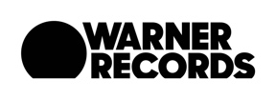
THE FLAMING LIPS ANNOUNCE SPRING 2020 WEST COAST TOUR DATES

Tickets on Sale December 13th at 10:00 AM Local Time

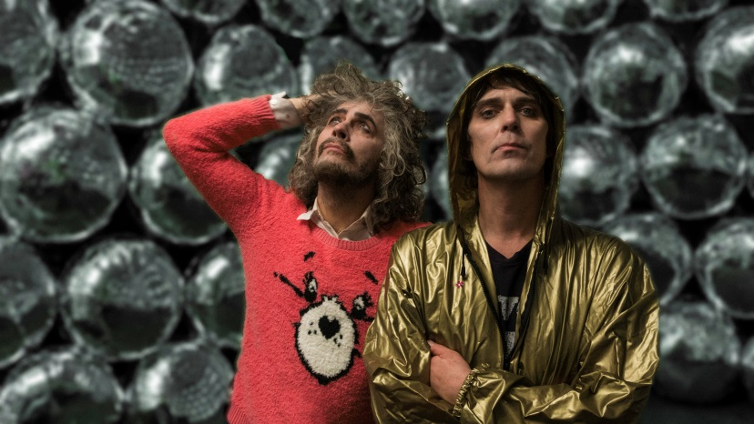
(Photo credit: George Salisbury. Click here for hi-res image)

December 10, 2019 (Los Angeles, CA) – THE FLAMING LIPS announce a brief run of west coast tour dates for 2020, targeting intimate theater shows beginning April 14th, in Spokane, WA. Tickets go on sale this Friday, December 13th at 10 AM local time. Purchase your tickets HERE.

Recently, The Flaming Lips released The Soft Bulletin Recorded Live At Red Rocks With The Colorado Symphony Orchestra, recorded May 26, 2016, at the prestigious Red Rocks Amphitheatre in Morrison, Colorado. As the title indicates, The Lips (Wayne Coyne, Steven Drozd, Michael Ivins, Derek Brown, Jake Ingalls, Matt Kirksey and Nicholas Ley) performed their universally acclaimed 1999 Warner Records album The Soft Bulletin in its entirety accompanied by a 69-piece orchestra and 56-strong chorus. The performance was conducted by the internationally celebrated conductor Andre de Ridder.
The album is available now. Click HERE to purchase.

Tour dates below will cover music from The Lips entire catalog which means, expect the unexpected.

2020 TOUR DATES:
April 14 Spokane, WA Fox Theatre
April 15 Missoula, MT The Wilma
June 12 Denver, CO Mission Ballroom
June 17 Los Angeles, CA The Wiltern
June 18 San Francisco, CA The Warfield Theatre
June 21 Vancouver, BC The Commodore Ballroom

Press Contact:
Rick Gershon at Warner Records
818-953-3473 | Rick.Gershon@warnerrecords.com

Follow The Flaming Lips
Press Site | Website | YouTube | Twitter | Facebook

