THE FLAMING LIPS ANNOUNCE NEW ALBUM AMERICAN HEAD
SET FOR SEPTEMBER 11TH RELEASE VIA WARNER RECORDS

Watch the Video for “My Religion Is You” HERE

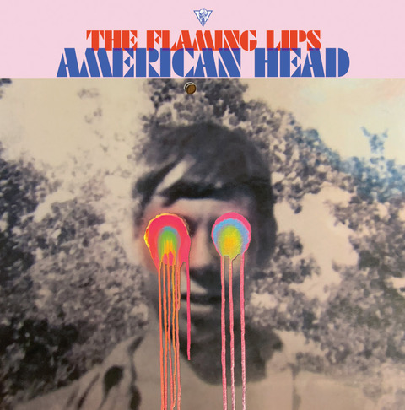
(Click HERE for hi-res artwork)

June 26, 2020 (Los Angeles, CA) – Multiple GRAMMY Award®-winning American Legends The Flaming Lips are pleased to announce the release of their 21st studio album, AMERICAN HEAD set for release on September 11th via Warner Records. The album is comprised of thirteen new cinematic tracks, produced by longtime collaborator Dave Fridmann and The Lips. Among them, “God and the Policeman” featuring backing vocals from country superstar Kasey Musgraves. As previewed on the recently released “Flowers Of Neptune 6,” AMERICAN HEAD takes on a welcome temporal shift that occupies a similar space to that of THE SOFT BULLETIN or YOSHIMI BATTLES THE PINK ROBOTS and just may be their most beautiful and consistent work to date. Album pre-order begins today and will include an instant download of the heartfelt “My Religion Is You.” Click here for audio and here for video.

There will be two vinyl versions of AMERICAN HEAD: a black vinyl double LP that will be released on September 11th alongside the digital and CD versions and a limited-edition colored vinyl double LP (one LP blue, one LP pink) which will be available on October 2nd. Additionally, there will be a limited edition, colored vinyl with exclusive art print signed by Wayne Coyne in printed plastic sleeve available exclusively on The Flaming Lips’ website. Click here to pre-order / pre-save American Head black vinyl, CD or digitally. Click here to pre-order the limited edition colored vinyl double LP.

AMERICAN HEAD finds The Flaming Lips basking in more reflective lyrical places as Wayne Coyne explains in a longer form story titled “We’re An American Band.” Excerpt below:

“The Flaming Lips are from Oklahoma. We never thought of ourselves as an AMERICAN band. I know growing up (when I was like 6 or 7 years old) in Oklahoma I was never influenced by, or was very aware of any musicians from Oklahoma. We mostly listened to the Beatles and my mother loved Tom Jones (this is in the 60’s)... it wasn’t till I was about 10 or 11 that my older brothers would know a few of the local musician dudes.
So... for most of our musical life (as The Flaming Lips starting in 1983) we’ve kind of thought of ourselves as coming from ‘Earth’... not really caring WHERE we were actually from. So for the first time in our musical life we began to think of ourselves as ‘AN AMERICAN BAND’… telling ourselves that it would be our identity for our next creative adventure. We had become a 7-piece ensemble and were beginning to feel more and more of a kinship with groups that have a lot of members in them. We started to think of classic American bands like The Grateful Dead and Parliament-Funkadelic and how maybe we could embrace this new vibe.
The music and songs that make up the AMERICAN HEAD album are based in a feeling. A feeling that, I think, can only be expressed through music and songs. We were, while creating it, trying to NOT hear it as sounds... but to feel it. Mother’s sacrifice, Father’s intensity, Brother’s insanity, Sister’s rebellion...I can’t quite put it into words.
Something switches and others (your brothers and sisters and mother and father...your pets) start to become more important to you…in the beginning there is only you... and your desires are all that you can care about...but... something switches.. I think all of these songs are about this little switch.”
AMERICAN HEAD TRACKLIST:
- Will You Return / When You Come Down
- Watching the Lightbugs Glow
- Flowers Of Neptune 6
- Dinosaurs On The Mountain
- At The Movies On Quaaludes
- Mother I've Taken LSD
- Brother Eye
- You n Me Sellin' Weed
- Mother Please Don't Be Sad
- When We Die When We're High
- Assassins of Youth
- God and the Policeman (Feat. Kacey Musgraves)
- My Religion Is You

As previously announced, Wayne Coyne has designed a brand new T-shirt featuring his drawing of what a quarantine time Flaming Lips show might look like. Click here to view the COVID Show 2020 shirt.
# # #
Contact Rick Gershon at Warner Records Publicity
Rick.Gershon@warnerrecords.com

Follow The Flaming Lips
Website | YouTube | Twitter | Instagram | Facebook | Spotify | Publicity Materials

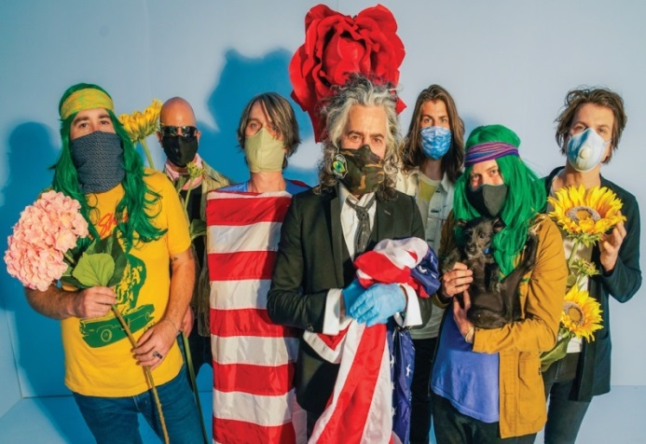
(Click HERE for hi-res artwork - Photo credit: George Salisbury)

