THE FLAMING LIPS RELEASE NEW VIDEO FOR
“DINOSAURS ON THE MOUNTAIN” – WATCH HERE

AMERICAN HEAD SET FOR SEPTEMBER 11TH RELEASE

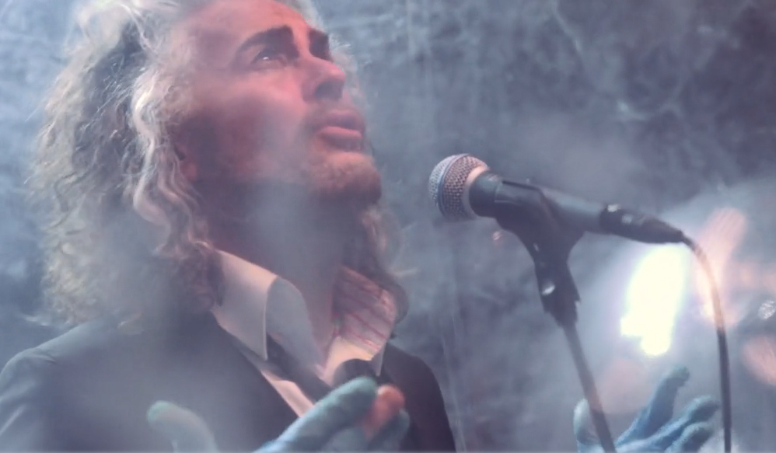

July 10, 2020 (Los Angeles, CA) – Today, The Flaming Lips release a new track and video, “Dinosaurs On The Mountain,” from their forthcoming album AMERICAN HEAD set for release on September 11th via Warner Records. “Dinosaurs On The Mountain” follows on the tailwinds of the plaintive “Flowers Of Neptune 6” and the heartfelt “My Religion Is You.” Click here to listen.

“Dinosaurs On The Mountain” was filmed during quarantine in THE LIPS’ home state of Oklahoma and directed by George Salisbury and Wayne Coyne for delo creative.

AMERICAN HEAD, their 21st full-length studio album, is comprised of thirteen vivid tracks produced by Dave Fridmann and The Lips, their most beautiful and consistent work to date.

As previously announced, AMERICAN HEAD will be available on CD, digital and a double black vinyl pressing on September 11th. A double color vinyl pressing (one LP blue, one LP pink) will be available on October 2nd. Additionally, there will be a limited edition, colored vinyl with exclusive art print signed by Wayne Coyne in printed plastic sleeve available exclusively on The Flaming Lips’ website.

Click here to pre-order / pre-save American Head black vinyl, CD or digitally.
Click here to pre-order the limited-edition colored vinyl double LP.

AMERICAN HEAD TRACKLIST:
Will You Return / When You Come Down
Watching the Lightbugs Glow
Flowers Of Neptune 6
Dinosaurs On The Mountain
At The Movies On Quaaludes
Mother I've Taken LSD
Brother Eye
You n Me Sellin' Weed
Mother Please Don't Be Sad
When We Die When We're High
Assassins of Youth
God and the Policeman (Feat. Kacey Musgraves)
My Religion Is You

Also available now is a new T-shirt designed by Wayne Coyne which features his drawing of what a quarantine time Flaming Lips show might look like. Click here to view the COVID Show 2020 shirt.
# # #
Contact Rick Gershon at Warner Records Publicity
Rick.Gershon@warnerrecords.com

Follow The Flaming Lips
Website | YouTube | Twitter | Instagram | Facebook | Spotify | Publicity Materials

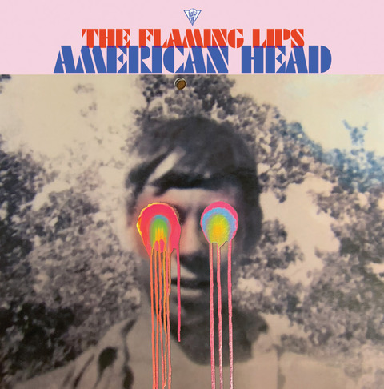
(Click HERE for hi-res artwork)

