THE FLAMING LIPS ANNOUNCE BRAND NEW SONG AND VIDEO
“FLOWERS OF NEPTUNE 6” AVAILABLE TODAY VIA WARNER RECORDS

LISTEN HERE
WATCH HERE

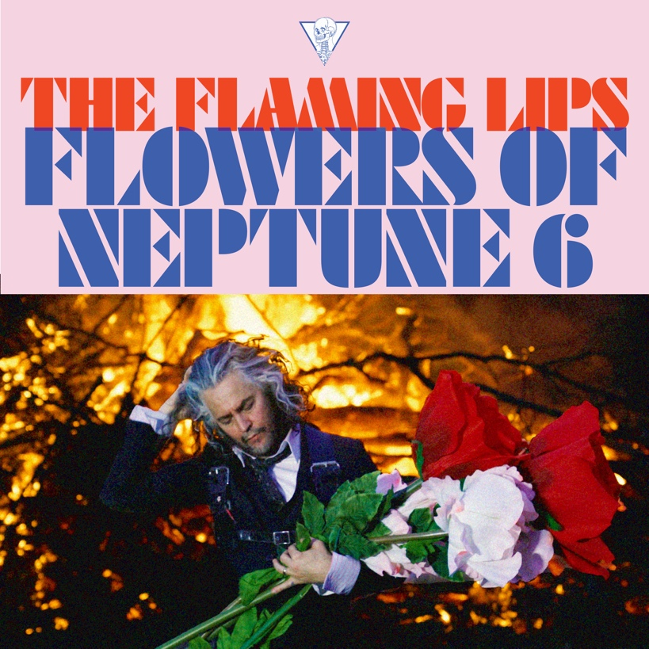
(Click here for hi-res artwork)

May 29, 2020 (Los Angeles, CA) – Today, THE FLAMING LIPS release a brand new track “Flowers of Neptune 6,” their first new recording of 2020. Produced by Dave Fridmann and The Flaming Lips, “Flowers of Neptune 6” reflects the gentler side of The Lips paisley oeuvre and melodically flows downstream into a welcoming wormhole of wistful summer pop. The track is accompanied by a video filmed in their home state of Oklahoma and directed by Wayne Coyne and George Salisbury. Click here for audio and here to view and share the video.
Wayne Coyne of The Flaming Lips explains the new track: “‘Flowers Of Neptune 6’ track started off as a very evocative series of melodies that Steven Drozd had woven together. The first time he played it for me I was stunned by its emotional flow. The 3 sections (well they seem like sections to me) seemed to hint at an older, mature mind reflecting back into a journey from younger innocence then starting to learn and understand and keeps going into the panic of becoming one with the world. The opening lyric ‘Yellow sun is going down so slow...Doing acid and watching the light-bugs glow like tiny spaceships in a row...’ is the coolest thing I’ll ever know...and is a combination of blissful, innocent, psychedelic experiences that Steven and Kacey Musgraves (she sings harmony with me on the track) and myself all discussed.”
“Flowers of Neptune 6” is the first new music from The Lips since 2019’s internationally acclaimed King’s Mouth Music And Songs. Expect additional details to be revealed soon.
In other Lips news, Wayne Coyne has designed a band new T-shirt featuring his drawing of what a quarantine time Flaming Lips show might look like. Click here to view the COVID Show 2020 shirt. Expect additional details to be revealed soon.
# # #
Contact: Rick Gershon at Warner Records
Rick.Gershon@warnerrecords.com

Follow The Flaming Lips
Website | YouTube | Twitter | Instagram | Facebook | Spotify | Publicity Materials

(Photo credit: George Salisbury)

