

**THE FLAMING LIPS RELEASE NEW VIDEO “GIANT BABY” FROM**

***KING’S MOUTH: MUSIC AND SONGS***

**Tour Of Europe, UK, Australia and US Dates Begins Sept. 1st**

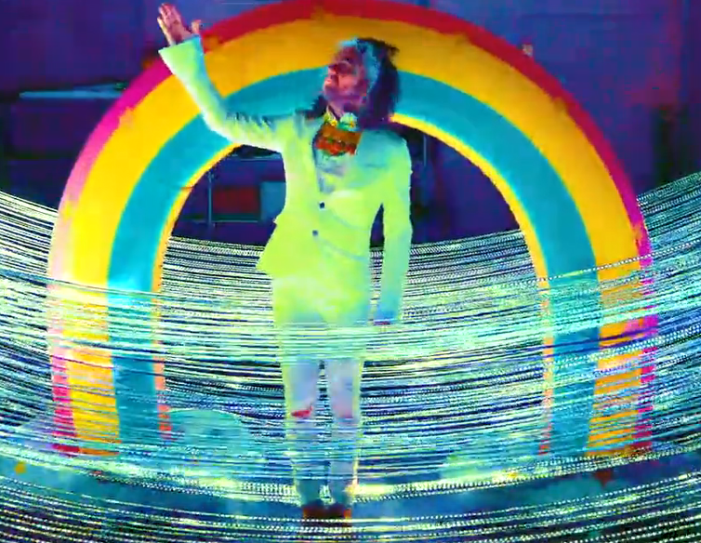

**August 30, 2019 (Los Angeles, CA)** – Today, [**THE FLAMING LIPS**](https://protect-us.mimecast.com/s/BKzQCW6jqZh8WEOxi6pKU0)release a brand new video for the track **“Giant Baby”** from the universally acclaimed Warner Records album ***King’s Mouth: Music And Songs.***  The video was filmed in Oklahoma City and Los Angeles, directed by Wayne Coyne and features a cameo by their long-time friend Fred Armisen. **“Giant Baby”** is perhaps the most lyrically poignant and personal song from the album but visually, the Lips still convey raw emotion in the most vivid and surreal way imaginable. Click [**HERE**](https://flaminglips.lnk.to/GiantBabyVideo) to view and share.

***King’s Mouth: Music And Songs***, which features narration from **Mick Jones** of **The Clash,** also serves asa soundtrack for Wayne Coyne’s immersive art installation of the same name. ***King’s Mouth: Immerse Heap Trip Fantasy Experience*** tells the story of the ***King’s Mouth*** through words and visuals by Coyne,adds yet another dimension to the project, which ranks among the band’s most ambitious thus far. About the vision, Coyne wrote, *“The King’s Mouth immersive/child-like qualities are born from the same spark and womb as The Flaming Lips’ live performances. The King’s Mouth adventure was made for humans of all sizes, ages, cultures, and religions.”* Click [**HERE**](https://www.youtube.com/watch?v=1NHk44OuD3Y)to view and share the making of the *KING’S MOUTH* Part 1.[**HERE**](https://www.youtube.com/watch?v=rQVgkJq1FrU) for Part 2. [**HERE**](https://www.youtube.com/watch?v=E6ax9acDj6k) for Part 3, and Part 4 [**HERE**](https://www.youtube.com/watch?v=e238t91xRi8)

***King’s Mouth: Music And Songs*** continues to dazzle the media:

“If there’s been one consistent in The Flaming Lips’ careening four-decade evolution, it’s that Wayne Coyne loves to tell a good story. *KING’S MOUTH* reminds us that Coyne can draw poignancy and pathos from the strangest sources.” – ***Pitchfork***

“Climb inside *KING’S MOUTH, the band’s kaleidoscopic new record.* The Flaming Lips remain remarkably ageless and endlessly creative.”– ***NPR***

“*KINGS MOUTH* will blow your mind. The new album by The Flaming Lips is a head trip – literally. The ever-evolving, mind-blowing alt-rockers have somehow upped their game. This is THE LIPS, after all.”

– ***Associated Press***

Click [**HERE**](https://flaminglips.lnk.to/KingsMouth) to purchase ***King’s Mouth: Music And Songs.***

**Upcoming Tour Dates:**

Sep 01 Prato, ITL [Piazza Duomo](https://www.ticketone.it/the-flaming-lips-eels-prato-biglietti.html?affiliate=ITT&doc=artistPages%2Ftickets&fun=artist&action=tickets&key=2396801%2411625707&jumpIn=yTix&kuid=459620)

Sep 05 Edinburgh, UK [Usher Hall](https://www.ticketmaster.com/the-flaming-lips-tickets/artist/821004)

Sep 06 Manchester, UK [Manchester Academy](https://www.alttickets.com/the-flaming-lips-tickets)

Sep 07 London, UK [O2 Brixton Academy](https://www.alttickets.com/the-flaming-lips-tickets)

Sep 13 Chicago, IL [Riot Fest Chicago](https://riotfest.org/chicago/lineup/)

Sep 20 Louisville, KY [Bourbon and Beyond Festival](https://bourbonandbeyond.com/)

Sep 28 Brisbane, AU [Fortitude Music Hall](https://www.ticketmaster.com.au/the-flaming-lips-brisbane-queensland-09-28-2019/event/130056E892FD4370?clickId=QBvR-T1F3xuIQil1vnXys0K3UklWZ1Q633GC340&irgwc=1&utm_campaign=1136451&utm_content=7566&utm_medium=affiliate&utm_source=1234554&utm_term=431533)

Sep 30 Sydney, AU [Sydney Opera House](https://www.sydneyoperahouse.com/events/whats-on/Contemporary-Music/2019/the-flaming-lips.html)

Oct 01 Sydney, AU [Sydney Opera House](https://www.sydneyoperahouse.com/events/whats-on/Contemporary-Music/2019/the-flaming-lips.html)

Oct 03-04 Melbourne, AU [Melbourne International Arts Festival](https://www.festival.melbourne/2019/events/the-flaming-lips/#.XS_EhZNKh0s)

Oct 10-13 Lake Perris, CA [Desert Daze](https://desertdaze.org/)

Nov 08 Austin, TX [Levitation – Stubb’s BBQ](https://levitation-austin.com/tickets/)

Dec 07 Cholula, Puebla, MX [Festival Cantina](https://www.eticket.mx/eventos.aspx?idartista=1321)

**# # #**

Contact: **Rick Gershon** at Warner Records 818-953-3473 / [**rick.gershon@warnerrecords.com**](mailto:rick.gershon@warnerrecords.com)

**Follow The Flaming Lips:**

Website: [**www.flaminglips.com**](http://www.flaminglips.com/)

Twitter: [**@TheFlamingLips**](https://twitter.com/theflaminglips)

Facebook: [**Facebook.com/FlamingLips**](http://www.facebook.com/FlamingLips)

YouTube: [**YouTube.com/FlamingLips**](http://www.youtube.com/FlamingLips)

Press Materials: [**http://press.warnerrecords.com/flaminglips/**](http://press.warnerrecords.com/flaminglips/)

