THE FLAMING LIPS EXTEND SPACE BUBBLE CONCERT DATES DUE TO POPULAR DEMAND

SHOWS ADDED FOR MARCH 12TH & 13TH IN OKLAHOMA CITY
TICKETS ON SALE FEBRUARY 3RD AT 10:00AM CT

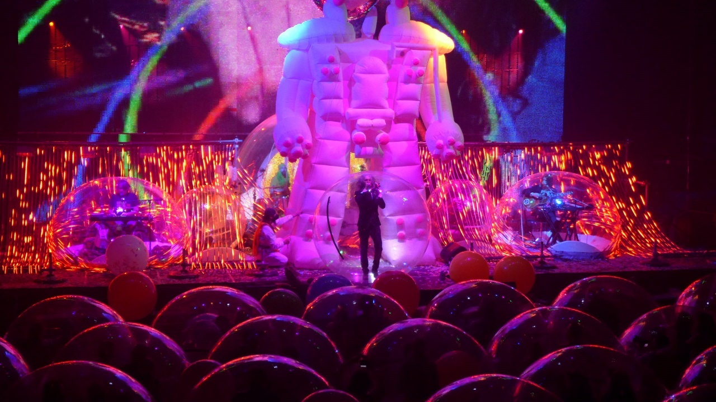
(Click here for image by Scott Booker and here for more selections)

“It’s not just another concert ...you’re part of this thing and it’s never been done before.” – Wayne Coyne

February 1, 2021 (Los Angeles, CA) – Following a pair of incredibly safe, fun, physically-distanced and wildly successful Space Bubble Concerts by The Flaming Lips, they’ve decided to do it all over again due to overwhelming demand. By all accounts, The World First-Ever Space Bubble Concerts have made headlines around the world and lifted spirits of celebrants into a much-needed electric communal bliss encased in matching plastic wombs.

These two shows, the first of their kind have been extensively covered in the media around the world. The New York Times reported, “Band members and concertgoers rocked out and bounced while encased in large individual plastic bubbles amid bright swirling lights in trippy scenes at concerts on Friday and Saturday in Oklahoma City. The band has taken the elaborate precautions at its live performances to protect against the transmission of the coronavirus.”

Last week’s shows sold out in minutes last year. Two additional events are scheduled for Friday, March 12th and Saturday, March 13th, at The Criterion (500 E. Sheridan Ave., Oklahoma City, OK). 7pm Doors / 8pm Show. Tickets go on sale for both shows on Wednesday, February 3rd at 10:00AM CT. Go to criterionokc.com to purchase tickets and for additional information. Local health and safety standards will be strictly observed for this full-production live Lips event.
For a preview of what a LIPS Space Bubble Show is like, click here to view and share “Brother Eye,” and here for “Assassins Of Youth,” from their internationally acclaimed new album AMERICAN HEAD. Both videos were directed by Wayne Coyne and filmed/edited by Blake Studdard for AtriaCreative.co.
“’American Head’ is a gorgeous, lush orchestral album of sheer beauty...a masterpiece.” – Forbes

“’American Head’ harkens back to their classic sound. Warm-hearted trippiness.” – NPR

“Devastatingly beautiful.” – Consequence Of Sound

“’American Head’ is an open invitation for you to hold onto whatever it is—whether it’s Jesus, Buddha, or, in Coyne’s case, family—that can help make this scary world feel a little more wonderful.” – Pitchfork

# # #
Contact Rick Gershon at Warner Records Publicity
Rick.Gershon@warnerrecords.com

Follow The Flaming Lips
Website | YouTube | Twitter | Instagram | Facebook | Spotify | Publicity Materials

