

**THE FLAMING LIPS RELEASE**

**“THE SPARK THAT BLED” FROM FORTHCOMING LIVE ALBUM**

[***THE SOFT BULLETIN RECORDED LIVE AT RED ROCKS WITH THE COLORADO SYMPHONY ORCHESTRA***](https://FlamingLips.lnk.to/SoftBulletinLivePreSave)

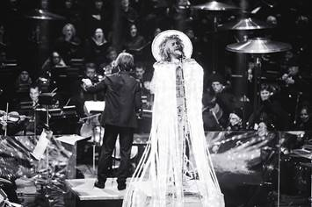

(Click [**here**](http://press.warnerrecords.com/wp-content/uploads/2019/10/The-Flaming-Lips-Red-Rocks-Shannon-Shumaker-1-HIGH-RES.jpg)for hi-res image by Shannon Shumaker)

**November 15, 2019 (Los Angeles, CA) –**Today [**THE FLAMING LIPS**](http://www.flaminglips.com)release **“The Spark That Bled”** from their first-ever live album, [***THE SOFT BULLETIN RECORDED LIVE AT RED ROCKS WITH THE COLORADO SYMPHONY ORCHESTRA***](https://FlamingLips.lnk.to/SoftBulletinLivePreSave)***.*** Pre-order the album, out November 29th, and receive an instant download of **“The Spark That Bled”** and **“Race For The Prize.”** Click **[here](https://flaminglips.lnk.to/SparkThatBled)** to view and share the visualizer for **“The Spark That Bled.”** Click [**here**](https://FlamingLips.lnk.to/SoftBulletinLivePreSave) to pre-order / pre-save the album.

**# # #**

**For further information contact:**

**Rick Gershon** 818-953-3473 / [rick.gershon@warnerrecords.com](mailto:rick.gershon@warnerrecords.com)

**Follow The Flaming Lips:**

Website: [www.flaminglips.com](http://www.flaminglips.com/)

Twitter: [@TheFlamingLips](https://twitter.com/theflaminglips)

Facebook: [Facebook.com/FlamingLips](http://www.facebook.com/FlamingLips)

YouTube: [YouTube.com/FlamingLips](http://www.youtube.com/FlamingLips)

**Press Materials:**

<http://press.warnerrecords.com/flaminglips/>