THE FLAMING LIPS SHARE JUBILANT
“ASSASSINS OF YOUTH” VIDEO - WATCH HERE

TRACK FROM AMERICAN HEAD FEATURING VIDEO WITH EVERYONE IN PLASTIC BUBBLES

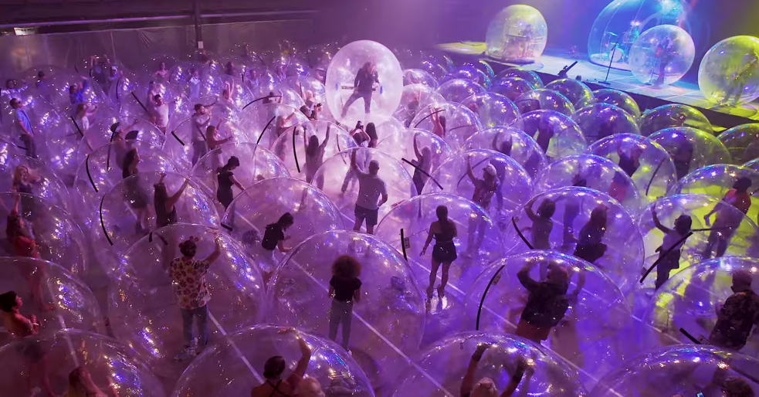

October 28, 2020 (Los Angeles, CA) – Today, The Flaming Lips return with a celebratory video for their nostalgic, reflective single “Assassins of Youth” taken from their September psych-pop masterwork American Head. Directed by Wayne Coyne, the clip was filmed at a recent socially distanced performance the band gave in Oklahoma City where both band and crowd members were encased in plastic bubbles. The event itself has since gone viral attracting headlines around the world and extensively reported on CNN, NPR, NME, Noisey-Vice, Rolling Stone, Entertainment Weekly, Buzzfeed, Variety, Uproxx, The Today Show, Marc Maron WTF, ABC, CBS, NBC, Fox, TMZ and more. Click here to view and share “Assassins of Youth.”

For years, frontman Wayne Coyne has walked atop ecstatic crowds in a bubble. But in the interest of bringing back their spectacular live gigs safely, the band extended the tradition to fans. The video captures the unexpected joy of the endeavor, celebrating The Flaming Lips’ uncanny ability to bring people together, even in the midst of these strange times. It’s a thrill just to see a crowd jumping up and down in 2020, even if they all happen to be in plastic orbs.

“Of course, our MAIN priority (when doing the performance for the music video) was making sure everyone was safe and all the health cautions were being enforced,” Coyne writes of the video. But there was a welcome side effect: “I forgot about how exciting and fun and ridiculous it is to do a Flaming Lips show!!! I think the video shows it!!!”

The band first unveiled the concept with a performance of “Race to the Prize” on The Late Show With Stephen Colbert. They followed with a spirited rendition of American Head track “God and the Policeman” on The Tonight Show Starring Jimmy Fallon in September, and continued their run of bubbled shows in October, appearing on NPR’s Tiny Desk Concerts in their newly intimate yet distant setup. The show captured in the “Assassins of Youth” video was their most ambitious yet, safely packing a hundred fans into a hometown venue.

Today, Coyne also appears on Comedy Central’s animated digital series Tales from the Trip, in which stars recount their most memorable psychedelic journey. Longtime fans of The Flaming Lips’ vibrant, kaleidoscopic compositions will know that Coyne has a story to tell. All of this caps a recent productive run for the always active group. In September, they released their studio album American Head, which quickly followed their acclaimed 2019 album King’s Mouth. They’re always up to something new and exciting, so stay tuned for more soon.

# # #
Contact Rick Gershon at Warner Records Publicity
Rick.Gershon@warnerrecords.com

Follow The Flaming Lips
Website | YouTube | Twitter | Instagram | Facebook | Spotify | Publicity Materials

