**THE FLAMING LIPS ADD MORE SPACE BUBBLE SHOWS IN OKLAHOMA CITY**

**FOR MARCH 19TH & 20TH**

**TICKETS FOR NEW DATES ON SALE FEBRUARY 12TH AT 10:00AM CT**

**The Lips To Perform At Tibet House For US 34th Annual Benefit Concert Virtual Edition On February 17th**

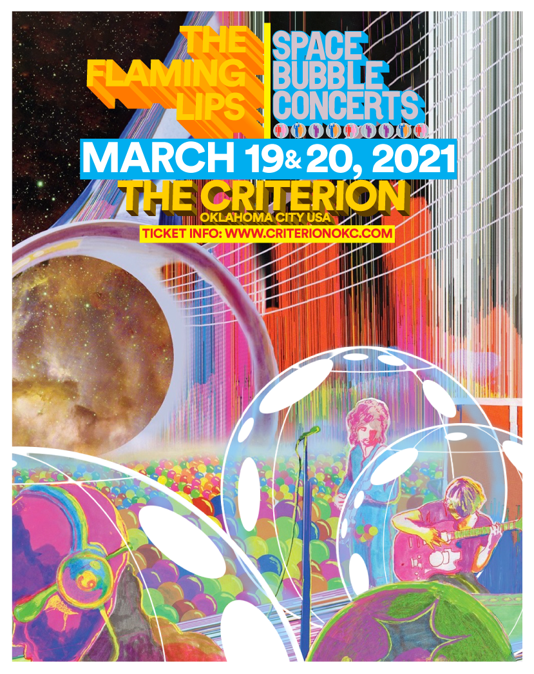

(Click [**here**](https://press.warnerrecords.com/flaminglips/) for live images from Space Bubble Concerts)

**February 10, 2021 (Los Angeles, CA) –** Due to demand for tickets,[**The Flaming Lips**](https://nam04.safelinks.protection.outlook.com/?url=https%3A%2F%2Fwww.flaminglips.com%2F&data=04%7C01%7CRick.Gershon%40warnerrecords.com%7C4d7f7d41865c44068c2108d8c6dd9006%7C8367939002ec4ba1ad3d69da3fdd637e%7C0%7C0%7C637478002356790999%7CUnknown%7CTWFpbGZsb3d8eyJWIjoiMC4wLjAwMDAiLCJQIjoiV2luMzIiLCJBTiI6Ik1haWwiLCJXVCI6Mn0%3D%7C1000&sdata=Og5X9zkO9y7Gvmp31zgGN65xwSujpjLc%2BHN1bE76f%2BI%3D&reserved=0) are adding two more **Space Bubble Concerts** to the run of March 2021 shows in Oklahoma City. The new dates are set for March 19th and 20th at [**The Criterion**](https://nam04.safelinks.protection.outlook.com/?url=https%3A%2F%2Fcriterionokc.com%2F&data=04%7C01%7CRick.Gershon%40warnerrecords.com%7C4d7f7d41865c44068c2108d8c6dd9006%7C8367939002ec4ba1ad3d69da3fdd637e%7C0%7C0%7C637478002356810903%7CUnknown%7CTWFpbGZsb3d8eyJWIjoiMC4wLjAwMDAiLCJQIjoiV2luMzIiLCJBTiI6Ik1haWwiLCJXVCI6Mn0%3D%7C1000&sdata=VcPUz1Rlmil1LLJO%2BCXZw4ufXpUDk3IHURMyZUhvusI%3D&reserved=0) (500 E. Sheridan Ave., Oklahoma City, OK) and tickets go on sale this Friday February 12th, at 10:00AM CT. Go to [**criterionokc.com**](https://nam04.safelinks.protection.outlook.com/?url=http%3A%2F%2Fcriterionokc.com%2F&data=04%7C01%7CRick.Gershon%40warnerrecords.com%7C4d7f7d41865c44068c2108d8c6dd9006%7C8367939002ec4ba1ad3d69da3fdd637e%7C0%7C0%7C637478002356810903%7CUnknown%7CTWFpbGZsb3d8eyJWIjoiMC4wLjAwMDAiLCJQIjoiV2luMzIiLCJBTiI6Ik1haWwiLCJXVCI6Mn0%3D%7C1000&sdata=zd%2BjxKYhZwmt4SL%2BEyh4MVGgGLxlGfR2d4pZz5JPKHg%3D&reserved=0) to purchase tickets and for additional information. 7pm Doors / 8pm Show. Local health and safety standards will be strictly observed for this full-production live Lips event. Wayne Coyne posted a message explaining how the shows work [**here**](https://www.instagram.com/p/CKUcplvpBpw/).

Click [**here**](https://nam04.safelinks.protection.outlook.com/?url=https%3A%2F%2Fflaminglips.lnk.to%2FBrotherEyeVideo&data=04%7C01%7CRick.Gershon%40warnerrecords.com%7C4d7f7d41865c44068c2108d8c6dd9006%7C8367939002ec4ba1ad3d69da3fdd637e%7C0%7C0%7C637478002356820863%7CUnknown%7CTWFpbGZsb3d8eyJWIjoiMC4wLjAwMDAiLCJQIjoiV2luMzIiLCJBTiI6Ik1haWwiLCJXVCI6Mn0%3D%7C1000&sdata=2%2F3Nw%2FwIIXrG1U%2FERKMdFSNNyr5AjZy50FHJuZrhn4I%3D&reserved=0) to view and share **“Brother Eye,”** and[**here**](https://nam04.safelinks.protection.outlook.com/?url=https%3A%2F%2Fwww.youtube.com%2Fwatch%3Fv%3D8j28LZbD_7A%26feature%3Dyoutu.be%26src%3DLinkfire%26lId%3D63ff9df8-033c-4131-ae85-003c369e7486%26cId%3Dd3d58fd7-4c47-11e6-9fd0-066c3e7a8751&data=04%7C01%7CRick.Gershon%40warnerrecords.com%7C4d7f7d41865c44068c2108d8c6dd9006%7C8367939002ec4ba1ad3d69da3fdd637e%7C0%7C0%7C637478002356830819%7CUnknown%7CTWFpbGZsb3d8eyJWIjoiMC4wLjAwMDAiLCJQIjoiV2luMzIiLCJBTiI6Ik1haWwiLCJXVCI6Mn0%3D%7C1000&sdata=eZBwzZ%2F4C6LwRkdfffdf3sNeIOEFJfr2FtdRFybbDOY%3D&reserved=0)for **“Assassins Of Youth,”** from their internationally acclaimed new album ***AMERICAN HEAD.***  Both videos were directed by **Wayne Coyne** and filmed/edited by **Blake Studdard** for [AtriaCreative.co](https://nam04.safelinks.protection.outlook.com/?url=https%3A%2F%2Fwww.atriacreative.co%2F&data=04%7C01%7CRick.Gershon%40warnerrecords.com%7C4d7f7d41865c44068c2108d8c6dd9006%7C8367939002ec4ba1ad3d69da3fdd637e%7C0%7C0%7C637478002356830819%7CUnknown%7CTWFpbGZsb3d8eyJWIjoiMC4wLjAwMDAiLCJQIjoiV2luMzIiLCJBTiI6Ik1haWwiLCJXVCI6Mn0%3D%7C1000&sdata=NRFFqRDGyQJCBufpJH1bofNmPmFnKKN5WHUgUWoW4hc%3D&reserved=0).

***AMERICAN HEAD*** continues to attract critical praise:

*“The Flaming Lips' most emotionally direct, personal album ever.”* ***– Brooklyn Vegan***

*“The imaginative innocence, acid trip dreaminess, Beatles-esque psych fitting together like the kind of Lips puzzle only they can assemble.”  –* ***SPIN***

*“’American Head’ is an open invitation for you to hold onto whatever it is—whether it’s Jesus, Buddha, or, in Coyne’s case, family—that can help make this scary world feel a little more wonderful.” –* ***Pitchfork***

As previously announced, **The Flaming Lips** will also perform virtually for this year’s **Tibet House US 34th Annual Benefit Concert** set for February 17th, at 8:00PM EST. Other performers include Eddie Vedder, Patti Smith, Iggy Pop, Phoebe Bridgers and many more. Click [**here**](https://shorefire.com/releases/entry/the-34th-annual-tibet-house-us-benefit-concert-virtual-edition#:~:text=New%20York%2C%20NY%20%E2%80%93%20January%2014,Mandolin%2C%20the%20premiere%20concert%20livestream) to view the press release and [**here**](https://boxoffice.mandolin.com/pages/tibet-house?utm_source=press-release&utm_medium=web&utm_campaign=tibet-house) for complete ticket and livestream details. Click [**here**](https://www.dropbox.com/s/lh5ni9t5wnl5kwr/tibet.jpg?dl=0)to view and share the poster.

**# # #**

Contact **Rick Gershon** at Warner Records Publicity

[**Rick.Gershon@warnerrecords.com**](mailto:Rick.Gershon@warnerrecords.com)

**Follow The Flaming Lips**

[**Website**](http://www.flaminglips.com/) **|** [**YouTube**](https://www.youtube.com/user/flaminglips) **|** [**Twitter**](https://twitter.com/theflaminglips) **|** [**Instagram**](https://www.instagram.com/waynecoyne5) **|** [**Facebook**](https://www.facebook.com/flaminglips/) **|** [**Spotify**](https://open.spotify.com/artist/16eRpMNXSQ15wuJoeqguaB) **|** [**Publicity Materials**](https://press.warnerrecords.com/flaminglips/)

