THE HEAD AND THE HEART’S LIVING MIRAGE
OUT NEXT FRIDAY, MAY 17TH

INTIMATE RELEASE DAY SHOW AT NEW YORK’S
BOWERY BALLROOM ANNOUNCED AND ON SALE NOW

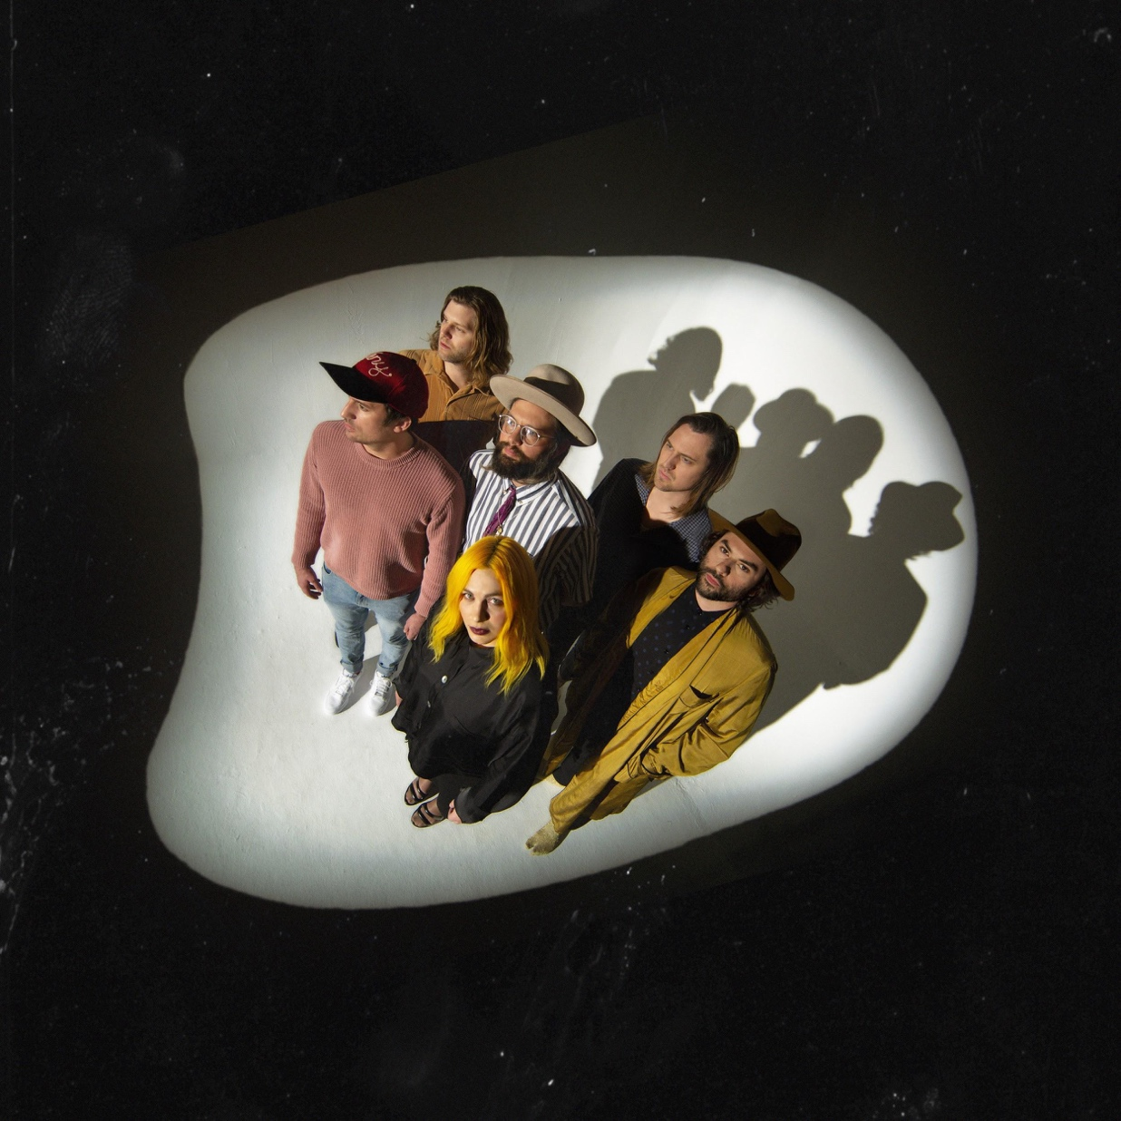

Band To Perform “Missed Connection” On The Tonight Show Starring Jimmy Fallon Thursday, May 16th

North American Tour On Sale & Album Available To Pre-Order

May 10, 2019 – (Los Angeles, CA) - The Head and The Heart’s newest album Living Mirage is due out next Friday, May 17th on Warner Bros. Records / Reprise Records. In anticipation of the release, the band announced an intimate, fan-focused release day show at New York’s legendary Bowery Ballroom with tickets on sale NOW. Front and Center will film the performance for an upcoming episode airing this summer on public television. This show is ahead of their previously announced headlining Forest Hills Stadium show slated for June 23rd.

In addition, The Head and the Heart will make an appearance on The Tonight Show Starring Jimmy Fallon to perform their current single “Missed Connection” on Thursday, May 16th. “Missed Connection” is one of three tracks to have been released off the forthcoming album, including “Honeybee” featuring the vocals of the band’s beloved Charity Rose Thielen, as well as “People Need a Melody” which, just yesterday, The Head and The Heart released a gorgeous video of a stripped version performed by frontman Jonathan Russell.

Watch the video for “Missed Connection” here.
Listen to “People Need a Melody” here or watch singer Jonathan Russell perform a stripped down version here.
Listen to “Honeybee” here.

The band will kick off a 38-city tour starting in Buffalo, NY on June 21st, making stops in Austin, Denver, Chicago, Atlanta and more, before wrapping in Toronto October 20th. A full rundown of tour dates can be found below. Special guest Hippo Campus will join the July dates of the tour. Tickets are on sale now via LiveNation.com. Tickets purchased online for select tour dates (as noted below) includes your choice of a CD or digital copy of the new album, Living Mirage, which will be released on May 17, 2019. Purchasers will receive instructions via email on how to redeem the album after ticket purchase. Complete list of tour dates below.

About The Head and The Heart
The Head and The Heart return this spring with their 4th full-length album, Living Mirage, featuring newly released “Missed Connection.” Initially self-released in 2011, The Head And The Heart’s self-titled breakout debut produced instant classics including “Rivers and Roads,” “Down In The Valley” and “Lost In My Mind” and is now Certified Gold. Their last two albums, 2013’s Let’s Be Still and 2016’s Signs of Light, settled into Billboard’s Top 10 albums chart, with Signs of Light securing the #1 position on Rock Album Charts. It also produced the song “All We Ever Knew” which reached #1 at Alternative, after holding the #1 spot at AAA for 9 straight weeks earlier that same year. They have appeared in Cameron Crowe’s Roadies, with music featured in countless other commercials, films and shows, among themCorona and Silver Linings Playbook. Having played consecutive sold-out Red Rocks shows and prime time mainstage slots at Coachella, Lollapalooza and Austin City Limits on the last campaign, the band have a headlining tour planned for 2019, including another two sold-out Red Rocks shows in July. In total, the band has performed 13 times on national television including appearances on Ellen, The Tonight Show Starring Jimmy Fallon, Austin City Limits and more.

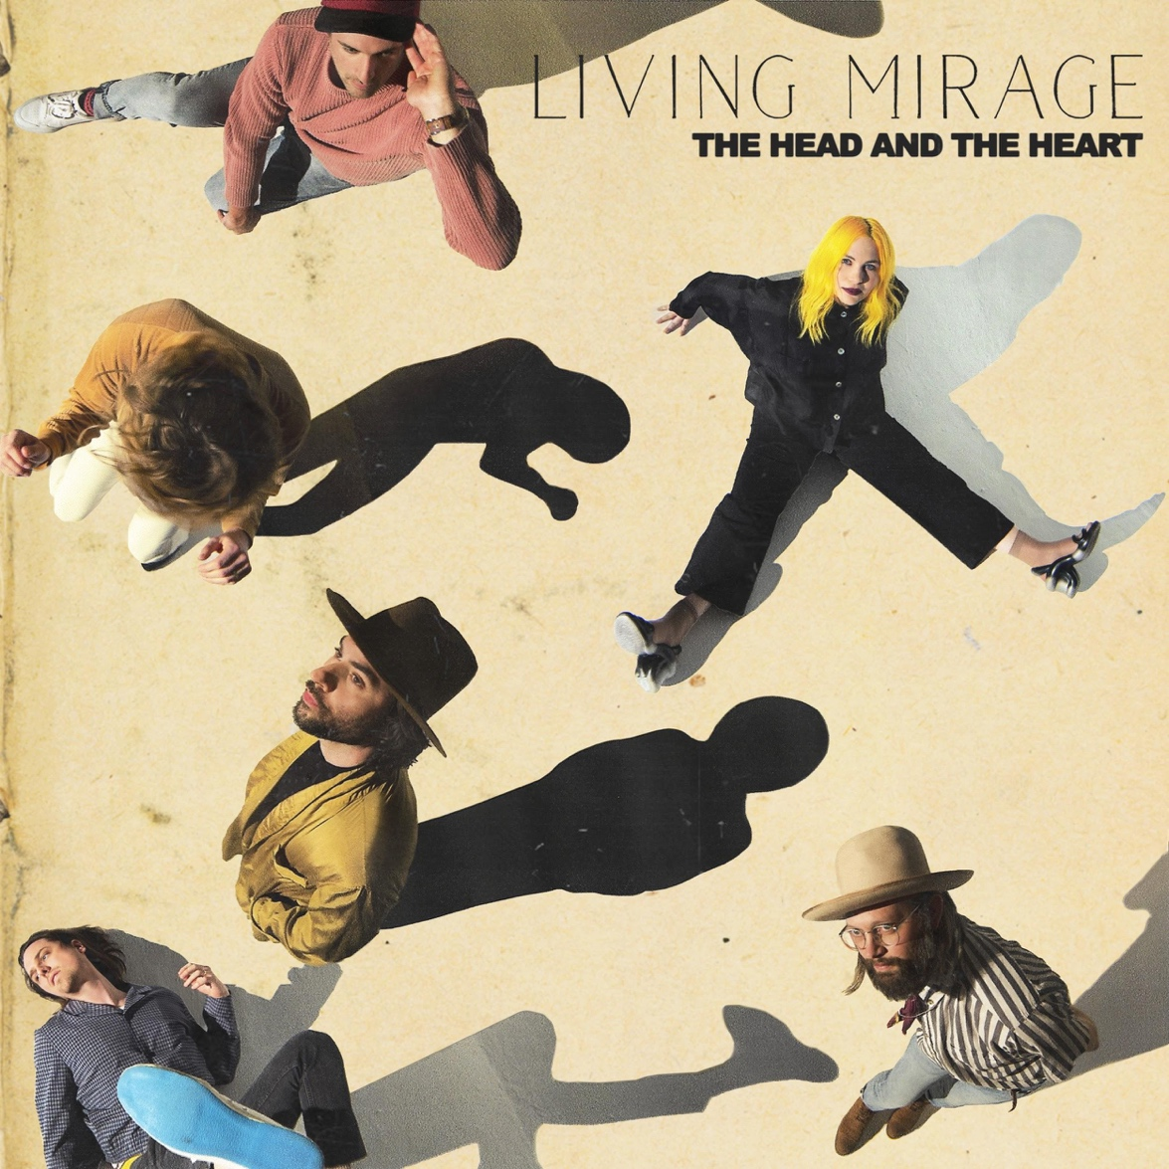

Living Mirage Tracklisting:
01. See You Through My Eyes
02. Missed Connection
03. People Need a Melody
04. Honeybee
05. Brenda
06. Running Through Hell
07. Up Against The Wall
08. Saving Grace
09. I Found Out
10. Living Mirage
11. Glory of Music

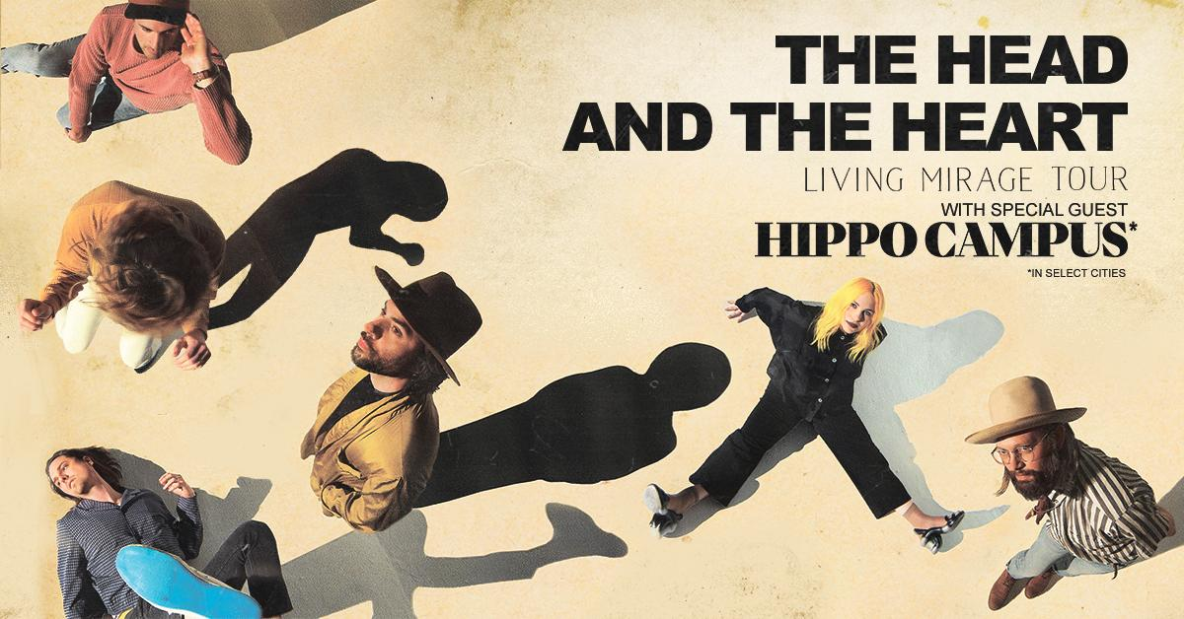

North American Tour Dates:
05/17/19 - Bowery Ballroom - New York, NY
06/21/19 - Alternative Buffalo’s Kerfuffle – Canalside – Buffalo, NY +^
06/23/19 - Alt 92.3 Summer Open - Forest Hills Stadium – New York, NY +^
07/05/19 - Summerfest - Milwaukee, WI +^
07/06/19 - Starlight Theatre - Kansas City, MO *
07/07/19 - Stifel Theatre - St. Louis, MO *
07/09/19 - ACL Live at The Moody Theater - Austin, TX *
07/10/19 - ACL Live at The Moody Theater - Austin, TX *
07/12/19 - The Pavilion at Toyota Music Factory - Dallas, TX *
07/13/19 - White Oak Music Hall - Houston, TX *
07/14/19 - Brady Theater - Tulsa, OK
07/17/19 - Red Rocks Amphitheatre - Denver, CO * +^
07/18/19 - Red Rocks Amphitheatre - Denver, CO * +^
07/19/19 - The Great Saltair - Salt Lake City, UT *
07/22/19 - Comerica Theatre - Phoenix, AZ *
07/23/19 - Santa Barbara Bowl - Santa Barbara, CA *+
07/25/19 - Grand Theatre at The Grand Sierra Resort - Reno, NV *
07/26/19 - Bill Graham Civic Auditorium - San Francisco, CA *
09/06/19 - Murat Theatre at Old National Centre - Indianapolis, IN
09/08/19 - PNC Pavilion at Riverbend Music Center - Cincinnati, OH
09/10/19 - Jacobs Pavilion at Nautica - Cleveland, OH
09/11/19 - 20 Monroe Live - Grand Rapids, MI
09/13/19 - Chicago Theatre - Chicago, IL
09/15/19 - The Sylvee - Madison, WI
09/18/19 - The Armory - Minneapolis, MN
09/19/19 - Stephens Auditorium - Ames, IA
09/21/19 - Pilgrimage Music & Cultural Festival - Franklin, TN +^
09/23/19 - Avondale Brewing Company - Birmingham, AL
09/24/19 - The Fillmore - New Orleans, LA
09/26/19 - Thomas Wolfe Auditorium - Asheville, NC
09/27/19 - The Tabernacle - Atlanta, GA
09/29/19 - Charlotte Metro Credit Union Amphitheatre - Charlotte, NC
10/01/19 - Red Hat Amphitheater - Raleigh, NC
10/03/19 - The Anthem - Washington, DC
10/08/19 - The MET - Philadelphia, PA
10/09/19 - Palace Theatre - Albany, NY
10/11/19 - Toyota Presents Oakdale Theatre - Wallingford, CT
10/12/19 - Agganis Arena - Boston, MA
10/14/19 - UPMC Events Center - Moon Twp., PA
10/15/19 - The Fillmore Detroit presented by Cricket Wireless - Detroit, MI
10/16/19 - Palace Theatre - Columbus, OH
10/18/19 - Algonquin Commons Theatre - Ottawa, ON
10/19/19 - MTELUS - Montreal, QC
10/20/19 - Sony Centre for the Performing Arts - Toronto, ON

*Hippo Campus
+not a Live Nation date
^ tickets purchased for this date will not include the album

For more information about The Head and The Heart, please contact:
Kate Jackson, KateJ@grandstandhq.com
Katie Nelson, KatieN@grandstandhq.com
Bobbie Gale Bobbie.Gale@wbr.com

