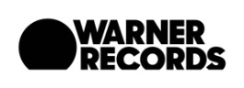
THE FLAMING LIPS ADD ORCHESTRATED SHOWS IN PORTLAND AND DALLAS
TO THEIR SPRING 2020 TOUR

Tickets for both Shows on Sale January 30th at 10:00AM

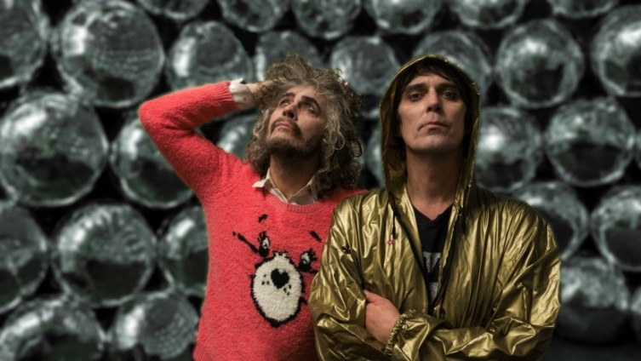
(Photo credit: George Salisbury. Click here for hi-res image)

January 27th, 2020 (Los Angeles, CA) – Due to popular demand, THE FLAMING LIPS have confirmed two additional shows to their Spring tour performing all of The Soft Bulletin in its entirety backed by full orchestras and vocal choirs in Portland, Oregon on April 13th and in Dallas, Texas as part of the Dallas Symphony’s SOLUNA Festival on April 19th. Tickets for both shows go on sale to the public January 30th, at 10:00am local time. Click HERE for details.

These very special shows honor the 20th anniversary of The Lips groundbreaking 1999 masterpiece, The Soft Bulletin. Two decades since its original release and the deep-seated affect and influence of this seminal work continues to resonate just as brightly.

“This is one of those albums people are going to obsess over for many years to come.” – Pitchfork

“Once you’ve labored in cult obscurity, fielded rumors that John Tesh wanted to cover one of your songs, appeared on Beverly Hills 90210, composed an orchestra for forty automobile tape decks and enjoyed a Top Forty blip, what do you do for a follow-up? The eccentric Oklahoma outfit The Flaming Lips serenely release another winning neo-psychedelic recording. Densely textured but melodic…No one else has posited a parallel universe in which the Sixties and the Nineties exist simultaneously.” – Rolling Stone

As previously announced, The Soft Bulletin Recorded Live At Red Rocks With The Colorado Symphony Orchestra was recorded May 26th, 2016, at the prestigious Red Rocks Amphitheatre in Morrison, Colorado. The Lips (Wayne Coyne, Steven Drozd, Michael Ivins, Derek Brown, Jake Ingalls, Matt Kirksey and Nicholas Ley) performed their universally acclaimed 1999 Warner Records album The Soft Bulletin in its entirety accompanied by a 69-piece orchestra and 56-strong chorus and was conducted by the internationally celebrated conductor Andre de Ridder. Click HERE to purchase.

2020 TOUR DATES:
# indicates orchestral show performing The Soft Bulletin

# April 13 Portland, OR Arlene Schnitzer Concert Hall
The Flaming Lips w/ The Oregon Symphony and Choir
April14 Spokane, WA Fox Theatre
April 15 Missoula, MT The Wilma
# April 19 Dallas, TX Soluna Festival at Morton H. Meyerson Symphony Center
The Flaming Lips w/ The Dallas Symphony Orchestra and Dallas Symphony Choir
May 22 Walton-on-Trent, UK Bearded Theory Spring Gathering
June 12 Denver, CO Mission Ballroom
June 13 Ogden, UT Ogden Amphitheatre
June 16 San Diego, CA San Diego State Fair
June 17 Los Angeles, CA The Wiltern
June 18 San Francisco, CA The Warfield Theatre
June 21 Vancouver, BC The Commodore Ballroom
June 22 Vancouver, BC The Commodore Ballroom
July 18 Galway, Ireland Galway International Arts Festival Big Top

# # #

Contact:
National: Rick Gershon at Warner Records
818-953-3473 | Rick.Gershon@warnerrecords.com

Regional: Bre Flores at Warner Records
818-953-3638 | Breanne.Flores@warnerrecords.com

Follow The Flaming Lips
Publicity Materials | Website | YouTube | Twitter | Instagram | Facebook | Spotify

