TOM PETTY’S
“YOU AND ME (CLUBHOUSE VERSION)”
VIDEO PREMIERES VIDEO CREATED USING PERSONAL PHOTOS AND FOOTAGE FROM FANS

AN AMERICAN TREASURE BOX SET TO BE RELEASED
SEPTEMBER 28 ON REPRISE RECORDS

60-TRACK SET INCLUDES NEWLY DISCOVERED RECORDINGS FROM TOM PETTY’S VAULTS
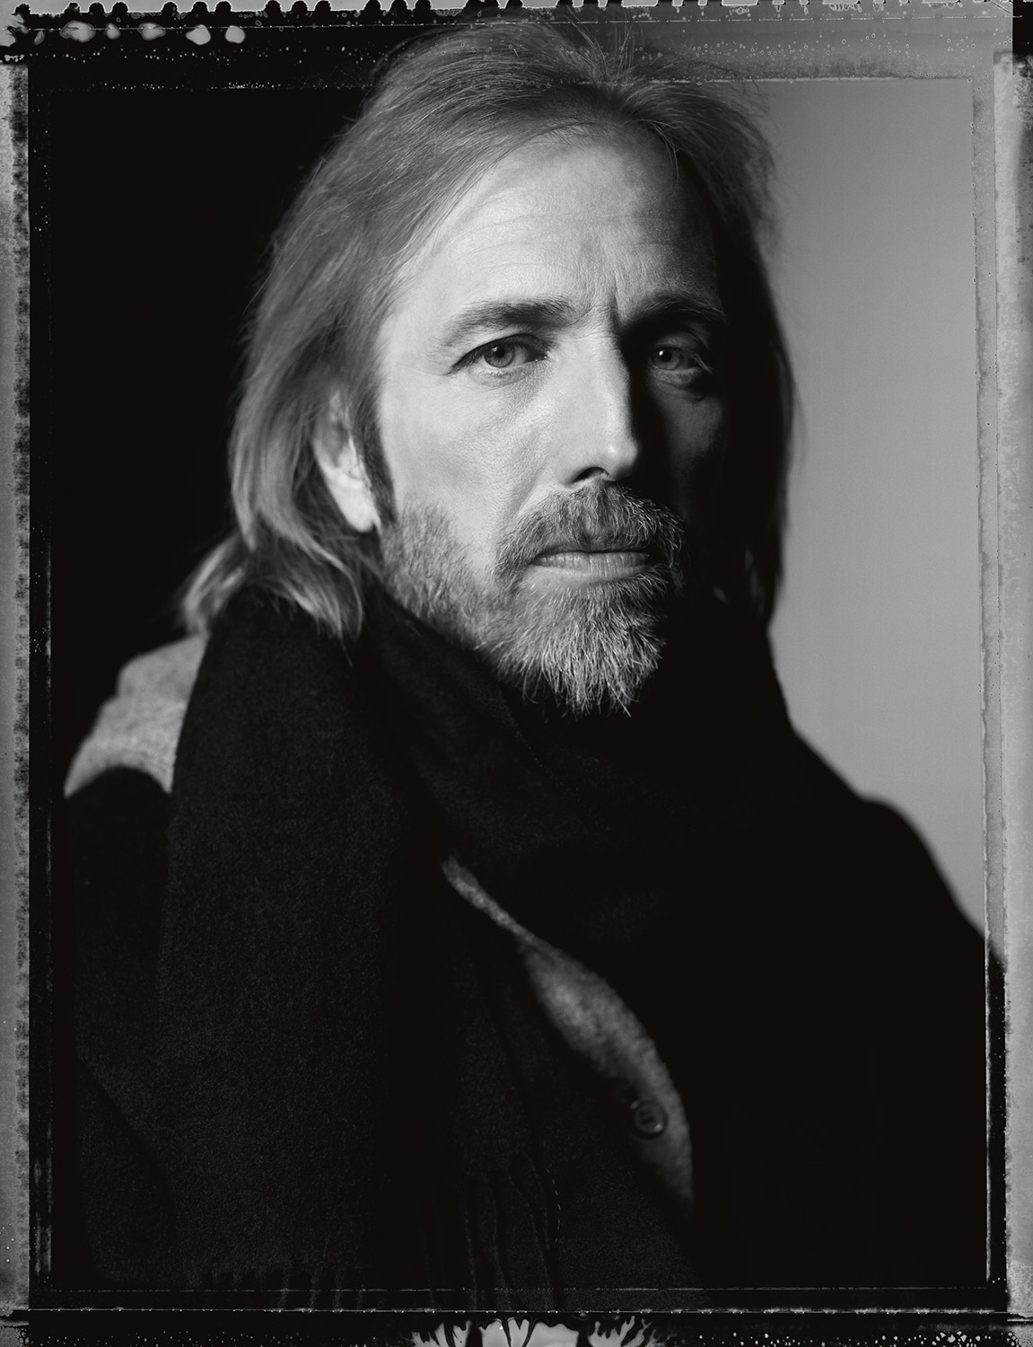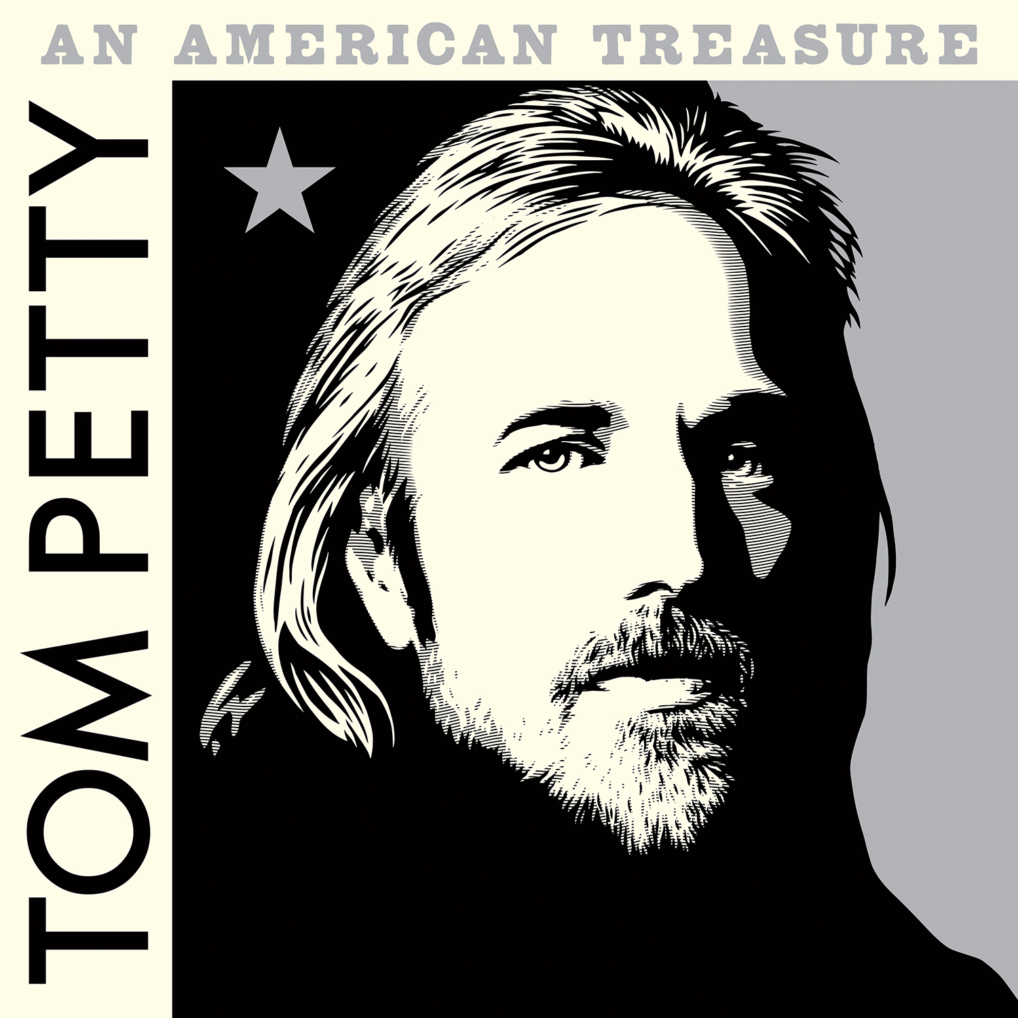
Photo credit: Mark Seliger Album artwork by Shepard Fairey
August 23, 2018 (Los Angeles) - “You And Me (Clubhouse Version)”—a previously unreleased alternate version of the song, recorded in 2007—is the latest track to be revealed from the upcoming, career-spanning Tom Petty box set An American Treasure. The video was created using fan-submitted personal photos and footage of their favorite and cherished moments of Tom and The Heartbreakers from throughout the years. Watch HERE. An American Treasure is available for pre-order now with instant downloads of “You And Me (Clubhouse Version)” as well as “Keep A Little Soul” HERE.
“You And Me (Clubhouse Version)” follows the release of “Keep A Little Soul”—a previously unreleased recording from 1982 sessions that resulted in Tom Petty & The Heartbreakers’ classic album, Long After Dark. “Keep A Little Soul” recently entered the top 10 on Billboard’s Adult Alternative Songs chart, making Tom the first artist in the history of the chart to reach the top 10 posthumously.
An American Treasure will be released September 28 on Reprise Records. The 60-track set unveils previously unreleased recordings, alternate versions of classic songs, rarities, historic live performances and deep tracks that spotlight Tom’s remarkable depth and evolution as a revered and tremendously influential songwriter, recording artist and performer. An American Treasure marks the first release of Tom Petty music since the artist’s tragic passing in October 2017.
Tom’s daughter, Adria Petty, and his wife, Dana Petty, were the primary catalysts for the commission, creation and release of An American Treasure—a tribute and love letter pointing to the music in between the hits, and a strong musical portrait of the person they know in their hearts. Adria and Dana both serve as the project’s Executive Producers, and, together with Tom’s bandmates of 45 years, Heartbreakers Mike Campbell and Benmont Tench, and his studio collaborator, Ryan Ulyate, curated the box set’s track list from Petty’s rich song catalog. Campbell, Tench and Ulyate also produced An American Treasure.
The creation of An American Treasure was a true labor of love, as Adria Petty and Dana Petty explain, “Everyone involved in this project chose each track with tremendous care and deep respect for the body of work Tom Petty created over the course of 40 years. He also accumulated a wealth of unreleased music in his vaults, and we have collectively uncovered one gem after another that will keep us all listening and discovering new facets of Tom’s talent for many years to come. We can’t wait to share with Tom’s fans this musical portrait of an artist who deeply affected our culture and indelibly touched the lives of fans the world over.”
The custom cover artwork for An American Treasure was created by prominent American artist
Shepard Fairey from an image of Petty by renowned photographer Mark Seliger.
An American Treasure will be released in multiple formats:
An American Treasure: Deluxe Edition—A 4-CD set that features all 60 tracks, plus a 52-page booklet with rare and previously unseen photographs of Tom, his bandmates, family and friends. The booklet also features detailed track-by-track liner notes by noted journalist and Tom Petty aficionado Bud Scoppa, who drew upon his previous interviews with Tom and new conversations with Mike Campbell, Benmont Tench and Ryan Ulyate, as well as Adria and Dana Petty.
An American Treasure: Super Deluxe Limited Edition—A 4-CD set that features all 60 tracks and an 84-page hardbound book expanded from the Deluxe Edition to include many additional photographs and an essay by renowned author Nicholas Dawidoff – written especially for An American Treasure – that speaks to Tom Petty’s presence in our lives and influence on our culture for more than 40 years. This special package also includes a newly-created lithograph of Shepard Fairey’s cover artwork, as well as custom reproductions of Tom Petty’s handwritten lyrics to four songs featured in this collection and a numbered certificate of authenticity.
An American Treasure: Vinyl Edition—A 6-LP set that features all 60 tracks and a 48-page booklet containing all of the photographic and editorial elements found in the CD Deluxe Edition. This set also includes the Nicholas Dawidoff essay. This special Vinyl Edition will be released on Friday, November 23, but is available for pre-order now.
An American Treasure: Standard Edition—A 2-CD set that features 26 career spanning tracks chosen from the Deluxe editions, as well as Bud Scoppa’s detailed track-by-track.
All newly released recordings on An American Treasure have been mixed by Ryan Ulyate from pristine transfers of the original studio multitrack masters. All 60 recordings have been re-mastered for this collection by Chris Bellman at Bernie Grundman Mastering.
AN AMERICAN TREASURE TRACK LISTING (4-CD Editions):
CD 1
1 Surrender Previously unreleased track from Tom Petty and the Heartbreakers sessions—1976
2 Listen To Her Heart Live at The Record Plant, Sausalito, CA—April 23, 1977
3 Anything That’s Rock ‘N’ Roll Live at Capitol Studios, Hollywood, CA—November 11, 1977
4 When The Time Comes Album track from You’re Gonna Get It!—May 2, 1978
5 You’re Gonna Get It Alternate version featuring strings from You’re Gonna Get It! sessions—1978
6 Radio Promotion Spot 1977
7 Rockin’ Around (With You) Album track from Tom Petty and the Heartbreakers —November 9, 1976
8 Fooled Again (I Don’t Like It) Alternate version from Tom Petty and the Heartbreakers—1976
9 Breakdown Live at Capitol Studios, Hollywood, CA—November 11, 1977
10 The Wild One, Forever Album track from Tom Petty and the Heartbreakers—November 9, 1976
11 No Second Thoughts Album track from You’re Gonna Get It!—May 2, 1978
12 Here Comes My Girl Alternate version from Damn The Torpedoes sessions—1979
13 What Are You Doing In My Life Alternate version from Damn The Torpedoes sessions—1979
14 Louisiana Rain Alternate version from Damn The Torpedoes sessions—1979
15 Lost In Your Eyes Previously unreleased single from Mudcrutch sessions—1974
CD 2
1 Keep A Little Soul Previously unreleased track from Long After Dark sessions—1982
2 Even The Losers Live at Rochester Community War Memorial, Rochester, NY—1989
3 Keeping Me Alive Previously unreleased track from Long After Dark sessions—1982
4 Don’t Treat Me Like A Stranger B-side to UK single of “I Won’t Back Down”—April, 1989
5 The Apartment Song Demo recording (with Stevie Nicks)—1984
6 Concert Intro Live introduction by Kareem Abdul-Jabbar, The Forum, Inglewood, CA—June 28, 1981
7 King’s Road Live at The Forum, Inglewood, CA—June 28, 1981
8 Clear The Aisles Live concert announcement by Tom Petty, The Forum, Inglewood, CA—June 28, 1981
9 A Woman In Love (It’s Not Me) Live at The Forum, Inglewood, CA—June 28, 1981
10 Straight Into Darkness Alternate version from The Record Plant, Hollywood, CA—May 5, 1982
11 You Can Still Change Your Mind Album track from Hard Promises—May 5, 1981
12 Rebels Alternate version from Southern Accents sessions—1985
13 Deliver Me Alternate version from Long After Dark sessions—1982
14 Alright For Now Album track from Full Moon Fever—April 24, 1989
15 The Damage You’ve Done Alternate version from Let Me Up (I’ve Had Enough) sessions—1987
16 The Best Of Everything Alternate version from Southern Accents sessions—March 26, 1985
17 Walkin’ From The Fire Previously unreleased track from Southern Accents sessions—March 1, 1984
18 King Of The Hill Early take (with Roger McGuinn)—November 23, 1987
CD 3
1 I Won’t Back Down Live at The Fillmore, San Francisco, CA—February 4, 1997
2 Gainesville Previously unreleased track from Echo sessions—February 12, 1998
3 You And I Will Meet Again Album track from Into The Great Wide Open—July 2, 1991
4 Into The Great Wide Open Live at Oakland-Alameda County Coliseum Arena—November 24, 1991
5 Two Gunslingers Live at The Beacon Theatre, New York, NY—May 25, 2013
6 Lonesome Dave Previously unreleased track from Greatest Hits sessions—July 23, 1993
7 To Find A Friend Album track from Wildflowers—November 1, 1994
8 Crawling Back To You Album track from Wildflowers—November 1, 1994
9 Wake Up Time Alternate version from early Wildflowers sessions—August 12, 1992
10 Grew Up Fast Album track from Songs and Music from “She’s the One”—August 6, 1996
11 I Don’t Belong Previously unreleased track from Echo sessions—December 3, 1998
12 Accused Of Love Album track from Echo—April 13, 1999
13 Lonesome Sundown Album track from Echo—April 13, 1999
14 Don’t Fade On Me Alternate take from Wildflowers—sessions—April 20, 1994
CD 4
1 You And Me Clubhouse version—November 9, 2007
2 Have Love Will Travel Album track from The Last DJ—October 8, 2002
3 Money Becomes King Album track from The Last DJ—October 8, 2002
4 Bus To Tampa Bay Previously unreleased track from Hypnotic Eye sessions—August 11, 2011
5 Saving Grace Live at Malibu Performing Arts Center, Malibu, CA—July 26, 2006
6 Down South Album track from Highway Companion—July 25, 2006
7 Southern Accents Live at Stephen C. O’Connell Center, Gainesville, FL—September 21, 2006
8 Insider Live (with Stevie Nicks) at O’Connell Center, Gainesville, FL—September 21, 2006
9 Two Men Talking Previously unreleased track from Hypnotic Eye sessions—November 16, 2012
10 Fault Lines Album track from Hypnotic Eye—July 29, 2014
11 Sins Of My Youth Early take from Hypnotic Eye sessions—November 12, 2012
12 Good Enough Alternate version from Mojo sessions—2012
13 Something Good Coming Album track from Mojo—July 15, 2010
14 Save Your Water Album track from Mudcrutch 2—May 20, 2016
15 Like A Diamond Alternate version from The Last DJ sessions—2002
16 Hungry No More Live at House of Blues, Boston, MA—June 15, 2016

TomPetty.com | Facebook.com/TomPetty | Twitter.com/TomPetty | Instagram.com/TomPettyOfficial

