THE FLAMING LIPS CONFIRM WORLD TOUR FOR 2022
TICKETS ON SALE MAY 7th

LONG SOUGHT-AFTER LIPS RARITY THE SOFT BULLETIN COMPANION
TO BE RELEASED ON VINYL FOR THE FIRST TIME EVER
IN HONOR OF RECORD STORE DAY ON JUNE 12 VIA WARNER RECORDS

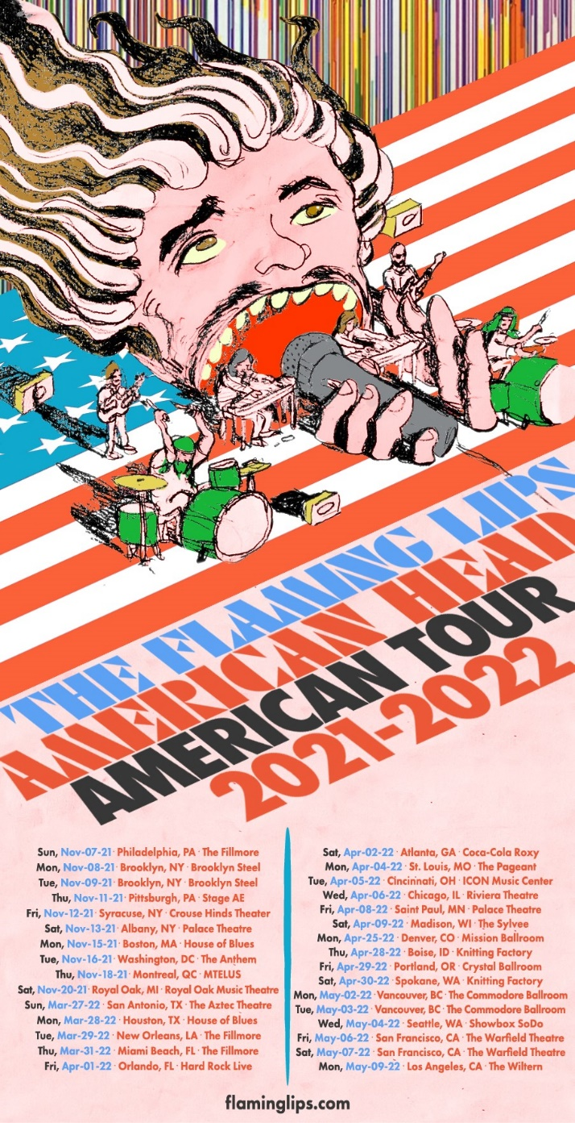

May 3, 2021 (Los Angeles, CA) – Following the overwhelming success and demand for tickets for the first-ever Space Bubble Concerts, The Flaming Lips announce their return to the road for a worldwide tour schedule to begin this summer with dates extending well into 2022. Tickets go on sale to the public Friday, May 7th. Click here for details.

THE FLAMING LIPS on Tour 2021/2022:
2021:
Fri Aug 20 Ogden Amphitheatre Ogden, UT
Sat Aug 21 Psycho Las Vegas Las Vegas, NV

Sun Nov 07 The Fillmore Philadelphia, PA
Mon Nov 08 Brooklyn Steel Brooklyn, NY
Tue Nov 09 Brooklyn Steel Brooklyn, NY
Thu Nov 11 Stage A&E Pittsburgh, PA
Fri Nov 12 Crouse Hinds Theater Syracuse, NY
Sat Nov 13 Palace Theater Albany, NY
Mon Nov 15 House of Blues Boston, MA
Tue Nov 16 The Anthem Washington, DC
Thu Nov 18 MTELUS Montreal, QC
Sat Nov 20 Royal Oak Music Theater Royal Oak, MI

2022:
Sun Mar 27 The Aztec Theatre San Antonio, TX
Mon Mar 28 House Of Blues Houston, TX
Tue Mar 29 The Fillmore New Orleans, LA
Thu Mar 31 The Fillmore Miami Beach, FL
Fri Apr 01 Hard Rock Live Orlando, FL
Sat Apr 02 Coca-Cola Roxy Atlanta, GA
Mon Apr 04 The Pageant St. Louis, MO
Tue Apr 05 ICON Music Center Cincinnati, OH
Wed Apr 06 Riviera Theatre Chicago. IL
Fri Apr 08 Palace Theatre St. Paul. MN
Sat Apr 09 The Sylvee Madison, Wi
Mon Apr 25 Mission Ballroom Denver, CO
Thu Apr 28 Knitting Factory Boise, ID
Fri Apr 29 Crystal Ballroom Portland, OR
Sat Apr 30 Knitting Factory Spokane, WA
Mon May 02 Commodore Ballroom Vancouver, BC
Tue May 03 Commodore Ballroom Vancouver, BC
Wed May 04 Showbox SoDo Seattle, WA
Fri May 06 Warfield Theatre San Francisco, CA
Sat May 07 Warfield Theatre San Francisco, CA
Mon May 09 The Wiltern Los Angeles, CA

Wed May 25 Stylus Leeds, UK
Thu May 26 Invisible Wind Factory Liverpool, UK
Mon May 30 Waterside Theatre Aylesbury, UK
Wed June 01 De La Warr Pavilion Bexhill, UK
Thu June 02 O2 Forum Kentish Town London, UK
Fri July 22 Galway Int’l Arts Fest. Galway IRE

Click here for additional ticket information.

Equally exciting for Lips fans is the unearthing one of the rarest and most sought-after gems in their legendary catalog. The Flaming Lips will finally release The Soft Bulletin Companion on vinyl for the first time as part of the Record Store Day drop on June 12, 2021. Pressed on double silver vinyl, this exclusive 2 LP edition set is limited to just 16,000 copies worldwide and is expected to sell out quickly. It will be available at independent record stores everywhere. The album will be more widely available later this year – details will follow.

Disseminated among press, radio, family, and friends in limited quantity 22 years ago, Lips’ management assembled The Soft Bulletin Companion by hand as a promo-only CD to accompany the band’s groundbreaking album The Soft Bulletin in 1999. It consisted of unreleased material, outtakes, early mixes, B-sides, international bonus tracks, and stereo versions of tunes from Zaireeka. Expanding the lore of this hidden treasure trove, “The Captain” emerged as a fan favorite rarity, yet never saw a release on vinyl—until now.

The Soft Bulletin represented a watershed moment in the group’s journey. Powered by signature tracks such as “Race for the Prize,” Pitchfork notably rated it a perfect score of 10.0 and pegged it at #3 on the “Top 100 Albums of the 1990s.” Entertainment Weekly awarded the album an “A,” and NME scored it “9-out-of-10.” It closed out the 20th century for the band and paved the way into the 21st century, setting the stage for three subsequent GRAMMY® Awards, sales in the millions, and unprecedented innovation. One of the most important albums of all time and a turning point, it cemented the group as an iconic alternative institution and asserted them as a perennial creative presence in popular culture.

Audiences finally get the chance to dive deeper into The Soft Bulletin era with The Soft Bulletin Companion on vinyl.

In case you missed The Flaming Lips’ incredible segment on CBS Sunday yesterday, click here to view and share. The Lips also recently appeared on ABC’s Jimmy Kimmel Live. Click here to view and share their performance of “Will You Return/When You Come Down,” from AMERICAN HEAD.

As previously reported, Wayne Coyne’s new cannabis product line, Love Yer Brain, officially launched on 4/20. Visit loveyerbrain.com for more details.

The Soft Bulletin Companion Tracklisting:
- 35,000 ft. of Despair (5:06)
- 1000 ft. Hands (early mix) (3:24)
- 2025 (Invisible Now) (5:54)
- Buggin’ (Lips mix) (3:24)
- A Machine in India (4:09)
- Okay I’ll Admit (4:32)
- The Captain (5:08)
- Satellite of You (4:33)
- The Spiderbite Song (early mix) (4:00)
- Slow Motion (early mix) (3:21)
- 1000 ft. Hands (final mix) (5:51)
- Little Hands (rough mix) (4:40)
- The Big Ol’ Bug (4:39)

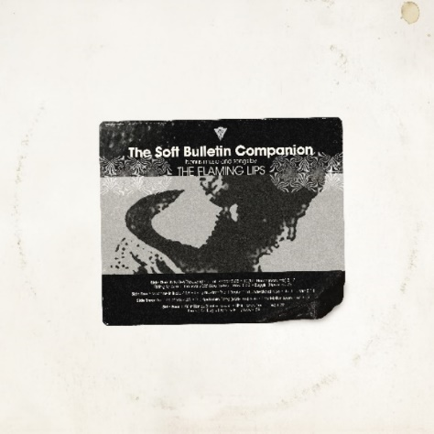
(Click here for hi-res album cover art)

# # #

Contact:
Rick Gershon at Warner Records
Rick.Gershon@warnerrecords.com

Follow The Flaming Lips
Website | YouTube | Twitter | Instagram | Facebook | Spotify | Publicity Materials
