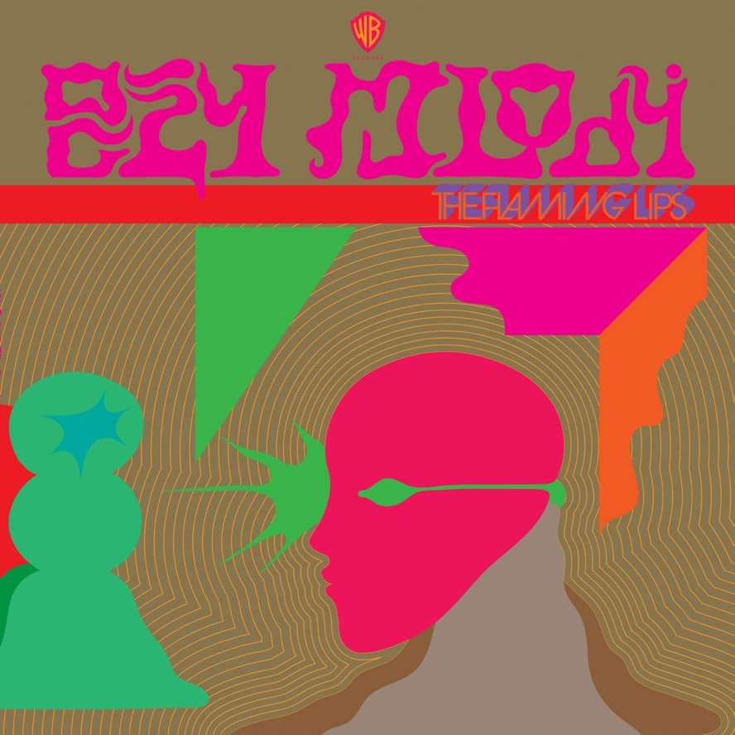

When asked (about our newest album Oczy Mlody) what does your new stuff sound like..?? My current response
has been that it sounds like Syd Barrett meets A$AP Rocky and they get trapped in a fairy tale from the future.. Ha.. Knowing full well that if you know who Syd Barrett is.. (original founder of classic rock/space opera group Pink Floyd) you probably DON’T know who A$AP Rocky is (current badass psychedelic rapper).. and if you know and like A$AP Rocky you probably don’t care or wouldn’t like Syd Barrett.. Ha..
So yeah.. I think, perhaps, it is only within The Flaming Lips world that these 2 (Syd and A$AP) could accidentally find themselves, like Dorothy stumbling upon the scarecrow as she wondered down the yellow brick road towards
Oz.. (not sure which one is Dorothy and which one is the scarecrow in this scenario..) But somehow they have gone through a hole in the night sky and arrived in a fucked up, day glow, fairy tale world in the future.. A future where Oczy Mlody is the current cool powerful party drug of choice and sleeping is the ultimate cure for everything.. sleeping for, like,
3 months.. Yeah sleeping.. So if you want to lose weight.. Ping!! You are put to sleep for 3 months and you wake up thin.. If you are addicted to drugs.. Ping!! You sleep yourself out of withdrawals and cravings and wake up sober.. Ha.. And it all takes place inside a gated community that has been made into a replicant fantasy fairy tale city where the mega-mega rich folks live and have self indulgent psycho parties (maybe I’ve been spending too much time around Miley Cyrus) where everyone takes Oczy Mlody (the drug uses your own sub-conscious memories and transports you to your perfect childhood happy mind) and everyone has sex while riding unicorns.. There are frogs and wizards and spiders and painful emotional therapy sessions where every primal desire is allowed and encouraged. Darkness in the dark while we listen with demon eyes on our way back home to our family.. WTF..

For further information contact Warner Bros. Records Publicity
w
National: Rick Gershon 818-953-3473 or rick.gershon@wbr.com
We began, what now has become, Oczy Mlody as far back as January 2015. The opening track called Oczy Mlody (watch a video: Wayne’s Explanation of Oczy Mlody) was haphazardly conceived one night from two recording session . The descending bass and slow drum machine stuff from one night and the magical crystalline melody synth line that was recorded the next night. It was just an off the cuff little moment but it kept haunting me (in a good way).. Ha.. I would keep returning to this simple, really nothing, of a track. It (the Oczy Mlody recording) has a kind of mellow suspen- sion about it. Something sooothing and soft and science sleep experiment sounding about it. It is all vibe vibe vibey. My attempts to actually turn it into a song never worked
and it remained this moody piece of wordless music and sound that compelled me. Maybe it is, or was, the type of mood or mindset I had been searching for but only knew it subconsciously. I think that must be music’s greatest power.. it somehow swirls around in your mind and touches things and opens things that you could never consciously touch or open.. It’s a motherfucker..
About five years ago I found a little paperback book in a used bookstore. (watch a video: Wayne shows the book)
I liked the cover, a painting of a woman that looks like Eryka Baddu crying and sweating,and the title Blisko Domu. I didn’t know what it meant. It’s written in Polish (Blisko Domu means Almost Home).. But I didn’t care. I liked it and it is one of the books I have in the studio that I would look at all the time in between mixes and slow recording times. I would read it as a kind of meditation. Meaningless (well, meaningless to me.
I don’t speak Polish) sentences and paragraphs. I would flow over the text like I was reading but It would never alight any story.. occasionally I would stumble upon cool sounding words and phrases not having any idea of their real mean- ing and I think I would allow the words to trigger something, maybe something subconscious, in my searching mind. I stumbled upon the words “Oczy Mlody”.. they struck me
as sounding like Oxy (as in Oxycodone) Melody and, as my imagination ran away with it, also the name of a drug made in the future. Every time I would pick this book up I would, kind of, add to the made-up meaning that I had given to
the words that I liked.. The actual meaning of “oczy mlody”
is something like “eyes of the young”.. which we (Steven and Dennis and I) thought was great.. Eyes Of The Young is not really a title that appealed to us but Oczy Mlody meaning “eyes of the young “greatly appealed to us.. Ha.. Who knows why.. And so we began to realize we were starting to make a record with this kind of removed,abstract substitute meaning.. or a record that we followed what meaning the initial sounds triggered.. . Sounds of words. Sounds of music. Sounds of beats..

Peace, Wayne

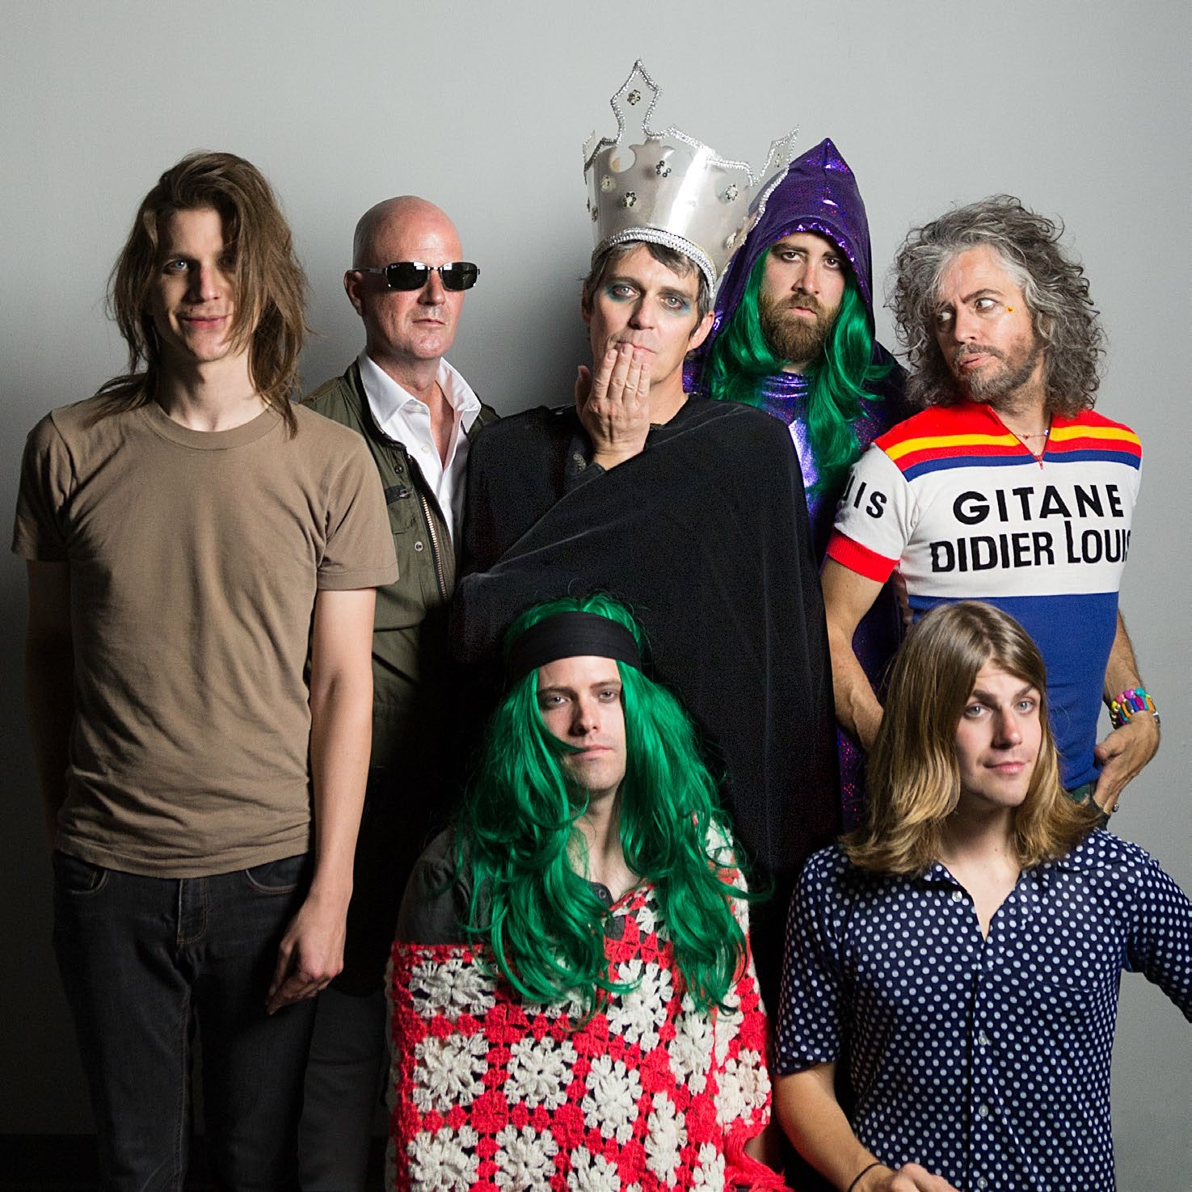HOW??
White trash rednecks, Earthworms eat the ground
Legalize it, Every drug right now
Are you with us.. Or are you burnin’ out??
Kill your rock n roll.. Motherfuckin’ hip-hop sound
I tried to tell you but I don’t know how!! I tried to tell you but I don’t know how!! How??
A thousand suns are in the sky right now Let them shine now shine for just one hour I tried to tell you but I don’t know how!!
I tried to tell you but I don’t know how!! How??
Back when we were young.. We killed everyone
If they fucked with us.. With our baby guns
We were young with our baby guns We were young with our baby guns A bird is singing.. Singing really loud
A jet is flying.. Flying through a cloud..

The initial recording started off as a longish back-n- forth jam session. A low key synth jam.. Ha.. with Ste- ven and Michael.Th’were in studio B while Dave and I were in studio A mixing.. Then Steven took it and

added an emotional and strange melody. I think the melody was a recording of small little section of Ste- ven singing and mumbling a couple of the melodic notes and then he would pitch-shift and time-stretch these little bits to extend and more fully realize the melody.. really jus putting it together willy nilly..
I think I heard it as he was still building and creating it and already thought it would make a great song.
The lyric is all stream of consciousness emotional syllables and fucked up junk-sta position of words and mood to create (accidentally) the mysterious, epic meaning or meaninglessness of the song. And maybe that’s why it works.. The lyric “I tried to tell you but I don’t know how!!”.. Is really what the main power and dilemma of the song is.. .which is often how we communicate with each other in real life situations all the time.. and in real life we struggle to find the right words to say some “all encompassing perfectly meaningful statement “and, on an emo- tional level it does communicate and then we fuck it up with words.. Ha

THERE SHOULD BE UNICORNS
Yeah there should be unicorns.. Ones with the purple eyes It should be loud as fuck, Hope the swans don’t die There should be burning sun, And naked slaves
And if the police show up..
We’ll give them so much money it will make them cry
And forgive us.. Yeah there should be unicorns the ones with the purple eyes not the green eyes Yeah there should be day glow strippers
Ones from the Amazon
Some edible butterflies.. We put ketchup on Some motorcycle stunts.. That always crash And if the police show up we’ll bribe them
into helping us steal the light of love from the rainbow sluts that live next door
Yeah there should be unicorns
Ones with the purple eyes.. Not the green eyes.. At first there should be unicorns. The ones with the
purple eyes not the ones with green eyes. Whatever
they give them, they shit everywhere. And it would be great if the moon was almost down... in a very red/ orange state... Let’s leave it like that for at least three hours… Hovering just above the horizon. And if the police show up we will give them so much money
that they can retire from their shitty, violent jobs and live the greatest life they’ve ever lived. And we will be high. And the love generator will be turned up to its maximum. And we’ll get higher when, at last, the sun comes up in the morning and we will collapse under the weight of the ancient earth. And it will be inside me and it will be inside you... and it will be the end of the world and the beginning of a new love...

The music started to come into being because of this funny drone machine at Dave Fridmann’s studio. The first bit of the recording happened quite fast. We added a drum beat and some thick bass synth stuff to the drone and we started to like the track. At first the idea was to have no lyrics but only have the spoken word part (the Reggie Watts part). It is meant to be a kind of “wish list” that someone is reading off to a party planner.. “At first there should be unicorns.. “as if unicorns are something you can just order to have at your party. So.. I quickly wrote it and texted it to Reggie(who I had been trying to get on one of our records for a while) and he said Yess!!
In between the time that we sent it to him and when was able to record it and get it back to us we kept fucking with the song. We felt like maybe it needed an emotional hook in it and we put in the part that is now like a chorus “yeah there should be unicorns the ones with the purple eyes.. not the green eyes”The lyrics implying that you can choose which unicorns you prefer.. the purple eyed ones or pink eyed ones or green eyed ones.. Ha..
And do I believe it just built from there and we couldn’t stop ourselves from turning it into a song..

SUNRISE
The sunrise insists on gladness.. But how can I be glad
Now my flower is dead
Oh, sun
I see you happy
You’ve made the morning dew
Now you’re showing me the truth but I don’t want to believe you.. The sunbeams
Burnin’ my child dreams

GALAXY I SINK
I saw the universe in your giant Eye
I want to touch your mind hole and go inside
Last night
Last night
And when I look at you it’s like the sun
I understand how space and time begun
Last night
Last night
Your face I sink

Dewy dewy dew
Let’s get together yeah Drip drip drippy glow Glowy and drippy yeah
Dewing in it right, dewing it like you care
Runnin’ all night through the flowers that eat us there and I thought we should spend the night together... Thought we should spend the night together
Glowy Glowy Glowy Glowy Glowy Glowy glow...

The machine that brings me joy, now it’s just a stupid toy  Oh, if I could | In time I sink  And I will never reappear  Your love I sink | LISTENING TO THE FROGS WITH DEMON EYES
Go back and find you | You’re everything I sink | Glistening in the moonlight
I’d kiss your glowing head | The threat that you’ll disappear | Listening to the frogs
And hear the things you said | And with the floating specs | Hiding ourselves in the trees
And always believe you... | In my tired eyes | Watching with demon eyes
Oh, the sunset | I can see all dimensions of my life | Here we go again, here we go...
Is fuckin’ with my head | How can the stars really know me now | Have you ever seen someone die
Feels like a dying love in the eyes of the young | When I fear their light will burn me up | in the summertime...??
Tell me love is neither living or dying | Hmmm… | Is that what your demon eyes see...??
It’s a power in your mind |  | Have you ever gone through the hole
I think it’s with you all the time |  | in the night sky...??
It only hurts when it leaves you. | ONE NIGHT WHILE HUNTING | I can’t see the moon though I know it’s there
 | FOR FAIRIES AND WITCHES | I can’t see the end but I know it is there

The first verse of this song is the same as the Miley Cyrus and Her Dead Petz version. It’s in its original key (we made it a slightly higher register for Cyrus) and has the same melody and chords but with a radically dif- ferent vibe.. the other verses are a kind of philosoph- ical take on the struggle and acceptance of death, the death of love, the pain of living in the face of sad- ness.. but it is, I think, also about being in awe of beau- ty and power and just the weirdness of existing.. Ha..
The passages between the verses is based on a melodic cycle that Steven was fucking with. I believe we edited a couple different, at first, unrelated sec- tions of Steven’s recording. We piled 5 or 6 harmonies (all Steven) on top of it and we really loved the cine- matic way it opened up and became the epic coun- terpoint to the more longing slightly sad verses.

NIGDY NIE
Never no no
No no no never
Never no no
No no no never Forever ever yeah Yeah yeah forever Forever ever yeah Yeah yeah forever Na na na na na na
AND WIZARDS TO KILL
One night while hunting for fairies and witches and wizards to kill
I came across a hole in a tree in the forest
I climbed inside the tree hole with small fear and loaded my gun
I should have heeded that small fear
I walked towards the wizard’s cave shooting to shoot out his wizard brains
With a wave of his hand he created a force field
My bullets all ricocheting, bouncing around his old cave
One of them shot through my temple and severed my eyes
Blinded by my own gun I got up and turned around to run
Stumbling and tripping I fell blooded on the ground The wizard and fairies and witches all came with their medicines to my side
They sprinkled some frog dust on my face
I saw death’s face, but somehow his bad grip let me go I awoke in a strange room with new eyes and that’s when I saw her

DO GLOWY
Glowy Glowy glow
Let’s get together yeah Glow glow glow glow Glarey and glarey yeah
Doin’ it right, doin’ it like you care
Under the tree where the spider got in your hair
and I thought we should spend the night together..
I can’t see the sun but I feel it’s there
I can’t see your love but I know it is there.. I know it’s forbidden
We can squash the stars New holes in the darkness Darkness in the dark
Yeah here we go again
Here we go.
Have you ever seen someone die in the summertime??
Is that what your demon eyes see..??

The title Listening To The Frogs With Demon Eyes goes back to 2012. I had posted on Instagram (maybe it was Twitter back then) of our little dog sitting by the creek in the park late one night. I had used the flash from my phone and so it gave the dog camera flash red eyes (so I said Demon Eyes). And.. we were actually listening to the frogs singing and croaking in the creek .
The first section is literally about that night in the park. The second section is loosely based on anoth- er real life experience. I was driving and noticed just up ahead ambulances and police cars. There was something happening inside some old apartments off to my left. And as I slowly drove by I could see inside (the door was open) and there was a huge bloat- ed and obviously dead man laying on a bed. I re- member he was really red. And it was a very hot summer evening. So yeah the “have you ever seen someone die.. In the summertime “part of the lyric is based on that.. The third section is, I think, different Tarot Card sayings, sort of, thrown together which,

in the flow of the song, is really deeper than I intend- ed. Haha.. But, luckily, it works really great in its mystic way.
The song was recorded, I believe the next cou- ple days. I think it was me discovering this great weird-ass bell sound and drum machine pattern thing on a synthesizer that Steven had jus bought.. It was late in the night, maybe on the Fourth of July.. I remember no one was around jus me sittin’ in the studio for a couple of hours. The eerie vibe of those disconnected chords made me sing the words and Steven, I think the very next day, set it all to a very expressive melody.. “glistening in the moonlight.. Listening to the frogs.. WTF.. Ha..
Steven and I are always very manic when we are connecting bits of our songs (that we kind of write by ourselves) together into one bigger song.. I think Listening To The Frogs With Demon Eyes is actually 3 different songs crammed together with a short attention span.. We (Steven and I) would be quickly satisfied and then move o n. I think we were both wor king frantically knowing that we had to leave the next day or something and we would do a section as quickly as we could get it recorded and think “ok it goes like that.. Like a sketch.. and then go “well what’s next”.. we both probably felt, in the moment of record-
ing it, that we would revisit it and flush out the very sketchiest bits later.. S o..
When we wer e finally able to listen to it I don’t think we r emember ed that we wer e gonna flush it out. We listened and r eally loved how spastic it was and how a lot of it just floated along. We accepted it as a gr eat gif t fr om the universe and never ques - tioned the song again..

THE CASTLE
Her eyes were butterflies.. Her smile was a rainbow
Her hair was sunbeam waves.. Shining round like a halo
Her face was a fairytale.. that has a poison apple
Her skull was a mighty moat.. Her brain was the castle
And the castle gets mistaken for a ship that is floating in the clouds
And the castle is brighter than a thousand Christmas trees
And the castle can never be rebuilt again...
No way... One day a strange storm rolled in while she was riding on her dragon
The mushrooms and the bumble bees told the flowers how it happened
She was lost in the invisible war..
Fighting in the battle
Her love is still buried there in the ruins of the castle
And the castle oscillates to the beating heart of her mind
And the castle is taller than the northern lights And the castle can never be rebuilt again... No way...

An embarrassingly pure little song.. Ha.. I say embar- rassing because as I wrote it (just a couple of lines, that didn’t end up in the song, and the one chorus line “and the castle can never be rebuilt again.. No way..” I was truly sad and I was singing and writing about this sad sad situation (a friend of ours had committed suicide) and felt like I was doing what a songwriter should do.. be real and let it flow.. Ha.. But the next day when I listened to it.. I thought it was really boring and ap- proached the song as being about the person (who had killed themselves) instead of it (the song) being about me.. So yeah.. I’m embarrassed about that part
.. But I think songs work like that.. They let you get some- thing out.. And I think this delicate whimsical song really came to life as soon as I sang (into my phone .. It was the only recording device I had in that moment) the very first lines..” Her eyes were butterflies her smile was a rainbow “.. I still heard it (the song) as being very very sad and so, to me, because I was convinced of its power (the pow- er of this sadness.. which, I think, was jus me being still sad about the real life situation) it allowed me to sing these utterly silly romantic lyrics as a way of masking something horrible and brutal and fucked up and unspeakable.. it’s a motherfucker.

ALMOST HOME (BLISKO DOMU)
Oh, we’re almost home Oh, oh, almost home.. Oh, we’re almost home Home...
The thought soon becomes the word
The word then becomes the deed
If the deed is evil blame the thought is the seed
Change the spark that makes the need
Did your mind invent your mind?? The insect crawls out on the leaf The leaf falls into the fire
Burning up my fragile dream of how the world is full of love. It’s not what I thought it was.
Hurting us until we’re dust.. Us, us, us
The action needs its energy
It takes it from your hate and greed
Makes you scared there’s gonna be
a stranger grabbin’ you by the throat... or is it someone that you know.
You fear revenge from those you’ve hurt... Haha
The first part of the track started off as an instru- mental.. I think we just really loved that synth/drum machine pattern and the sudden shift to A, kind of, symphonic folksy thing.. Right at the end (of recording and mixing the record) I added the lyrics “oh We’re almost home.. oh we’re almost home”..
The second part just happened one day as an after thought to, what ended up being, the 7 inch sin- gle B side called Jest (There Is).. we turned, what was, in that song, a bass line into a bell and vibraphone sound and as it went by, I think almost the first time, I wrote down the lyrics. I think I saw a Buddha quote on Instagram and I just kept the parable going..

WE A FAMLY
It’s been a long cold winter
Feels like it’s been forever yeah... We both travelin’...
I’m somewhere south of Wichita
You’re somewhere up there under the moon
I can’t see you
Flying along the engines hummin’
Jesus and the spaceships comin’ down
Oh and I just can’t imagine life
without you could ever happen now!! It’s you and me..we a famly...
It’s been a long hot summer
I miss you, it’s a bummer yeah
We both travelin’
You’re somewhere south of Wichita
I’m up here somewhere under the moon
I can’t see you..
Flyin’ along the engines hummin’
Jesus and the spaceships comin’ down
Oh and I just can’t imagine life without you ever happen now It’s you and me... we a famly

