

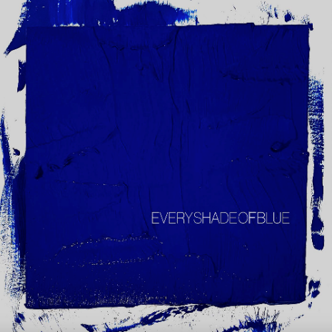

Initially self-released in 2011, **The Head and The Heart’s** self-titled breakout debut produced instant classics including **“Rivers and Roads,” “Down In The Valley”** and **“Lost In My Mind”** (#1 at AAA) and is now Certified Gold. 2013’s ***Let’s Be Still*** and 2016’s ***Signs of Light***, settled into Billboard’s Top 10 albums chart, with ***Signs of Light*** securing the #1 position on Rock Album Charts, securing the band’s first #1 at Alternative position with **“All We Ever Knew”** and also held the #1 spot at AAA for nine straight weeks. The band’s fourth full-length album, ***Living Mirage***, was released to critical praise in 2019. **“Missed Connection”** which secured the #1 position on the Alternative Chart and #1 at Mediabase and BDS alternative charts, already having achieved #1 on the AAA chart. The album’s breakout track, **“Honeybee”,** became a fan favorite with 153M+ total global streams and 1M+ global weekly streams. They have appeared in Cameron Crowe’s Roadies, with music featured in countless other commercials, films and TV, among them Corona, *Silver Linings Playbook* and more. The band has established their status as a touring powerhouse, having landed prime time mainstage slots at Coachella, Lollapalooza and Austin City Limits. In total, the band has performed 15 times on national television including appearances on Ellen, The Tonight Show Starring Jimmy Fallon, The Late Show With Stephen Colbert, Austin City Limits with more.

**Contacts:**

**Grandstand Media**

Kate Jackson [**katej@grandstandhq.com**](mailto:katej@grandstandhq.com)

Katie Nelson [**katien@grandstandhq.com**](mailto:katien@grandstandhq.com)

**Warner Records**

Rick Gershon [**Rick.Gershon@warnerrecords.com**](mailto:Rick.Gershon@warnerrecords.com)

Jenny Huynh [**Jenny.Huynh@warnerrecords.com**](mailto:Jenny.Huynh@warnerrecords.com)

**Follow The Head And The Heart:**

[**Official**](https://theheadandtheheart.com/) **|** [**Instagram**](https://www.instagram.com/theheadandtheheart/) **|** [**Twitter**](https://twitter.com/headandtheheart) **|** [**Facebook**](https://www.facebook.com/theheadandtheheart) **|** [**Tik Tok**](https://www.tiktok.com/@theheadandtheheart) **|** [**Press Materials**](https://press.warnerrecords.com/theheadandtheheart/)

