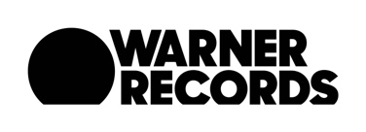

The Head and The Heart Perform #1 Single “Missed Connection” Tonight on
Jimmy Kimmel Live!

Band Also Appears on Dax Shepard’s “Armchair Expert” Podcast

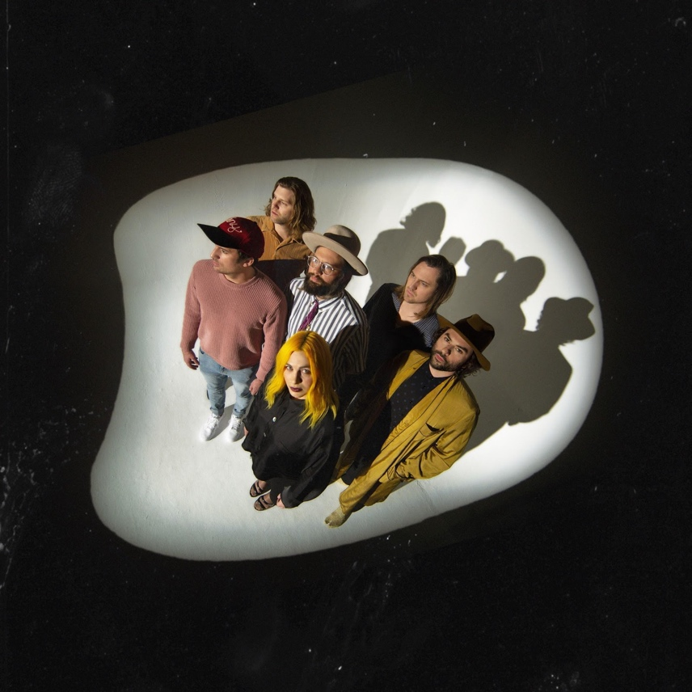
Click HERE for hi-res photo

August 1, 2019 (Los Angeles, CA) - Today, Dax Shepard’s beloved podcast “Armchair Expert” released its latest installment featuring The Head and The Heart performing their breakout hit “Missed Connection.” The episode was recorded on the road in the band’s native Pacific Northwest and features an in-depth interview with fellow Seattle luminary Dan Savage, the activist, journalist, media pundit and writer behind “Savage Love.” Listen here. In addition, the band will return to the Outdoor Concert Stage at Jimmy Kimmel Live! tonight, August 1st, with three songs being livestreamed here at 8:20pm PT. LA-based fans can go to 1iota for a chance to be a part of the live taping.

All of this comes on the heels of The Head and The Heart’s “Missed Connection” securing the #1 position on the Alternative Chart and #1 at Mediabase and BDS alternative charts just last week, already having achieved #1 on the AAA chart. “Missed Connection” is the lead single from Living Mirage, the band’s fourth full-length album, released on Warner Records / Reprise Records to critical praise earlier this year. This marks the band’s second #1 at Alternative, having previously landed the position for “All We Ever Knew” (Signs of Light), which also held the #1 spot at AAA for nine straight weeks in 2016. This win caps a monumental week including two SOLD OUT shows at the legendary Red Rocks Amphitheatre that were live streamed via nugs.tv.

The Head and The Heart have been bringing their high-energy live show out on the road in the US. Tickets purchased online for select tour dates (as noted below) includes your choice of a CD or digital copy of the new album, Living Mirage. Purchasers will receive instructions via email on how to redeem the album after ticket purchase. Stream and purchase Living Mirage here.

Initially self-released in 2011, The Head and The Heart’s self-titled breakout debut produced instant classics including “Rivers and Roads,” “Down In The Valley” and “Lost In My Mind” (#1 at AAA) and is now Certified Gold. Their last two albums, 2013’s Let’s Be Still and 2016’s Signs of Light, settled into Billboard’s Top 10 albums chart, with Signs of Light securing the #1 position on Rock Album Charts. They have appeared in Cameron Crowe’s Roadies, with music featured in countless other commercials, films and TV, among them Corona, Silver Linings Playbook and more. The band has established their status as a touring powerhouse, having landed prime time mainstage slots at Coachella, Lollapalooza and Austin City Limits. In total, the band has performed 15 times on national television including appearances on The Ellen DeGeneres Show, The Tonight Show Starring Jimmy Fallon, The Late Show With Stephen Colbert, Austin City Limits with more to come in the coming months.

North American Tour Dates:
08/02/19 - The Observatory - San Diego, CA +^
08/03/19 - Alt 98.7 Summer Camp - Long Beach, CA+^
08/18/19 - Xfinity Live! - Philadelphia, PA
09/06/19 - Murat Theatre at Old National Centre - Indianapolis, IN
09/07/19 - Murat Theatre at Old National Centre - Indianapolis, IN
09/08/19 - PNC Pavilion at Riverbend Music Center - Cincinnati, OH
09/10/19 - Jacobs Pavilion at Nautica - Cleveland, OH
09/11/19 - 20 Monroe Live - Grand Rapids, MI
09/13/19 - Chicago Theatre - Chicago, IL
09/15/19 - The Sylvee - Madison, WI
09/16/19 - The Sylvee - Madison, WI
09/18/19 - The Armory - Minneapolis, MN
09/19/19 - Stephens Auditorium - Ames, IA
09/21/19 - Pilgrimage Music & Cultural Festival - Franklin, TN +^
09/23/19 - Avondale Brewing Company - Birmingham, AL
09/24/19 - The Fillmore - New Orleans, LA
09/26/19 - Thomas Wolfe Auditorium - Asheville, NC
09/27/19 - The Tabernacle - Atlanta, GA
09/29/19 - Charlotte Metro Credit Union Amphitheatre - Charlotte, NC
10/01/19 - Red Hat Amphitheater - Raleigh, NC
10/03/19 - The Anthem - Washington, DC
10/04/19 - Kings Theatre - Brooklyn, NY
10/05/19 - The Capitol Theatre - Port Chester, NY
10/08/19 - The MET - Philadelphia, PA
10/09/19 - Palace Theatre - Albany, NY
10/11/19 - Toyota Presents Oakdale Theatre - Wallingford, CT
10/12/19 - Agganis Arena - Boston, MA
10/14/19 - UPMC Events Center - Moon Twp., PA
10/15/19 - The Fillmore Detroit presented by Cricket Wireless - Detroit, MI
10/16/19 - Palace Theatre - Columbus, OH
10/18/19 - Algonquin Commons Theatre - Ottawa, ON
10/19/19 - MTELUS - Montreal, QC
10/20/19 - Sony Centre for the Performing Arts - Toronto, ON

+not a Live Nation date
^ tickets purchased for this date will not include the album

For more information about The Head and The Heart, please contact:
Kate Jackson, KateJ@grandstandhq.com
Katie Nelson, KatieN@grandstandhq.com
Bobbie Gale, Bobbie.Gale@warnerrecords.com

Website / Facebook / Twitter / Instagram / Youtube / Soundcloud

