For Immediate Release April 8, 2022
FURTHER JOY OUT TODAY VIA WARNER RECORDS
READ TRACK-BY-TRACK GUIDE IN CONSEQUENCE

PERFORM THEIR NEW SINGLE “ANXIETIES (OUT OF TIME)” ON JIMMY KIMMEL LIVE!
PERFORMING AT COACHELLA AHEAD OF 19-DATE
FURTHER JOY HEADLINING TOUR

“…captures the Regrettes’ effortless transformation from teenage punks into pop powerhouses.”
-Rolling Stone
“halfway between Gwen Stefani’s modern pop era and No Doubt’s Rock Steady phase.”
-Consequence

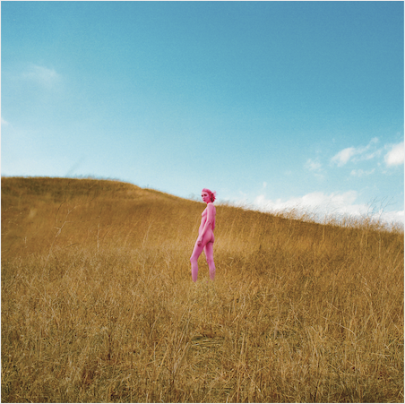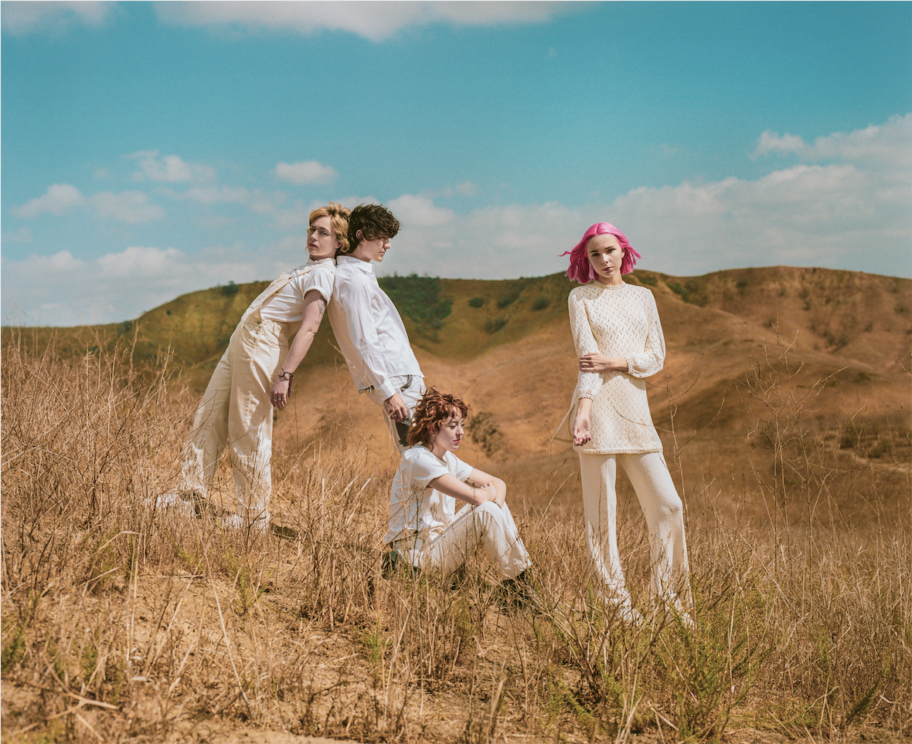

Photo Credit @oclaire / Claire Marie Vogel
Hi-res Album Art And Press Photo Available HERE
Today, The Regrettes release their highly anticipated third studio album, Further Joy, via Warner Records. With the album, The Regrettes, consisting of singer and songwriter, Lydia Night, as well as Genessa Gariano (guitar), Brooke Dickson (bass) and Drew Thomsen (drums), have written a manual for living in these times, replete with highly personalized songs about things we’re all going through. Night shares, “that phrase, ‘further joy,’ summarized what it meant to be on the hamster wheel of constantly chasing happiness, but in turn, that’s what makes you unhappy. I was stuck in a loop of wanting to be better, wanting to be good, and therefore I couldn’t be here. I couldn’t be present.” The desire to break free of that cycle is what the band’s third album, Further Joy, is all about, a joyous and self-aware soundtrack for those interested in what Lydia refers to as “dancing the pain away.” Further Joy is available here in formats including digital/streaming, CD, and vinyl. Independent Record Stores and The Regrettes official store will have “Joy” pink vinyl.
The band today share a track-by-track guide to Further Joy via Consequence, who calls the album “XXXX.” Read the band’s in-depth guide here.
Recently, The Regrettes performed their latest single “Anxieties (Out Of Time)” on ABC’s Jimmy Kimmel Live! Watch the performance, of which Rolling Stone said “driven by heavier, more prominent guitar tracks and an emotionally charged vocal performance by lead singer Lydia Night, the Los Angeles band delivers an electrifying performance of the song — and reveals the effortless manner in which the group still invokes their punk rock roots,” here.
The Regrettes will perform at both weekends of Coachella ahead of their 19 date Further Joy headlining tour (full dates below), with support from Alex Lahey on all dates. Tickets for the dates will are on sale here. Additionally, the band has confirmed appearances at Lollapalooza, Shaky Knees, and Bonnaroo 2022. Tickets for these dates and VIP packages are available here.
The band has recently shared music videos for their singles “Anxieties (Out Of Time)” which Rolling Stone calls “an ebullient song examining the complexities and frustrations of insecurity,” “That’s What Makes Me Love You,” which Consequence calls “halfway between Gwen Stefani’s modern pop era and No Doubt’s Rock Steady phase,” and “Monday” which NME hails as “a whip smart track about messy rooms and existential crises.”
As the pandemic set in and Los Angeles shut down, The Regrettes were having a full-blown identity crisis. Lydia had been touring since she was 12-years-old, meeting guitarist Genessa when they were just teens in music school, and formed a cohesive lineup with Brooke and Drew. They’d spent the past two years headlining sold-out shows across North America and Europe, performing at mainstay festivals like Coachella and Reading and Leeds and playing their hit singles on Good Morning America, Conan, and Jimmy Kimmel Live!. As NME said of their sophomore album, The Regrettes were “truly unstoppable” until the world shut down.
In January of 2021, after more than a year apart, The Regrettes reconvened for a 10-day writing retreat in Joshua Tree. They went on hikes, stargazed, transformed their living room into a disco, and had candid conversations, some of which made their way into songs. They left the desert with a vision for the record and demos in hand, slowly bringing it to life through zoom writing sessions, and working separately with producers Jacknife Lee and Tim Pagnotta. Although the subject matter is anything but light, Night still calls it the “poppiest, and danciest” album they’ve ever made.
The band were quick to get back on their feet, selling out a California underplay tour in 2021, confirming upcoming appearances at major US festivals including Bonnaroo and Coachella 2022, and releasing two songs, “You're So Fucking Pretty,” which Rolling Stone called “a brutally honest confessional ballad that captures The Regrettes’ effortless transformation from teenage punks into pop powerhouses,” and single “Monday,” which cracked the top 15 at alternative radio in advance of their forthcoming album Further Joy.
Further Joy is a step into the band’s next era, and it is their most actualized, collaborative, and vulnerable album to date. These new songs, written in Night’s singular voice and with vast influences including Pat Benatar, Blondie, and Gwen Stefani, touch on subjects such as anxiety and mental health, feeling lost in one’s own environment, and coming to terms with one’s sexuality. They are also about hope, embracing and standing up for your inner child. A lesson she hopes fans can take away from the album is that “we all deserve happiness and to be present, and we'll never get there if we feel so much shame and guilt for not being there already,” she adds. “Don't get caught constantly chasing joy.”
The Regrettes- Further Joy Track Listing
- Anxieties (Out of Time)
- Monday
- That's What Makes Me Love You
- Barely on My Mind
- Subtleties (Never Giving Up On You)
- La Di Da
- Homesick
- Better Now
- Rosy
- You're So Fucking Pretty
- Step 9
- Nowhere
- Show Me You Want Me
The Regrettes Current Tour Dates (FURTHER JOY DATES IN BOLD)
Apr 15 – Indio, CA at Coachella
Apr 18 – Pomona, CA at The Fox Theater Pomona^
Apr 21 – San Diego, CA at Humphreys Concerts By the Bay^
Apr 22 – Indio, CA at Coachella
Apr 23 – Tucson, AZ at Rialto Theatre⁺
Apr 26 – Austin, TX at Scoot Inn⁺
Apr 27 – Dallas, TX at Echo Lounge & Music Hall⁺
Apr 29 – Atlanta, GA at The Masquerade - Hell+
Apr 30 – Atlanta, GA Shaky Knees Festival
May 1 – Charlotte, NC at The Underground⁺
May 3 – Washington DC at Lincoln Theatre⁺
May 4 – Philadelphia, PA at Theatre of Living Arts⁺
May 6 – Boston, MA at Big Night Live⁺
May 8 – New York, NY at Irving Plaza⁺
May 10 – Toronto, ON at Opera House⁺
May 12 – Columbus, OH at Newport Music Hall⁺
May 13 – Chicago, IL at Metro⁺
May 14 – Madison, WI at Majestic Theatre⁺
May 15 – Minneapolis, MN at Varsity Theater⁺
May 17 – Denver, CO at Summit Music Hall⁺
May 18 – Salt Lake City, UT at The Depot⁺
May 20 – Portland, OR at Roseland Ballroom⁺
May 21 – Vancouver, BC at Fortune Sound Club⁺
May 22 – Seattle, WA at The Neptune Theatre⁺
May 24 – San Francisco, CA at The Fillmore⁺
Jun 17 – Manchester, TN at Bonnaroo Music & Arts Festival
Jul 01 – Rotselaar, BEL at Rock Werchter
Jul 03 – Bilbao, ESP at Bilbao Bizkaia Rock Day
Jul 06 – Madrid, ESP at Mad Cool Festival
Jul 08 – Glasgow, UK at TRNSMT Festival
Jul 09 – Cheltenham, UK at 2000trees Music Festival
Jul 28-31 – Chicago, IL at Lollapalooza
Sep 22-25 – Dover, DE at Firefly Music Festival
^supporting Wallows
⁺support from Alex Lahey
https://www.theregrettes.com/
https://www.facebook.com/regrettes
https://twitter.com/regrettesband
https://www.instagram.com/theregrettesband/
https://youtube.com/theregrettes
https://www.tiktok.com/@theregrettes
For more information, please contact Emilio Herce (emilio@qprime.com) or Mary Moyer (mary@qprime.com) at Q Prime, 212.302.9790.

