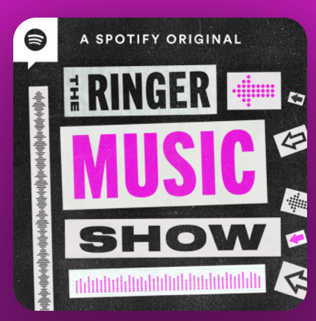

January 12, 2021

Listen Here: https://open.spotify.com/episode/6lwSobagjtYQEHOy1MrNQF?si=Jl0yk39vTJGmdFIGlWCeXQ

