November 5, 2020

https://www.instagram.com/p/CHORbvJDsLH/?igshid=svpdu3y81cz6

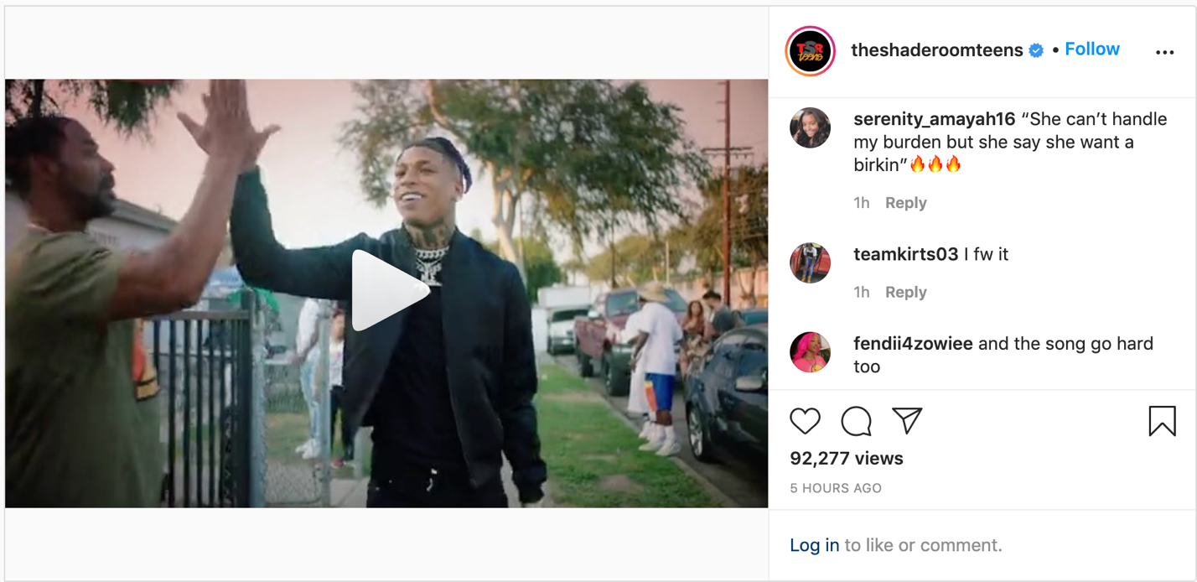

“Keeping It 100”
https://www.youtube.com/watch?v=0csGxXaI_VM

