THE WALTERS MAKE THEIR TV DEBUT ON JIMMY KIMMEL LIVE! PERFORMING HIT SINGLE “I LOVE YOU SO”
WATCH IT HERE

“I LOVE YOU SO” IS #8 ON THE SPOTIFY TOP 50 US CHART, #19 ON SPOTIFY GLOBAL 50; CHARTING AT TOP 40 RADIO
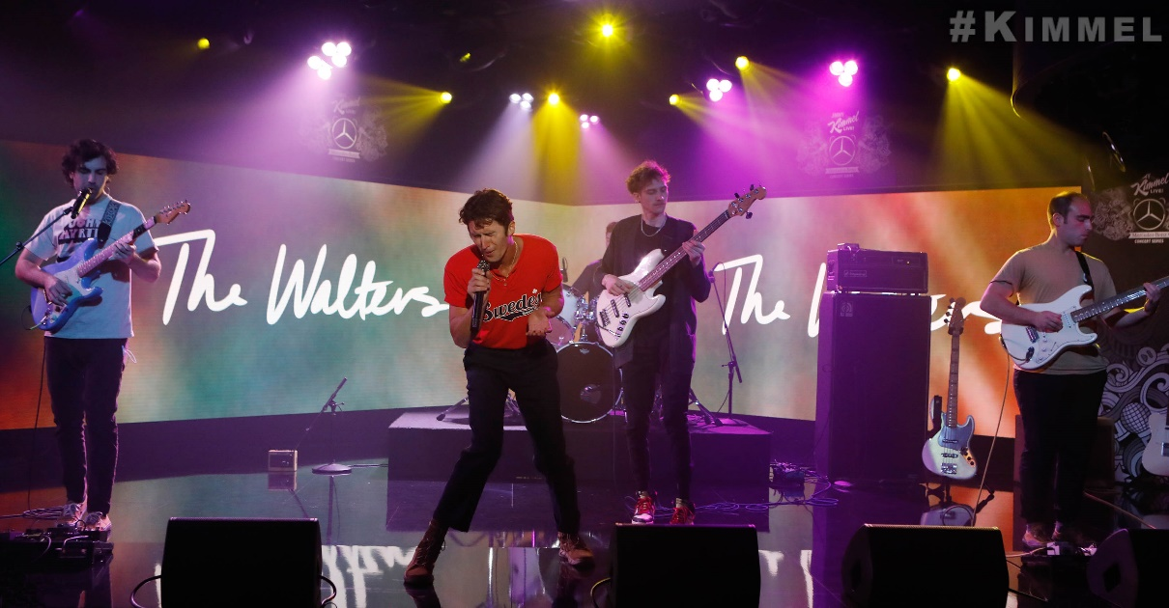
January 28, 2022 (Los Angeles, CA) – Continuing their explosive new chapter, Chicago indie quintet The Walters made their television debut last night on Jimmy Kimmel Live!, performing their rapidly rising viral hit “I Love You So.” Watch it HERE.

The global smash continues its rising success as it reaches #8 on the Spotify Top 50 US chart, and #19 on the Spotify Global Chart and charting at Top 40 radio. Next up, the band will perform at Los Angeles’ The Wiltern on March 5, with much more to come very soon.

About The Walters:
The Walters artfully intersect a dreamy sound rooted in eloquent songcraft, catchy hooks and soundtrack-worthy instrumentation steeped in a bit of magic. Listeners first fell under the spell of the Chicago-based quintet Luke Olson [lead vocals, guitar], Walter Kosner [lead guitar], MJ Tirabassi [rhythm guitar, vocals], Danny Wells [bass], and Charlie Ekhaus [drums]—with a pair of fan favorite EPs Songs for Dads [2014] and Young Men [2015]. They captivated crowds in hallowed venues across their hometown such as The Metro, performed at Riot Fest, and left the audience stunned and amazed at Lollapalooza 2017. Following the latter, their paths diverged during a mutual hiatus. In early 2021, the musicians reconnected and started plotting their return when the viral success of “I Love You So” accelerated their timeline. Signing to Warner Records in 2021, The Walters are only at the beginning of an exciting new chapter to come.

For more information, please contact:
Jaime Rosenberg / Jaime.Rosenberg@warnerrecords.com
Patrice Compere / Patrice.Compere@warnerrecords.com

