CHICAGO INDIE PHENOMS THE WALTERS REUNITE & ANNOUNCE THREE HEADLINE SHOWS

SIGN TO WARNER RECORDS

“I LOVE YOU SO” SCALING THE
SPOTIFY GLOBAL 50 (#39) & US TOP 50 (#40) CHARTS

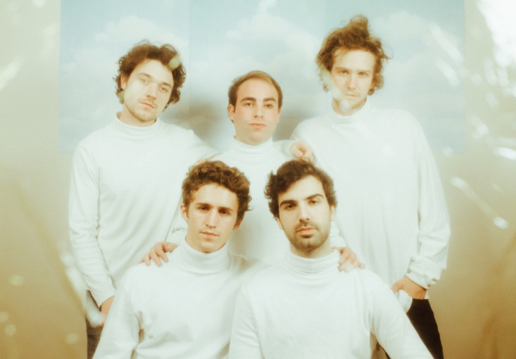
Photo Credit: Kristina Pederson

November 3, 2021 (Los Angeles, CA) – Breaking a four-year silence, Chicago indie stalwarts The Walters will headline their first three live shows since 2017 this December. The announcement comes as the band signs to Warner Records amid the success of their song “I Love You So” going viral on TikTok, with over 376k fan-created videos. The song is rapidly scaling the Spotify Global Top 50 chart, currently at #39 and climbing, as well as #40 in the US Spotify Top 50, with over 4M streams per week.

The band states, “Hey this is The Walters. So happy the world is rediscovering our music, especially “I Love You So”. This song kicked off our career and now it’s the song that got the band back together. We’re so excited for the future and can’t wait to share new music with you.”

Visiting both coasts, the alternative quintet will perform at The Bowery Ballroom in New York, NY on December 6 and The Regent in Los Angeles, CA on December 8 before what promises to be an unforgettable homecoming at The Metro in Chicago on December 30. Tickets go on sale November 5 at 10am local time.

The Walters artfully intersect a dreamy sound rooted in eloquent songcraft, catchy hooks and soundtrack-worthy instrumentation steeped in a bit of magic. Listeners first fell under the spell of the Chicago-based quintet Luke Olson [lead vocals, guitar], Walter Kosner [lead guitar], MJ Tirabassi [rhythm guitar, vocals], Danny Wells [bass], and Charlie Ekhaus [drums]—with a pair of fan favorite EPs Songs for Dads [2014] and Young Men [2015]. They captivated crowds in hallowed venues across their hometown such as The Metro, performed at Riot Fest, and left the audience stunned and amazed at Lollapalooza 2017. Following the latter, their paths diverged during a mutual hiatus. In early 2021, the musicians reconnected and started plotting their return when the viral success of “I Love You So” accelerated their timeline. Signing to Warner Records, The Walters launch a new era in 2021 with their first shows in four years.

The Walters Tour Dates

December 6 New York, NY Bowery Ballroom
December 8 Los Angeles, CA The Regent
December 30 Chicago, IL Metro

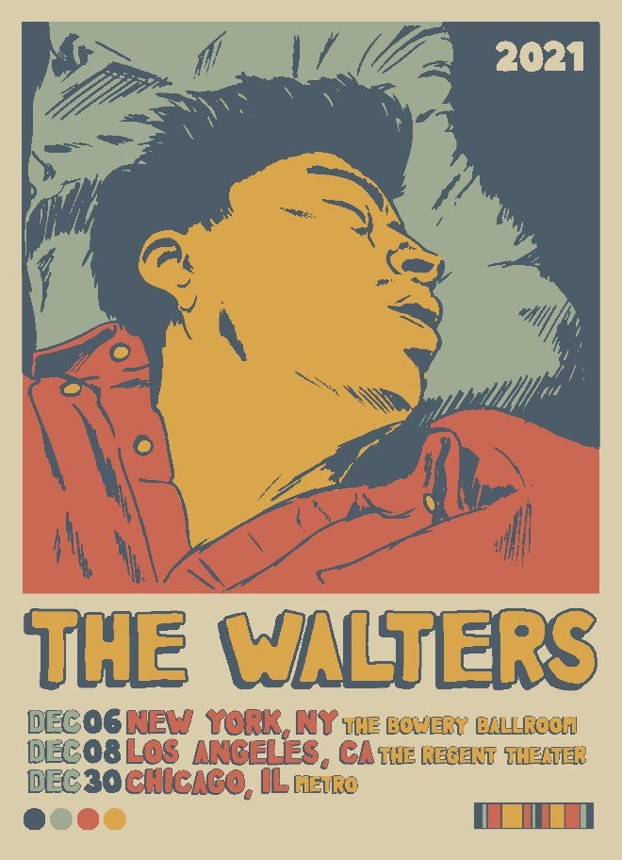

##

Follow The Walters:
Website | Instagram | Facebook | Twitter | Youtube

For more information, please contact:
Jaime Rosenberg / Jaime.Rosenberg@warnerrecords.com
Patrice Compere / Patrice.Compere@warnerrecords.com

