THE WALTERS RELEASE MUCH ANTICIPATED NEW EP TRY AGAIN – LISTEN HERE
LAUNCH NORTH AMERICAN HEADLINE TOUR ON MAY 14

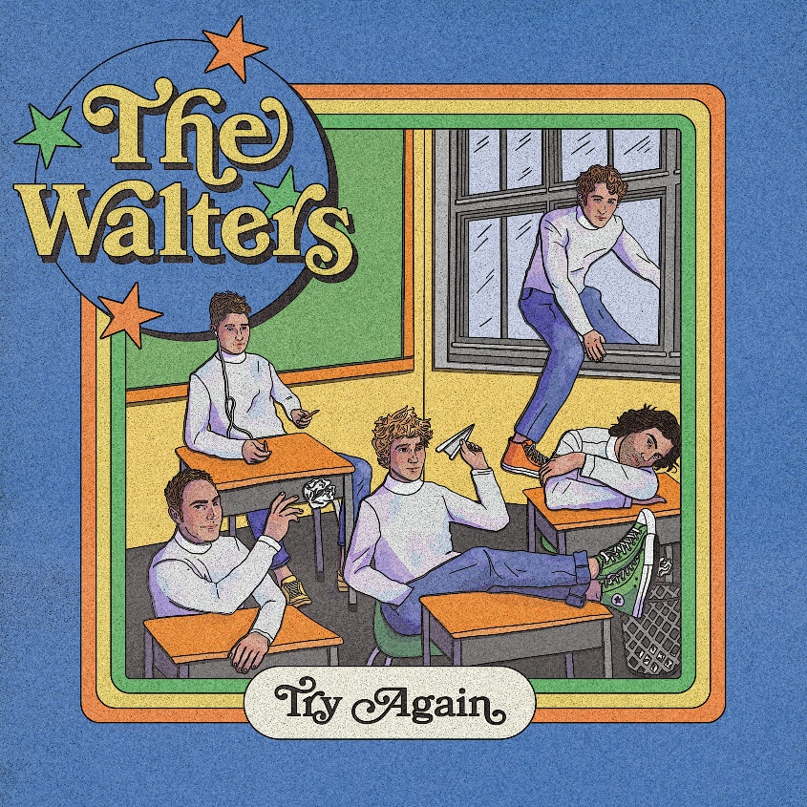

May 6, 2022 (Los Angeles, CA.) – Pop wonderkids The Walters have taken the world by storm with their platinum-certified global hit single “I Love You So,” to become one of the most talked about success stories in recent years. While still ascending the Billboard Top 40 charts, the quintet releases their anxiously awaited new 6-song EP Try Again today via Warner Records, which features the single/video “Million Little Problems.” Listen to Try Again, featuring the new single/video “Million Little Problems,” HERE.

“Million Little Problems” has garnered over 636K global streams to date. Meanwhile, COLOURVISION Magazine applauded, “The Walters are back and better than ever,” while Consequence defined the track as “a subtler, more refined sound. Hooky as ever and laid back with a touch of melancholy, the track is perfect for anyone that feels slightly more optimistic with the onset of summer, but no less moody.”

The six-track EP illuminates the nuances of the group’s conjuration of dynamic, dreamy, and diverse alternative bliss. Drummer Charles Ekhaus and The Walters notably co-produced the project. Under the glow of clean guitars and their trademark harmonies, “Black Moon” shines with a hummable hook and hypnotic solo. On “Lover,” acoustic guitar-laced verses give way to a summery refrain punctuated by vintage Southern California inspired sounds. Then, there’s the vulnerable ballad “Eyes For You.” It culminates on a tender promise, “I only have eyes for you.” During the closer “I’ll Make You Mine,” a soft intro builds towards a boisterous chorus that reveals a modern nostalgic vibe that permeates the sound of The Walters.

To date, the band’s runaway smash “I Love You So” has impressively exceeded 5 billion global views on TikTok and 468 million global streams on Spotify alone. The single also climbed to #29 at US Top 40 Radio. Earning critical acclaim, Variety said of “‘I Love You So,” “Reverb-drenched guitar chords and dreamy vocal harmonies…sounds as fresh as ever.”

The Walters will hit the road for the first time since 2017 for their spring headline tour which will conclude on June 9 at The Wiltern in the band’s new hometown of Los Angeles. Tickets are available HERE.

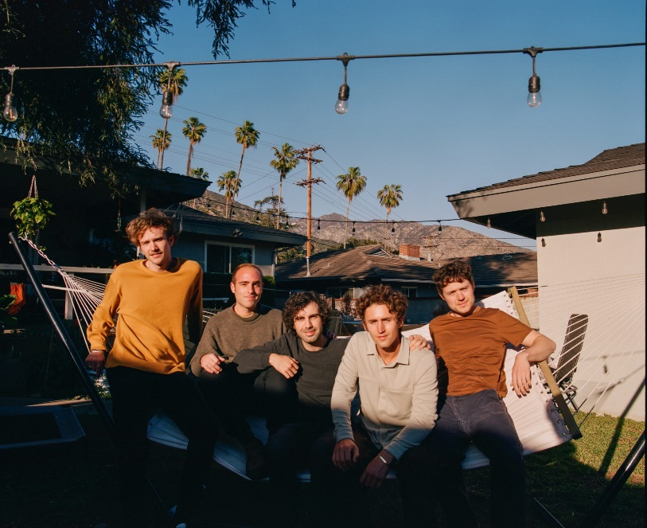
2022 Tour Dates:
May 13 Salt Lake City Kilby Block Party
May 14 Denver, CO Summit
May 19 Asbury Park, NJ House of Independents
May 20 Washington DC The Howard Theatre
May 21 Richmond, VA The National
May 22 New Haven, CT Toad’s
May 24 Boston, MA Paradise
May 26 Philadelphia, PA Brooklyn Bowl
May 27 New York, NY Webster Hall
June 07 San Francisco, CA August Hall (Rescheduled new date)
June 09 Los Angeles, CA The Wiltern (Rescheduled new date)

About The Walters:
After a 4-year hiatus, indie stalwarts The Walters return in full force amid the widespread success of their viral hit “I Love You So” on TikTok and DSPs, signing to Warner Records and announcing their first three headline shows since 2017, all of which sold out almost instantly. Hailing from Chicago, and now relocated to Los Angeles, The Walters artfully intersect clever songwriting, catchy hooks, and soundtrack-worthy instrumentation steeped in a bit of a magic. Listeners first fell under the spell of the quintet—Luke Olson [lead vocals, guitar], Walter Kosner [lead guitar], MJ Tirabassi [rhythm guitar, vocals], Danny Wells [bass], and Charlie Ekhaus [drums]—when they independently released 2014’s Songs For Dads EP. Among many highlights, “Fancy Shoes” generated over 32 million streams with “New Girl (Tom’s Song)” and “Life” on its heels. 2015’s Young Men only maintained the group’s momentum as they attracted an impassioned and dedicated fan base. They captivated crowds in hallowed venues across their original hometown, performed at Riot Fest, and left the audience amazed at Lollapalooza 2017. Following a self-imposed break, the band reconnected in early 2021 to plot their return when the viral success of “I Love You So” accelerated their timeline. The song has swept across TikTok with over 1.2M fan-created videos. A standout from 2014’s Songs For Dads, its success overwhelmingly translated to DSPS, reeling in north of 72 million streams on Spotify and scaling the Global Top 50. Signing to Warner Records, The Walters launch a new era in 2022 with “I Love You So” as its climbed to #1 in over 7 countries on Spotify’s Viral 50, accumulated over 5 billion global TikTok views and 468 million global streams on Spotify to date The track as has now attained Platinum certified sales status and is still climbing the US Top 40 Charts. The Walters’ new single entitled “Million Little Problems” was premiered by Zane Lowe upon release on his Apple Music 1 New Music Daily show. This is the first track off their forthcoming EP Try Again. The Walters have just announced their first US tour in four years.

# # #

Follow The Walters:
TikTok | Website | Instagram | Facebook | Twitter | YouTube | Press Materials

For More Information, Please Contact:
Rick Gershon / Rick.Gershon@warnerrecords.com
Patrice Compere / Patrice.Compere@warnerrecords.com
Regional: Jenny Huynh / Jenny.Huynh@warnerrecords.com

