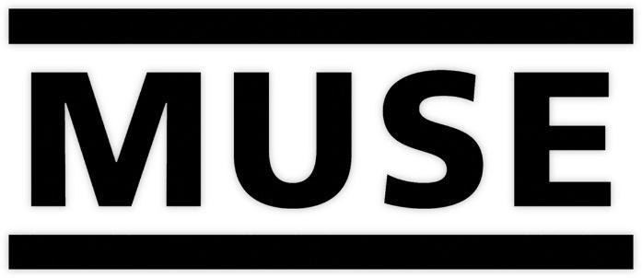

MUSE RETURNS WITH BRAND NEW SONG
“WON’T STAND DOWN”

WATCH THE VIDEO NOW HERE

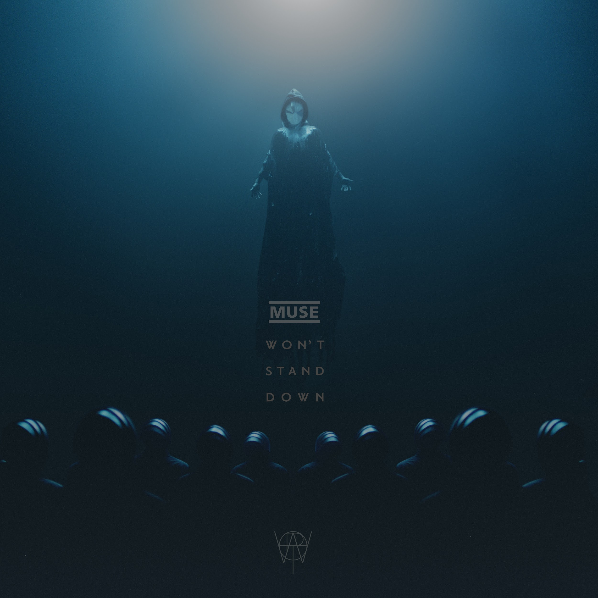

January 13, 2022 (Los Angeles, CA) - GRAMMY Award-winning English rock band Muse returns with brand new song, “Won’t Stand Down,” out today via Warner Records. Produced by Muse and mixed by Dan Lancaster (Bring Me The Horizon), “Won’t Stand Down” is an arena-ready anthem of controlled chaos, with heavy guitars and industrial-like distortions amplifying Bellamy's striking lyrics about taking one's power back.

Listen to “Won’t Stand Down” now HERE.

“Won’t Stand Down is a song about standing your ground against bullies, whether that be on the playground, at work or anywhere,” says Matt Bellamy. “Protecting yourself from coercion and sociopathic manipulation and to face adversity with strength, confidence and aggression.”

Today, the band also shared the video for the song. Directed by award winning filmmaker Jared Hogan (girl in red, Joji) and shot in Kyiv, Ukraine, the visual features a fragile, mysterious figure that siphons the collective energy of a dark army in order to transmute into an augmented being. Watch the video HERE.

In further news, the band will be performing at the following European festivals this summer:

June 3, 2022 Rock AM Ring Nürburgring, Germany
June 5, 2022 Rock Im Park Nürburgring, Germany
June 9, 2022 Nova Rock Festival Nickelsdorf, Austria
June 11, 2022 Tempelhof Sounds Berlin, Germany
June 17, 2022 Firenze Rocks Florence, Italy
June 19, 2022 Isle of Wight Festival Newport, England
June 21, 2022 VOLT Festival Hungary, Sopron
June 24, 2022 Tinderbox Festival Odense, Denmark
June 26, 2022 Mallorca Live Mallorca, Spain
June 29, 2022 Ejekt Festival Athens, Greece
July 2, 2022 OpenAir St. Gallen, Switzerland
July 3, 2022 Les Eurockéennes De Belfort Belfort, France
July 6, 2022 Beauregard Festival Hérouville-Saint-Clair, France
July 8, 2022 Mad Cool Festival Madrid, Spain
July 10, 2022 Les Déferlantes Festival Céret, France

ABOUT MUSE
Muse is Matt Bellamy, Dominic Howard and Chris Wolstenholme. Their last album, Simulation Theory, debuted at #1 and marked the band’s sixth straight album to debut in the U.K top spot. Their previous studio album, Drones, went on to win a Grammy Award for Best Rock Album, the band’s second, in February 2016. Since forming in 1994, Muse have released eight studio albums, selling over 20 million albums worldwide.

Widely recognized as one of the best live bands in the world, Muse have won numerous music awards including two Grammy Awards, an American Music Award, five MTV Europe Music Awards, two Brit Awards, eleven NME Awards and seven Q Awards, amongst others. The band is currently working on more new music.
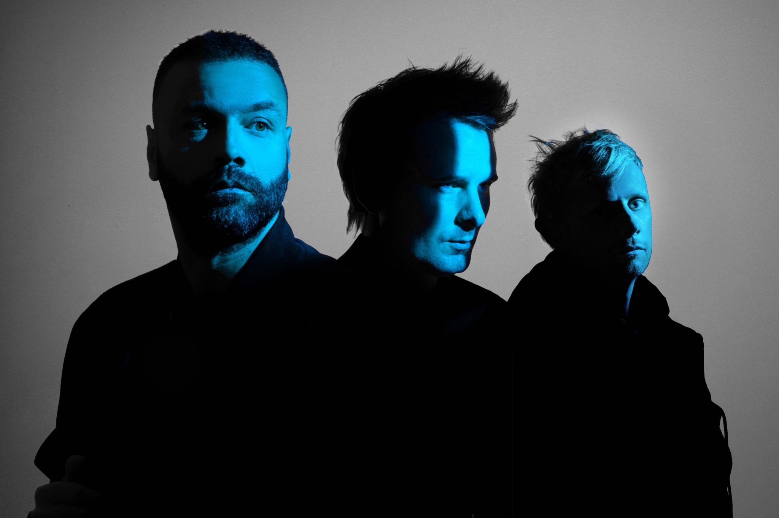
Muse (Photo Credit: Nick Fancher)

Website
Spotify
Apple Music
YouTube
Facebook
Twitter
Instagram

# # #

For more information, please contact:
Luke Burland, BB Gun Press
luke@bbgunpress.com

Stephanie Estrada, BB Gun Press
stephanie@bbgunpress.com

Laura Swanson, Warner Records
laura.swanson@warnerrecords.com

Mary Moyer, Q Prime
mary@qprime.com

Emilio Herce, Q Prime
emilio@qprime.com

