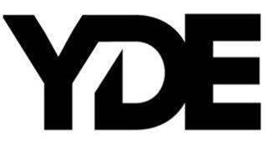

SHORT BIO:

With razor-sharp lyrics about personal transformation, and her relationship with the future, YDE (EE-dee) writes catchy, alt-skewering pop songs about what it means to be human. Simultaneously humble and herculean, the Australian-born, Filipino singer/songwriter dives even deeper into the human condition on her new single, “Old Her,” and upcoming project via Warner Records. “Ultimately, I really hope that people who need to hear my music, hear it,” YDE says.

Born in Australia, Breanna, her real name, moved to the US with her parents as a toddler. YDE went on to land starring roles on Nickelodeon series, The Haunted Hathaways at the age of nine, and School of Rock, before landing on the Netflix Series, Malibu Rescue. Most recently, the multi-faceted artist starred in the live production of WILD: A Musical Becoming alongside Idina Menzel.

